Jenn and James are drawing pictures of their dream house using PastDraw, where they have explored many different layouts of rooms and furniture. They have been working on the drawings for several weeks. When they both agreed on a change made to a diagram, they used the system’s “accept changes” feature so that PastDraw would no longer track and display information about that event. The last time that they agreed on the changes that they each made was a week ago.

One morning James wakes up to find a note from his wife saying that she was up most of the night working in PastDraw because she had an inspiration for some new designs.

Being intensely curious about the changes made, James loads up the house drawing in PastDraw (Figure 6.2). He first looks at the overview of the house displayed in the project overview (top right corner), which shows thumbnail images of the two levels of the house. To the left of the project overview is the real-time radar view (Gutwin 1997) of the diagram that is currently loaded, the document overview. Within these two overviews, objects that have been changed are colored to indicate which PastDraw user made the changes. We see in the figure that objects changed by James are colored blue (or black if the image is in black and white) while the ones that Jenn changed are green (or medium gray). Together, the project overview and the document overview provides him with a rough idea of where changes occurred, what objects were changed, as well as who made the changes.

James then looks at the detailed main view, shown in the large area in the left part of Figure 6.2, in order to find out more information about changes made to the first floor. Since James is already aware of his own changes, he selects the filters (right middle) to filter changes by person so that PastDraw will show only Jenn’s changes. Through the animation controls (bottom middle of figure), he sets the change display mechanism to animations and then pushes play to get more information. These animations literally replay what happened during the last week

Main view of diagram.

Project overview (project radar)

Jenn’s changes

Indicator for no. of changes.

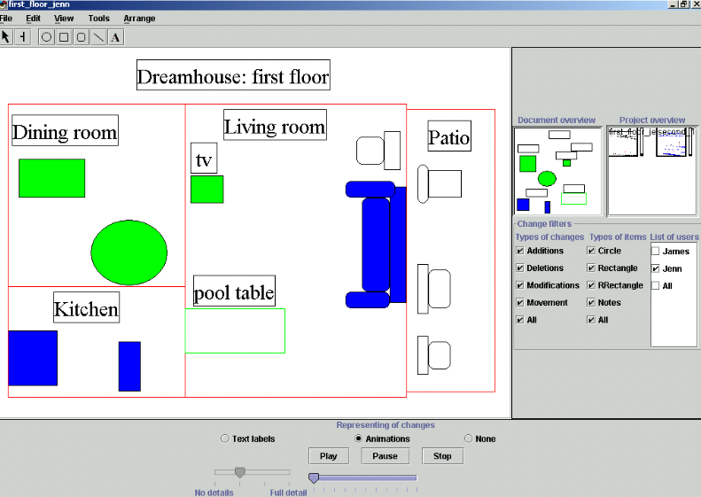

Animation controls

James’ changes

Controls for the text-based mechanism

Document overview (document radar)

Figure 6.2: Overview of the main features of PastDraw.

James tries to find the spot where Jenn started working last night but he discovers that PastDraw will only replay the changes starting from a week ago. In this version, he cannot fast forward the slider to start displaying changes from last night onwards. Nor does there exist the ability to filter the changes made during the week to show only the ones from last night.

In addition, Jenn had many false starts so much of the replayed sequence shows activities that do not really go anywhere. James finds these animations just too literal a recount of what happened: even small formatting adjustments (the movement and resizing of objects) are replayed. He sets the filters again, this time to screen out movements and modifications from the animation but now he finds that too much information is missing. He no longer gets a sense of the editing flow, and he still cannot determine what are false starts, and what are fruitful actions. Since James does not know what objects Jenn has changed, he does not touch the controls to filter by object type.

James decides that he needs a better general understanding of the changes that Jenn made during the night. There are just too many changes being displayed by the animations, and what’s worse, each change stays on-screen only briefly so that James cannot get a general sense of what happened. While the thumbnail overviews give some change information (‘where’, ‘who’ and the specific objects changed), James wants more details.

Previous location of TV.

James switches the change display mechanism to show “text labels” that briefly describe each change that has occurred over the last week (Figure 6.3). We see, for example, by the “DEL” indicator that his pool table (center) has been deleted from the living room. The diagram also includes outlined/faded graphical cues that provide additional details about ‘how’ certain types of labeled objects changed. With the living room television, for example, an arrow shows the previous location of the television as well as its final destination. Also two outline images and some resizing arrows show the dimensions of the TV before and after it was resized. In contrast to animations that show all of the intermediate locations, the approach employed with the text labels and cues show only the initial and final view of the television’s movement path.

James is somewhat overwhelmed by all this information, so he uses the slider control for the text labels (Figure 6.2, bottom left) to adjust the level of detail shown by the labels and images. We see in Figure 6.4 the effect that the different slider levels have on the display of changes for text labels in the detailed view. “No details” turns off the display of all change information (Figure 6.4a). The next level provides only color cues for changes (Figure 6.4b). The level after that adds text labels that describe changes (Figure 6.4c). “Full detail” augments the text labels with graphical cues like the arrows used for spatial moves.

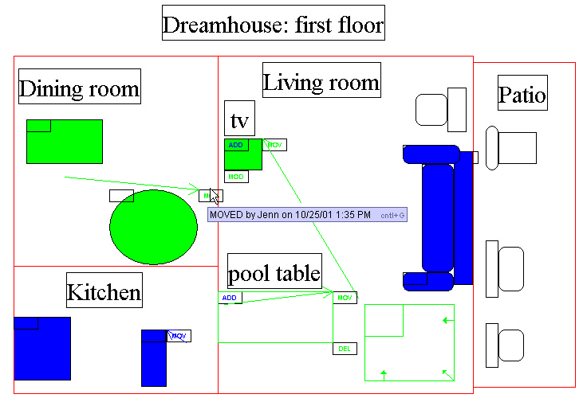

Faded ‘ghost’ outline of pool table and text label indicating its deletion.

Resizing of TV.

Past location of TV.

Current location of TV.

Figure 6.3: Text labels describing the changes.

After a few minutes of exploring this changed view of the first floor, James thinks he knows what has changed. He then looks at the thumbnail image for the second floor, and he notices a fair amount of change coloring. He clicks on the graphic to load it up in the main view (Figure 6.5). James notices that most changes occurred in the pool room (lower left), where a lot of new furniture has been added to it. He also notices that the pool table, which had been deleted from the first floor, is now added here. Out of curiosity why Jenn added the table, James mouses-over the label and sees that Jenn has added a note explaining what happened here i.e., that this room would now serve as a recreation room (bottom of Figure 6.5).