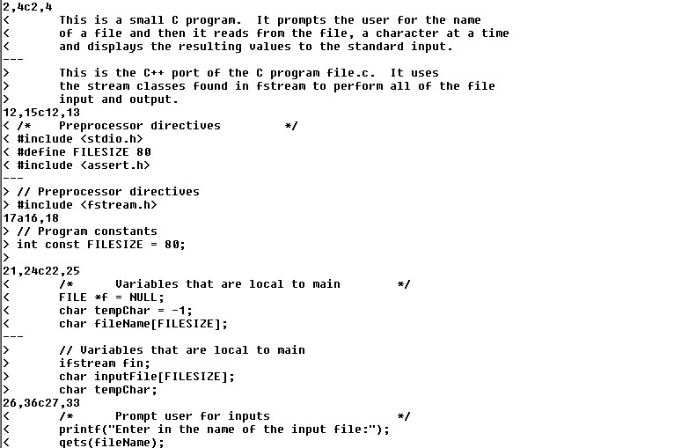

Figure

Figure 1. Common word processors such as Microsoft Word began to include change awareness techniques using in-line change displays, change indicators and annotations. The types of changes tracked are the addition, deletion or modification of items in the document. Figure 2 shows a Word document with the change tracking function turned on. We see that modifications are treated as an insertion immediately followed by a deletion. We also see a vertical bar in the left margin beside lines that have changed, which helps people spot lines with small changes. Text that is the same between versions is rendered in the original black; text that differs between versions is rendered in different colors, one for each editor. The example in the figure highlights changes by coloring the changed text red. Text added to the version is rendered with an underlined typeface, while text that has been deleted is rendered with a strike-through typeface. Changed text that has been annotated with comments by an author is highlighted in yellow, and mousing-over it will reveal the annotation in a small, transient, pop-up window.

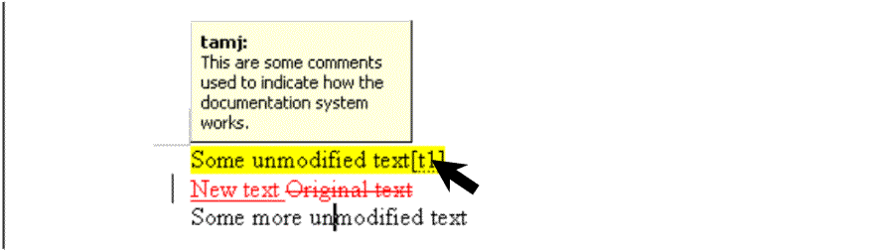

Document change indicator

Unchanged text

Modified text (shown as an addition and deletion)

Text annotated with documentation

Documentation

Figure 2: In Microsoft Word (Microsoft 1983), the modification of a string of text is treated as an insertion followed immediately by a deletion of the old text.

Unlike version control systems, which compare saved snapshots, Word allows the reader to track changes in real time. As a change is made to the document, a corresponding change indicator will be immediately displayed to the user. In the older version control systems, one had to leave the text editor and run a separate program to track changes.

A more sophisticated system that displays changes inline is Flexible Diff (Neuwirth, 1992), illustrated in Figure 2. Flexible Diff is an extension of the PREP editor (Cavalier, 1991). In this figure, we see how four columns are used to communicate the nature of a change. The original and modified text are in the first and second columns respectively. Column 3 shows only the differences between these versions while Column 4 shows annotations added by the author that explain the changes.

This last column of annotations was included to alleviate the frustrations that authors would sometimes experience when they encountered unexpected changes made by other co-authors (Cross, 1990). Annotations (Figure 3) also help draw a reader’s attention to a particular change (Neuwirth, 1992).

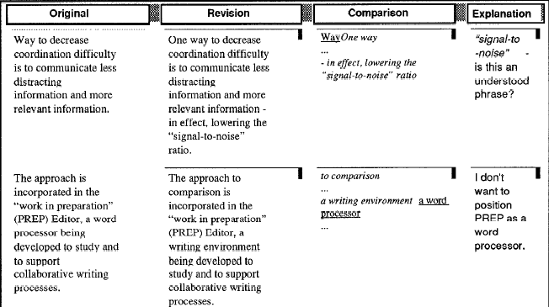

Figure 3: The four-column view of changes provided by Flexible Diff (Neuwirth, 1992)