Write a program that simulates the life of a student in CPSC 231 (fall 2016 term as shown in Figure 1).

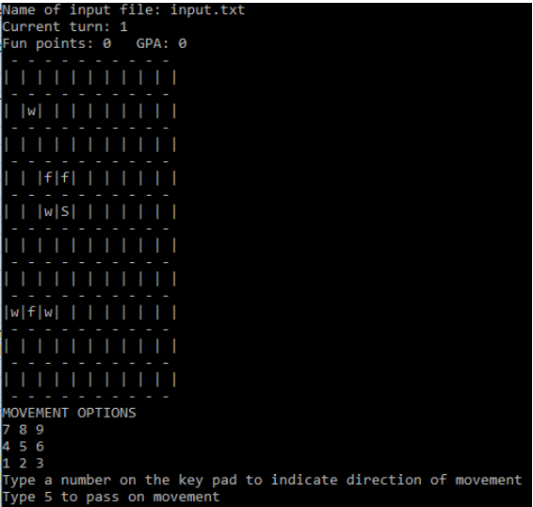

Figure 1

The simulated world will be represented by a 2D Python list of single character strings. A student 'S' can either choose to maximize his/her fun times 'f' during the term or the person can choose to expend time working 'w' in order to maximize the term grade point (GPA) and letter graded awarded. In this simulation there is not only a direct but a perfect correlation between time spent working and the grade awarded. However like a semester in "real life" there is only a finite amount of time during a term and the simulation will run for a maximum of 13 turns (weeks). Each time that the user is prompted to move the student (or if the choice is given up) a time unit will be expended.

The initial starting positions will be read in from a text file whose name is specified as the program is started. The student's 'Score' (fun and grade points earned along with the term letter grade) is saved to another text file 'Scores.txt'. Only one set of Scores are retained, each time that the simulation runs previous sCoREz are overwritten.

--

A CPSC 231 Assignment, fall 2016