**Subdocument1:**

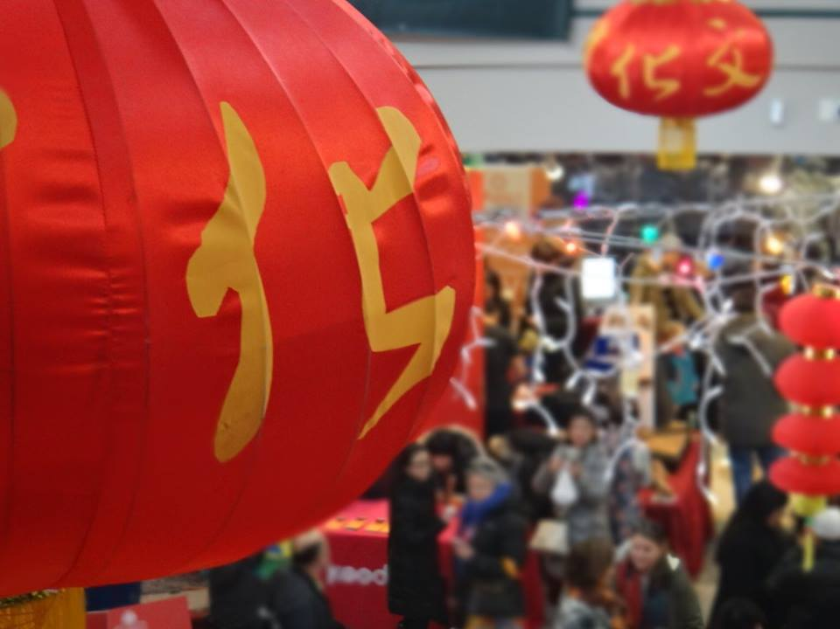

Figure : Lunar New Year 2018

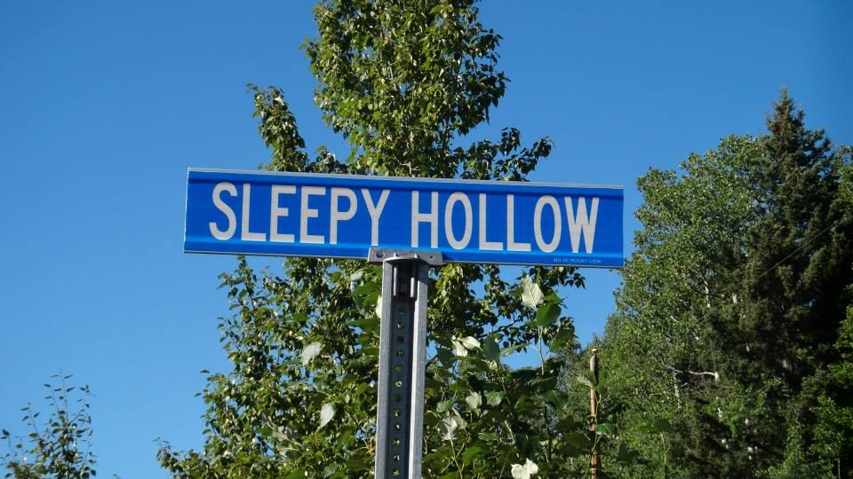

Figure : Somewhere near Bragg Creek Provincial Park - I think

