Confluence Park/Nose creek parkway: Split Rock

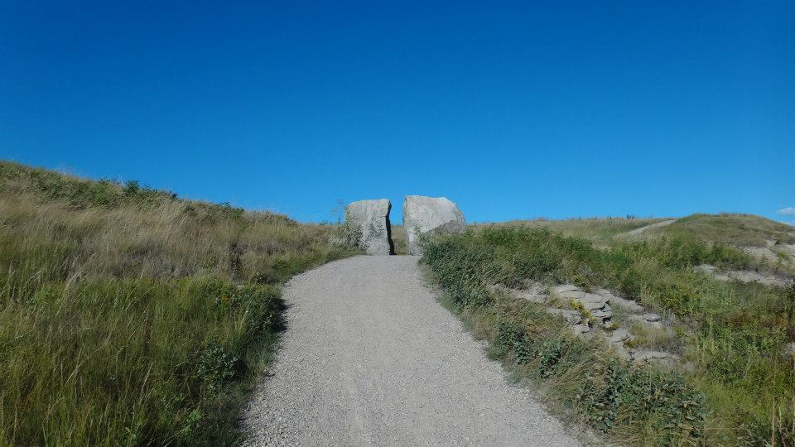

Nose Creek park — in [Airdrie, Alberta](https://www.facebook.com/pages/Airdrie-Alberta/103763379662585)

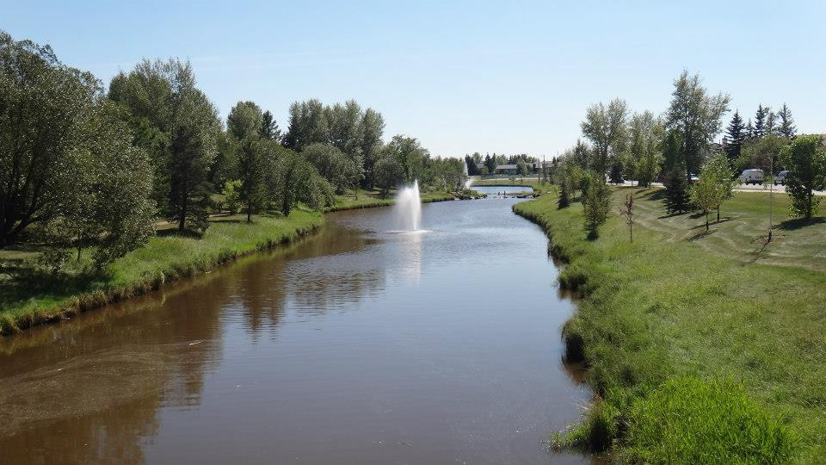

[Sharjah Buhairah Corniche](https://www.facebook.com/pages/Sharjah-Buhairah-Corniche/143139555752087)

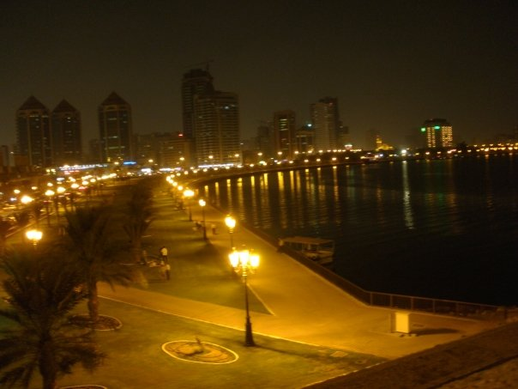

Terra cotta warrior, a guardian of Chun Gi Wong the first emperor of China - Chinese Cultural Center museum

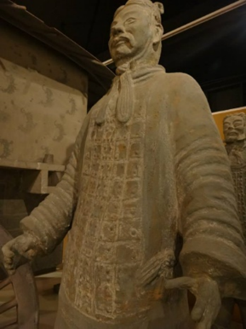

Japanese Garden – Lethbridge

