# CPSC 203: ~2010 - 2015

A text for an old version of the course.

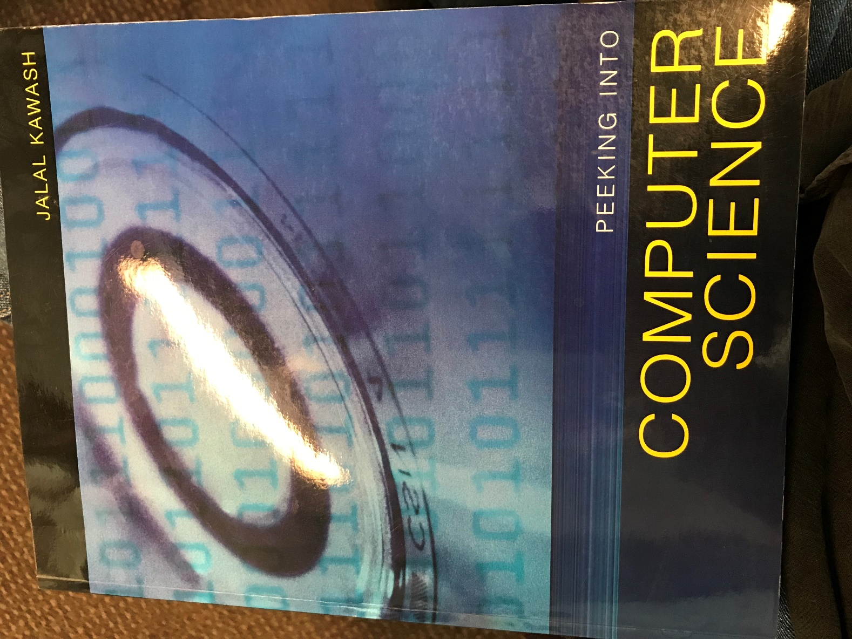

# CPSC 203: 2015+

The text for the current version of the course.

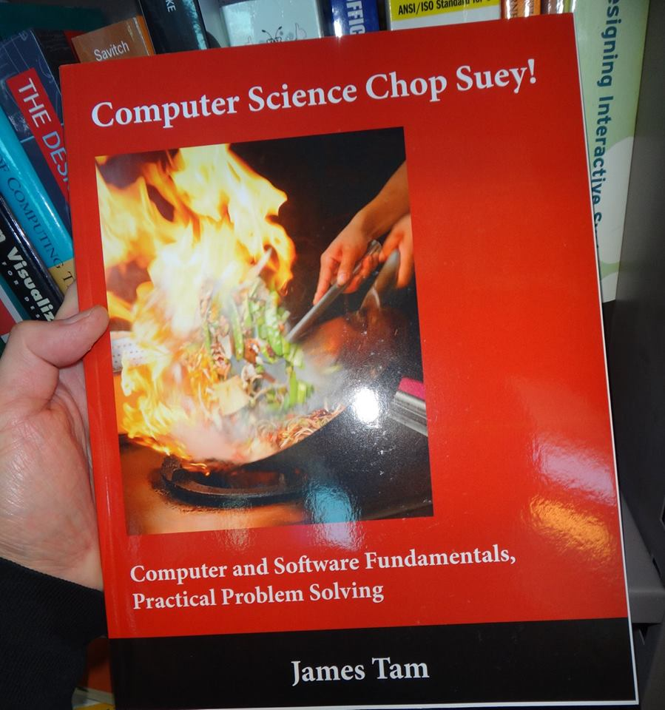

# CPSC 203: Workbook

A very early version of the cover icon/logo for the “Chop-chop” text.

