Contents

CPSC 203: ~2010 - 2015 2

CPSC 203: 2015+ 3

CPSC 203: Workbook 4

# CPSC 203: ~2010 - 2015

A text for an old version of the course.

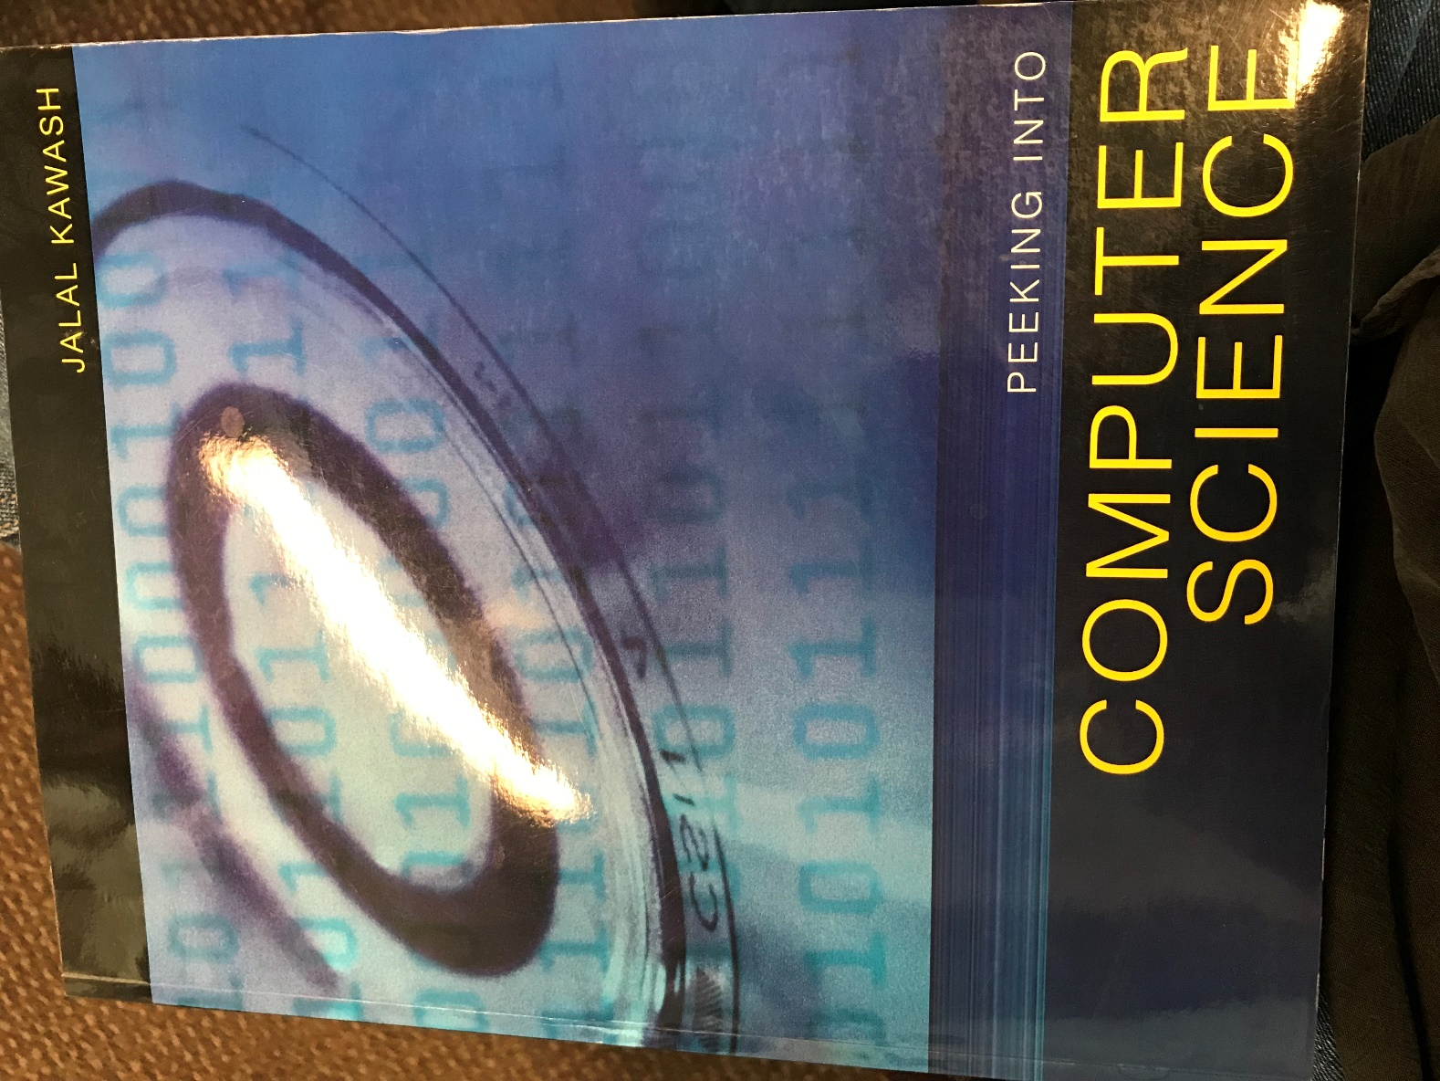

Figure

# CPSC 203: 2015+

The text for the current version of the course.

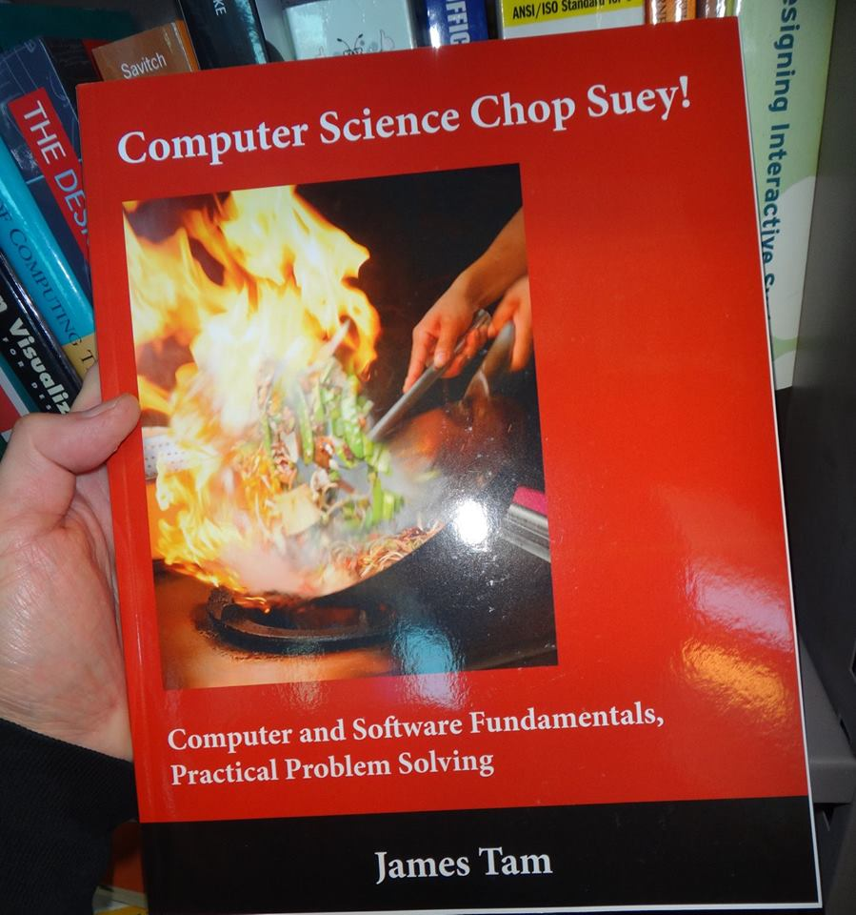

Figure 2

# CPSC 203: Workbook

A very early version of the cover icon/logo (Figure 3[1]) for the “Chop-chop” text.

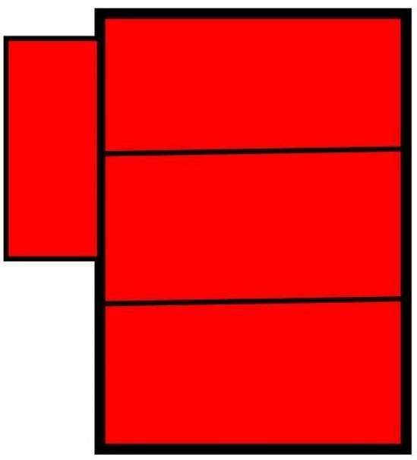

Figure 3

[2]

# Bibliography

*Computer Science Chop Suey*. (n.d.). Retrieved from http://pages.cpsc.ucalgary.ca/~tamj/research/computer_science_chop_suey_book.html

*Peeking into Computer Science*. (n.d.). Retrieved from http://pages.cpsc.ucalgary.ca/~kawash/peeking.html

1. This icon was actually the very first version of the cover.
2. These three books were used in different versions of CPSC 203 over the years.