**Writing on Stone national park**

This place contains the largest concentration of First Nation petroglyphs (rock carvings) and pictographs (rock paintings) on the great plains of North America. (Description from https://albertaparks.ca/writing-on-stone/).

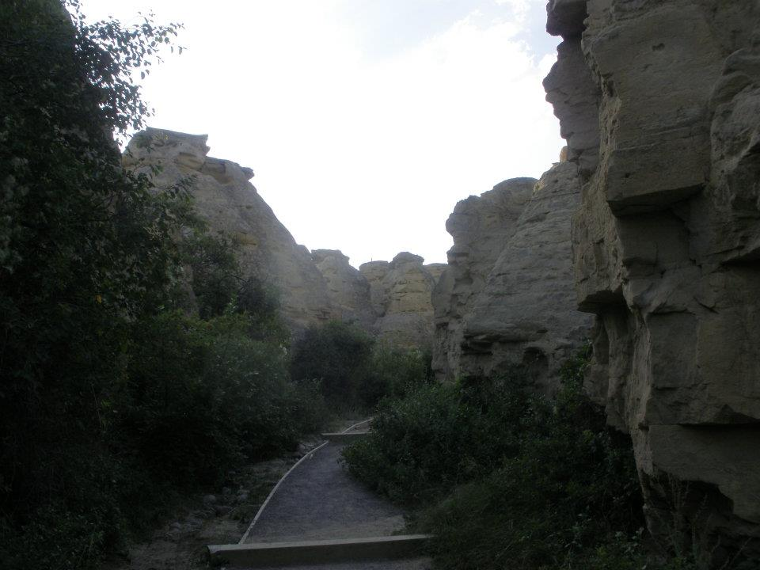

Battle scene petroglyph:

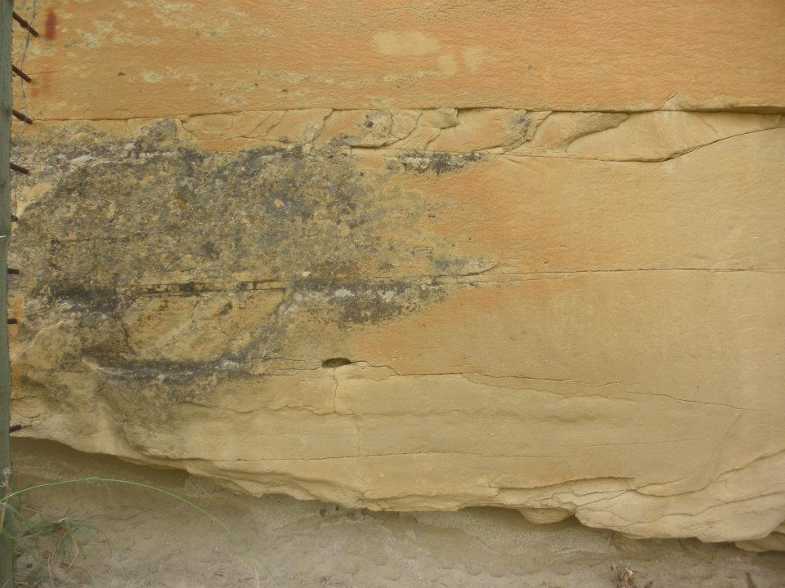

**Crowsnest pass and Frank slide**

A current day view of the slide with a close up of a boulder which is probably similar to the ones that came down during the original tragedy. It may help to illustrate that destructive power of the rockslide.

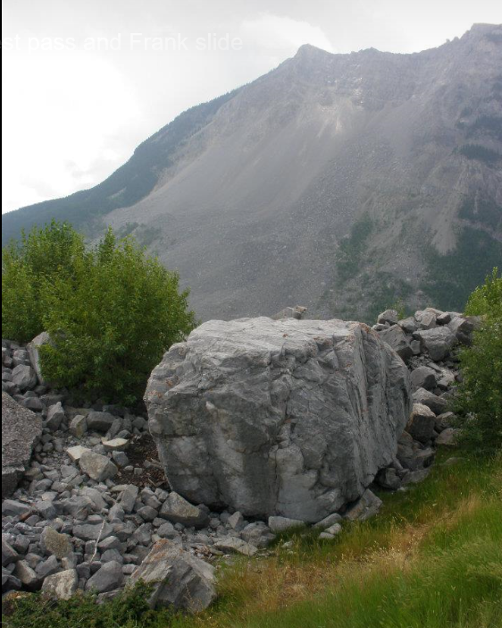

Bellevue Underground Mine

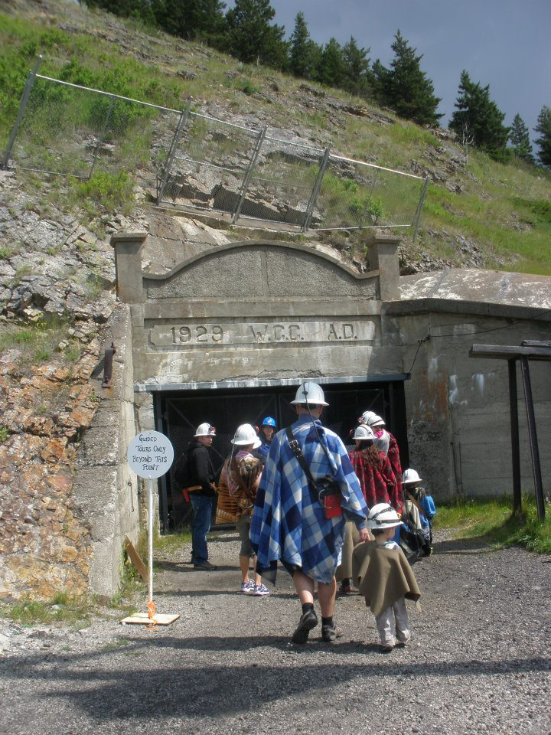

**Banff and Lake Louise**

Vermillion lake

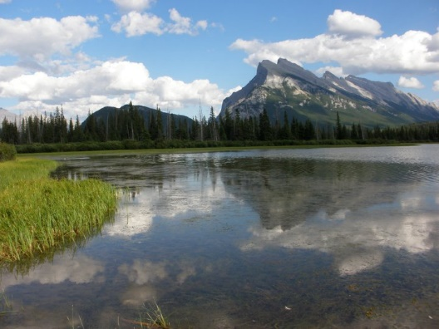

The grounds of Chateau Lake Louise

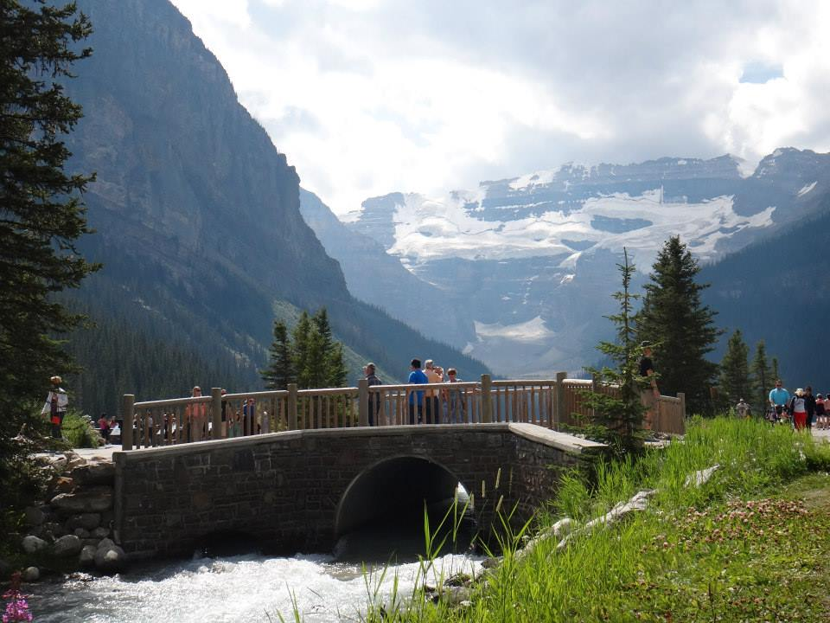

Peyto lake

