To do during tutorials (Nov 23 - 29)
First tutorial
- Go over the requirements of A5
- Show a simple Object-Oriented example: first/CarExample.py
  - Define class with attributes, create instance
- Class with methods: second/CarExample.py
  - Same example but includes a method
- Classes split into modules: third/CarExample.py, Driver.py
  - Code is in two files: Driver.py (no pun intended, this is the class containing the starting method), Car.py
- Objects referring to other objects: fourth/
<< Driver.py >>
from Parent import *
from Child import *

def start():
aChild = Child("Sonnie-boy")
aParent = Parent("Mommie",aChild) # Parent’s name, ref. to kid
aParent.display()
aChild.display()

start()

<< Parent.py >>
class Parent:
def __init__(self,aName,aChild):
self.name = aName
self.myChild = aChild # One obj. ref. to another obj.

def display(self):
print("My name is %s ", self.name)
print("My child's name is %s ", self.myChild.name)

<< Child.py >>
class Child:

def __init__(self,aName):
self.name = aName

def display(self):
print("My name is %s " %(self.name))

Second tutorial
- Tracing example: fifth (code in one file)
  - Focus on ‘self’
def method1(self,name,age):
self.name = name
self.age = age

def method2(self,name,age):
name = name # No self, only changes locals
age = age

def method3(self,aName,anAge):
name = aName # No self, still only changes locals
age = anAge

# Error: why? No ‘self’
# def method4(aName,anAge):
# self.name = aName
# self.age = anAge

def start():
person1 = Person() # Default args: Katie etc.
print("Person1: %s, %d" %(person1.name,person1.age))
person1.method1("Micah Sloat",25)
person1.display()
person1.method2("Kim Kardassian",30)
person1.display()
print()
person2 = Person()
person2.display()
person2.method3("Heather Morris",17)
person2.display()

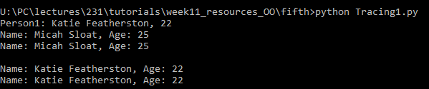

- Tracing example: sixth (code in multiple files)
import Tracing2 # Needs module name to call methods
from Tracing3 import * # Mass import

def start():
aTracing2 = Tracing2.Tracing2() # Module prefix
print(Tracing2.CONSTANT1) # Module prefix
aTracing2.method1()
aTracing2.method2()
print(aTracing2.CONSTANT2)
print()

# Mass import (wild card *) allows for shorter notation
aTracing3 = Tracing3() # No module name needed
aTracing3.method3() # Method requires an instance
fun1() # Function not method, no instance needed

start()

No student exercise this term (“Timelord” example removed)

