To do during tutorials
Documentation requirements
Specs out of the assignments
First tutorial
- GUI example “button_events”: react to button events:
  - Calling the ‘button_clicked()’ method
  - Setting the property of the button (‘text’)
Program:
# Change the text in the button to "Press me"
# When the botton pressed change the text to "Stop pressing me!"

from tkinter import *

aWindow = Frame()
aButton = Button(aWindow)

def button_clicked() :
global aButton
aButton['text'] = "Dude stop pressing me!!!"

def start ():
global aWindow
global aButton

aWindow.pack()
aButton['text'] = "Press me"
aButton['command'] = button_clicked
aButton.grid(row=0, column=0)
aWindow.mainloop()

start()

Before press | After press
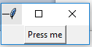 | 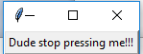

- tkinter module ‘graphics’ example
  - Drawing various primitives, first four properties determine the size of the ‘bounding box’ for the primitive:
    - First two: Top LHS corner (x,y)
    - Second two: Bottom RHS corner (x,y)
  - Drawing lines (properties specify the (x, y) coordinates of the two end points
  - Other properties: ‘fill’, ‘outline’ (to set colors), ‘tag’ (used to give a shape a name that can be referred to later – see the ‘moving’ primitive)
  - Calling the ‘move()’ function of a ‘Canvas’ can update the position of primitives on the canvas making them appear to move.
  - Creating a drawing window and running the main gui loop

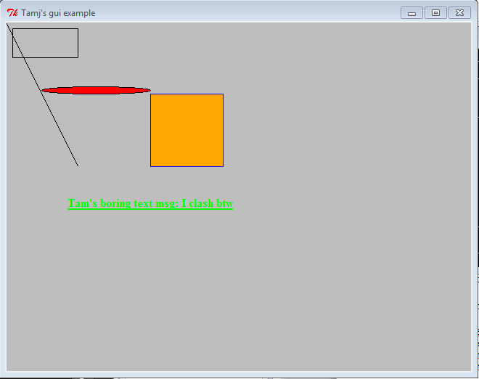

def createShapes(aDrawingCanvas):
# Shape's first four properties: Top LHS(x,y), Bottom RHS(x,y)
aDrawingCanvas.create_rectangle(10,10,100,50)
aDrawingCanvas.create_oval(50,100,200,90, fill = "red")

aDrawingCanvas.create_text(200,250, text="Tam's boring text msg: I clash
btw", font = "Times 12 bold underline",fill="green")
aDrawingCanvas.create_rectangle(300,100,200,200,fill =
"orange",outline="blue",tag="rect2")

# Point 1(x1,y2), Point 2(x2,y2)
aDrawingCanvas.create_line(1,1,100,200)

def animate(aDrawingCanvas):
input("Hit enter to see rectangle two move")
aDrawingCanvas.move("rect2",100,300)

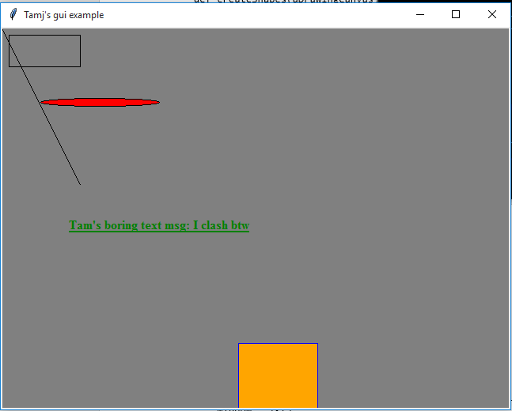
def start():
# Create a window with certain visual characteristics
window = Tk()
window.title("Tamj's gui example") # Label the title bar
aDrawingCanvas = Canvas(window,width=640,height=480,bg ="grey")
createShapes(aDrawingCanvas)

# Draw window and start the gui
aDrawingCanvas.pack()
animate(aDrawingCanvas)

window.mainloop()

tkinter module ‘graphicsV2’ example
The parameters to the methods can be determined at runtime
from tkinter import *
LHS_X1 = 50
LHS_Y1 = 50
SIZE = 100
RHS_X2 = LHS_X1 + SIZE
RHS_Y2 = LHS_Y1 + SIZE

def createShape(aDrawingCanvas):
# Shape's first four properties: Top LHS(x,y),Bottom RHS(x,y)
aColor = input("Enter fill color: ")
aDrawingCanvas.create_rectangle(LHS_X1,LHS_Y1,RHS_X2,RHS_Y2,fill=aColor)

def start():
# Create a window with certain visual characteristics
window = Tk()
window.title("Second example") # Label the title bar
aDrawingCanvas = Canvas(window,width=320,height=240,bg ="red")
createShape(aDrawingCanvas)

# Draw window and start the gui
aDrawingCanvas.pack()

window.mainloop()

start()

Mini-A4b
Part I
def button_clicked() :
global aButton
print("Button pressed")

Part II
def drawShape(aDrawingCanvas,lhs_x1,lhs_y1,size,aColor):
rhs_x2 = lhs_x1 + size
rhs_y2 = lhs_y1 + size
aDrawingCanvas.create_rectangle(lhs_x1, \
lhs_y1, \
rhs_x2, \
rhs_y2, \
fill=aColor)

Go over the highlights of A4

Second tutorial (File input/output, exceptions and data processing a list)

DATAFILE_NAME = "employees.txt"

def display(employees):
last = len(employees)
print("EMPLOYEE LIST")
print("-------------")
for r in range (0, last, 1):
print("Employee #%d" %(r))
for c in range (0, 3, 1):
print("\t%s" %(employees[r][c]))

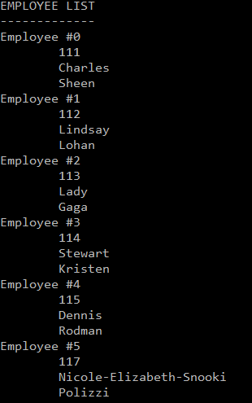

Input file
112 Lohan,Lindsay
113 Gaga,Lady
114 Kristen,Stewart
115 Rodman,Dennis
117 Polizzi,Nicole-Elizabeth-Snooki

def fileRead():
employees = []
try:
inputFile = open(DATAFILE_NAME, "r")
for line in inputFile:
employeeID, name = line.split()
lastName, firstName = name.split(',')
anEmployee = [] #Create 1 list from row in file
anEmployee.append(employeeID)
anEmployee.append(firstName)
anEmployee.append(lastName)
employees.append(anEmployee) #Append 1 list onto 2D
inputFile.close()
except IOError:
print("Trouble reading/opening file %s" %(DATAFILE_NAME))
return employees

def fileWrite(employees):
try:
outputFile = open(DATAFILE_NAME, "w")
for employee in employees:
employeeID = employee[0]
employeeID = employeeID + " "
outputFile.write(employeeID)
firstName = employee[1]
lastName = employee[2]
name = lastName + "," + firstName + "\n"
outputFile.write(name)
outputFile.close()
except IOError:
print("Trouble writing/opening file %s" %(DATAFILE_NAME))

def main():
employees = fileRead()
if (len(employees) > 0):
display(employees)
del employees[0]
fileWrite(employees)

main()

