Racing game: A CPSC 219 assignment
Create a racing simulation with two separate driving tracks: arctic and desert. For this version of the program the arctic track contains an SUV (Sport Utility Vehicle) and the desert track contains a sports car. Each car will try to reach the end of its respective track without running out of fuel and prior to the other car (see Figure 1). If either or both cars reach the end of the track then the simulation ends: draw (if both reach it during the same turn), win (for the car that reached it first), and loss (for the car that didn't reach it first). If one car runs out of fuel then the simulation continues until: both cars run out fuel (tie) or the other car reaches the end (win for that car). The simulation is also a 'draw' if the user quits the program early.
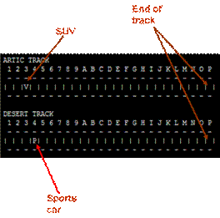
Figure 1: Race tracks with their respective vehicles
There is a random chance of a weather event occurring in each track. The arctic track can have a blizzard that prevents non-AWD (All Wheel Drive) movement (but doesn't stop the expenditure of fuel) while the desert track can be hit with a heat wave that can cause sports cars to overheat and double the fuel consumption rate (movement distance is unchanged). Finally the simulation allows for a 'cheat' option - see Figure 2 - for testing purposes: debugging messages can be toggled on/off, the fuel level of either car can be manually set, a car can be manually moved to any location within its current track, a weather event can be invoked in the other track (meant to hinder the other car so the cheat option shouldn't work on one's own track. Because the weather event for a track is determined immediately after the user's choice for that track, the user's option for causing a weather event in their own track will be ignored.

