**Part II: Creating your first Python program**

You are to write a Python program that will use the 'print()' function to display information about the planets in our solar system1 in the following format:

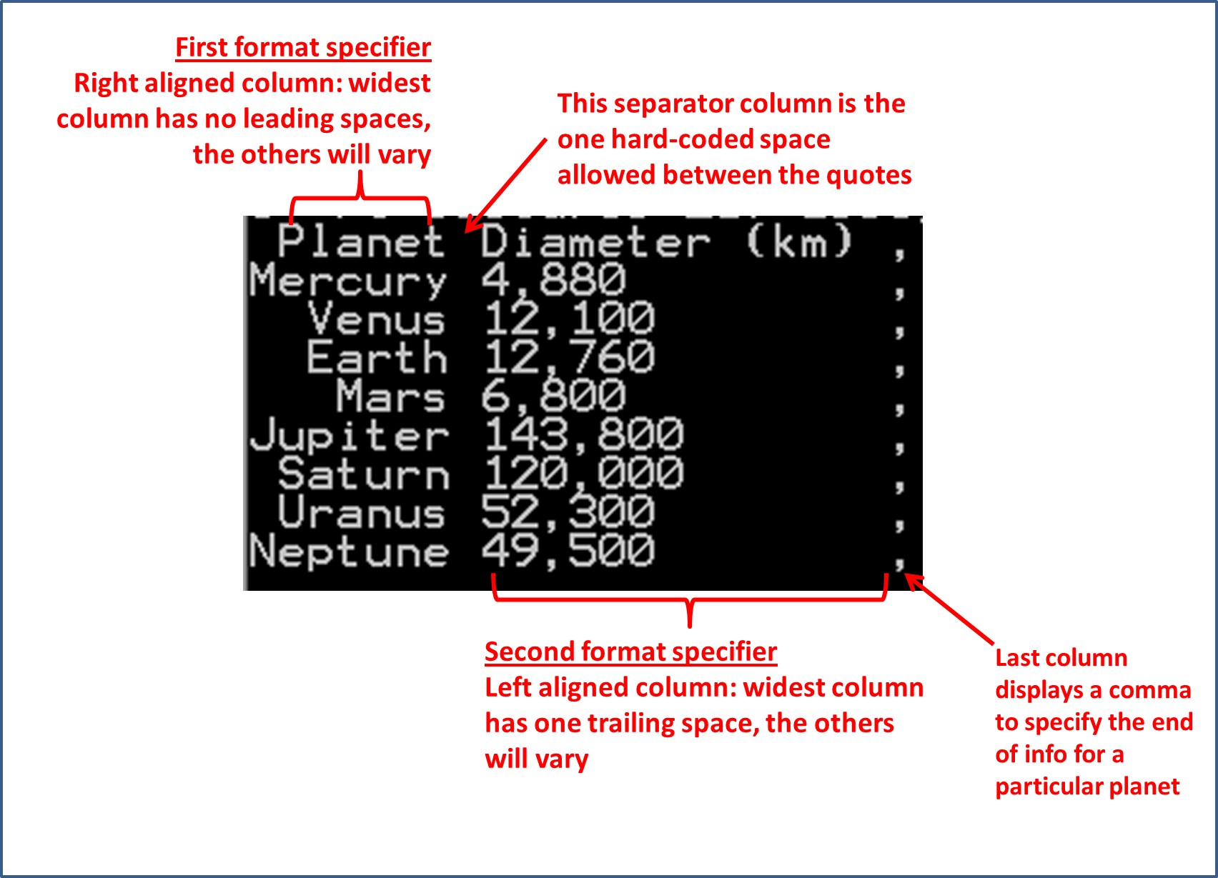

Each planet's information will be displayed by it's own print instruction: print("%s %s," %(<String for planet name>, <String for planet diameter>). You need to figure out how to use the format specifiers in order to get your program output to match the output shown in the image. In the assignment one directory you will find the code for the starting program 'planets.py' that you will copy to your home directory and modify. The alignment should be implemented by using the 'field width' property of the print function and not by manually inserting spaces (this is referred to as 'hard coding'). The only hard coded space allowed is the separator between columns.