**Learning objective:**

Learning what level of function variables should be declared while trying to minimize the scope of variables i.e. declare them at the lowest level possible.

**Program:** see whereToCreateVariables_STARTING.py

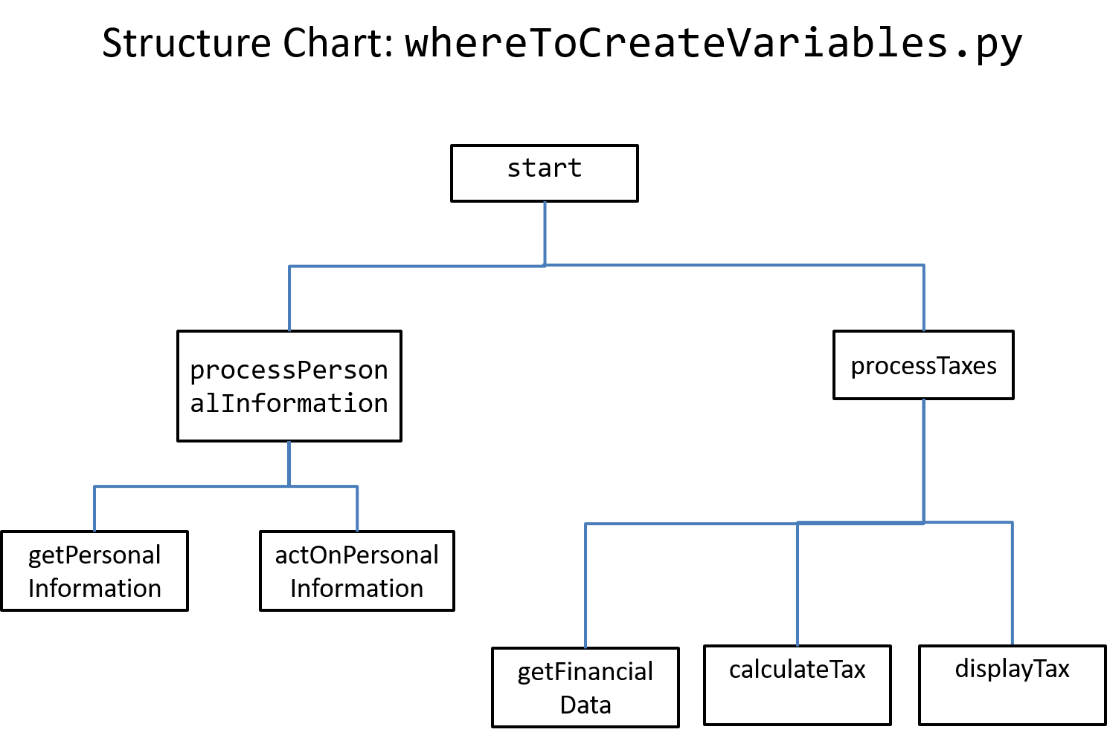

**Terminology:**

Variable declaration, think of it in python when you create a variable e.g. num = 12

**Begin with the starting program**: whereToCreateVariable

* For functions with variables e.g. getFinancialData you need to determine if these variables can be declared only in this function or if they need to be declared in higher level calling function.
* Reminder: declare functions at the lowest level possible to minimize their scope.
* Once you have determined where the variables are to be declared then make necessary modifications such as: return instructions or assignments as needed.