**Places of Interest: Calgary**

## Spruce Meadows

The festival of lights. It’s pretty. It’s held annually. Best of all it’s completely free, the only drawback is that it’s a bit of commute for some as it’s outside the southern city limits on Highway 22x.

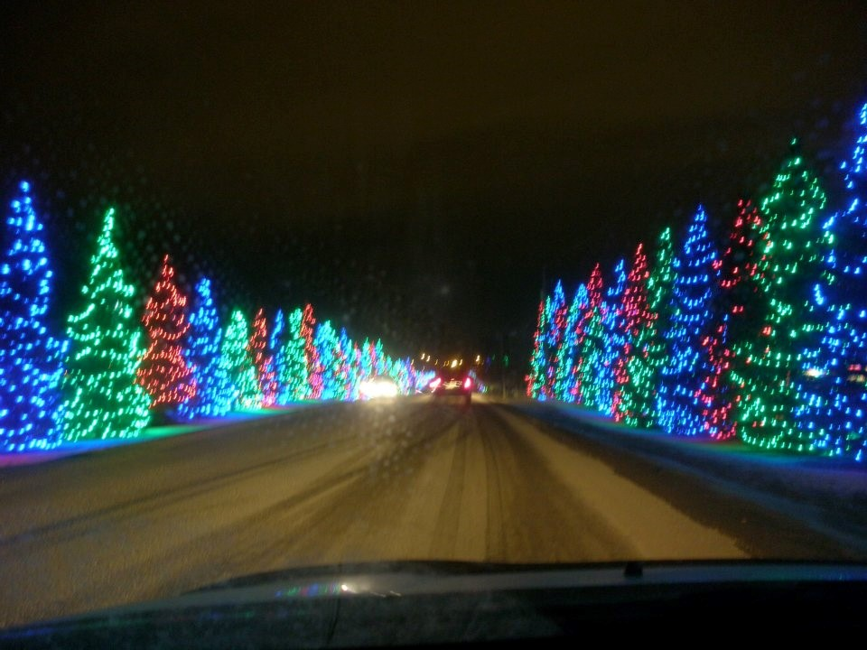

## 

## “Cool” running bridge

This old bridge might not look like much but Disney filmed part of the movie "[Cool Runnings](https://www.imdb.com/title/tt0106611/?ref_=fn_al_tt_1)" here (the place where the Jamaican bobsled team pelts [John Candy](https://www.imdb.com/name/nm0001006/) with snowballs).

**“One dream. Four Jamaicans. Twenty below zero.”**

For me it used to be the far apex of my old running route when I competed in school. It brings back some ‘painful’ memories of the "bear" (abdominal cramps caused by physical exertion) coming to get me right around here. As an incentive not to let “the bear get me” this was where I entered the start of the training route of the aspiring members of the Olympic team from running clubs such as “The Roadrunners” and “The Spartans”.

