Figures in this document

**Figure** **Page**

Figure 1: New Years: 2014 1

Figure 3: Honan Shaolin's dragon meets the big headed Clown. 2

Figure 4: Petra (Wadi Musa) 3

Figure 5: Petra Treasury. 4

Figure 6: Eiffel Tower: it lights up in twinkling lights on the hour every hour at night. 5

Figure 8: Christmas at Spruce Meadows 6

Figure 9: Spooky 6

Figure 10: Bad mood dude 7

Figure 11: CSGS Halloween party 9

Figure 12: It slices! It dices! It's the gin-su knife!!! 9

Who would think that there would be such a beautiful re-creation of a Japanese garden (see Figure 1: New Years: 2014) and house in the middle of the Canadian prairies, a very tranquil and relaxing place. I had to do the Zen meditation ala the quickie version because I was running out of time that day before they closed (to be more efficient in my travels I went to the buffalo jump, and toured Lethbridge and Claresholm all in one day. Since it's over 4 hours travel time I was really pressed for time in the end. Thanks Kelly for the tip about this place

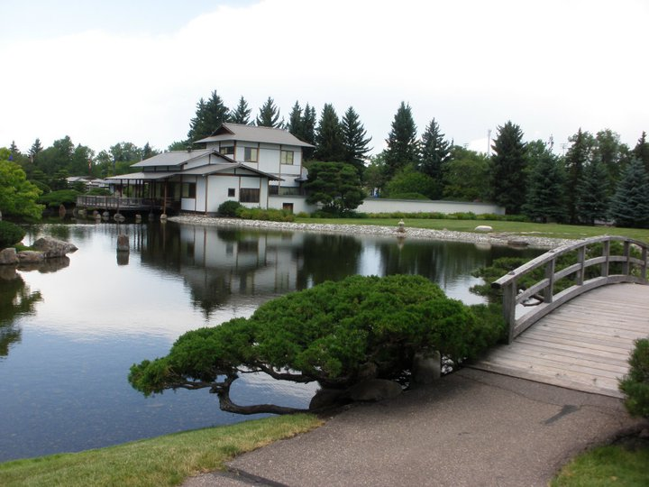

Figure 1: New Years: 2014

Also went to see our sister club Honan Shaolin (see Figure 2: Honan Shaolin's dragon meets the big headed Clown.)

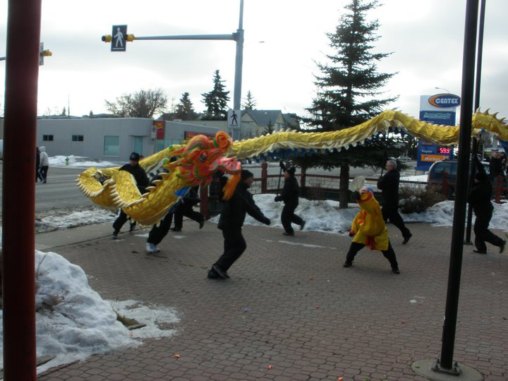

Figure 2: Honan Shaolin's dragon meets the big headed Clown.

This is the Figure 3: Petra (Wadi Musa) that people think of when they think of Jordan. An ancient archaeological site that was the home to numerous movies: Indiana Jones, Mortal Kombat, the second Transformers movie and more.

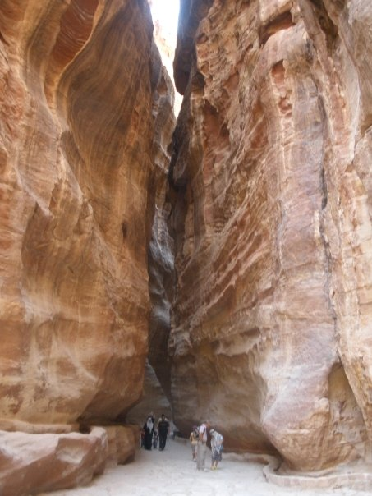

Figure 3: Petra (Wadi Musa)

Treasury (Figure 4: Petra Treasury.) taken at Near Wadi Musa about 240 km south of Amman Jordan.

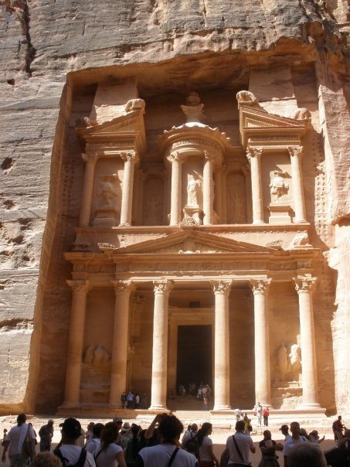

Figure 4: Petra Treasury.

Although I have pictures of it in other albums I think that the tower (Figure 5: Eiffel Tower: it lights up in twinkling lights on the hour every hour at night.) is special enough to merit its own album. Because of the snow and the cold weather I couldn't go any higher than the first floor platform (there's a second level above that and then the lift all the way to the top). I tried coming back a few times while I was there but the answer was the same. :(

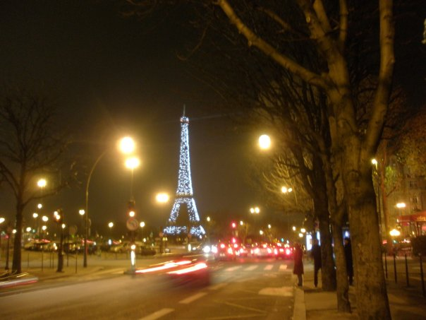

Figure 5: Eiffel Tower: it lights up in twinkling lights on the hour every hour at night.

Spruce Meadows (Figure 6: Christmas at Spruce Meadows) near the exit at Highway 22X, I just missed the corner and slid into the ditch. Christmas Eve and I thought I'd be stranded just outside of the city because even my SUV couldn't make it back up.

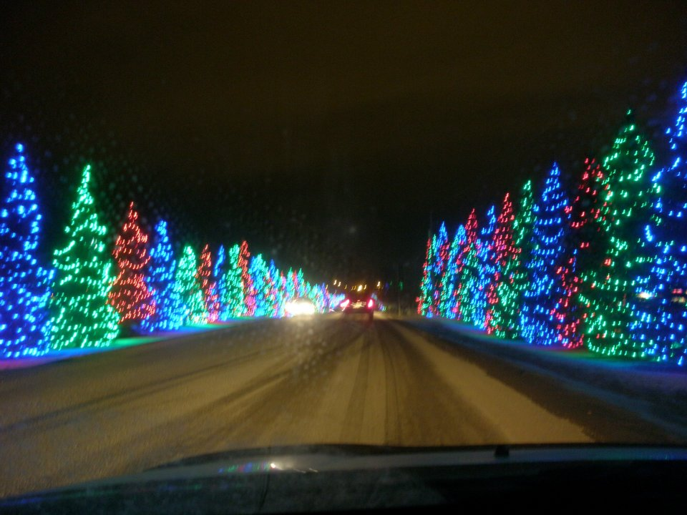

Figure 6: Christmas at Spruce Meadows

I love Silent Hill, I must be going nuts cuz I see it everywhere now (Figure 7: Spooky).

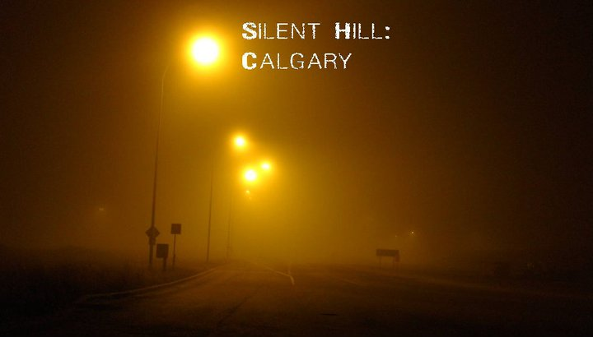

Figure 7: Spooky