# Calgary

## Split rock

Confluence Park/Nose creek parkway: Calgary's version of Stonehenge!

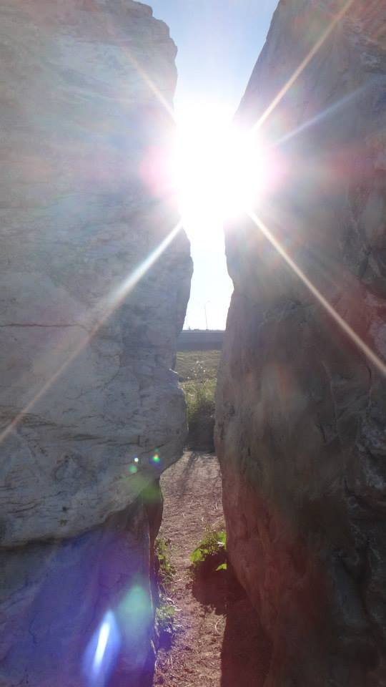

## New picture

## 

## Traffic artwork:

A painting under the Edmonton trail flyover going into downtown near the Drop-in centre.

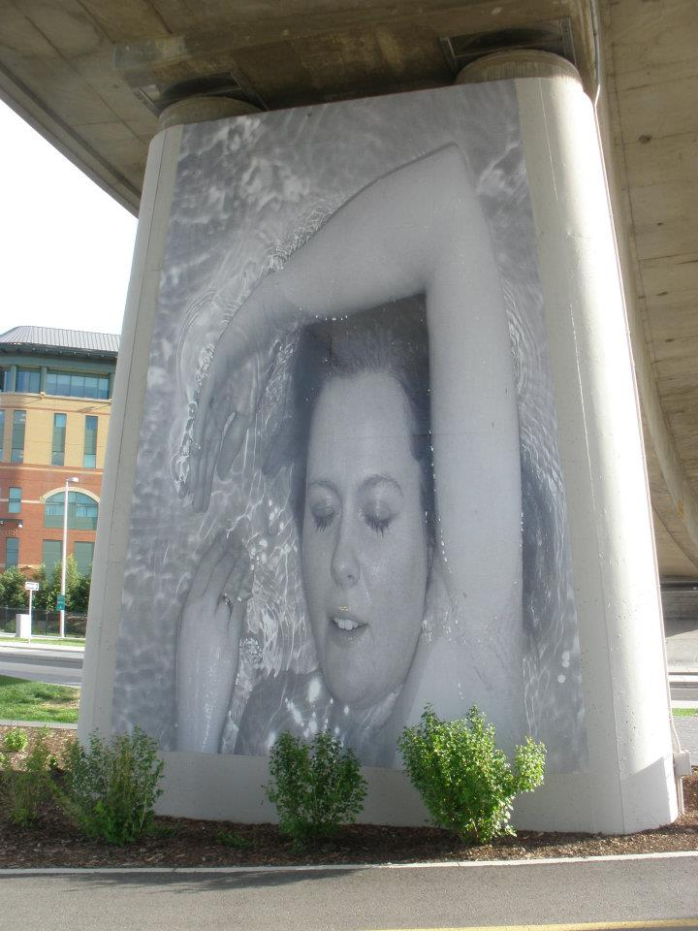

## 

## Spruce Meadows

The festival of lights. It’s pretty. It’s held annually. Best of all it’s completely free, the only drawback is that it’s a bit of commute for some as it’s outside the southern city limits on Highway 22x.

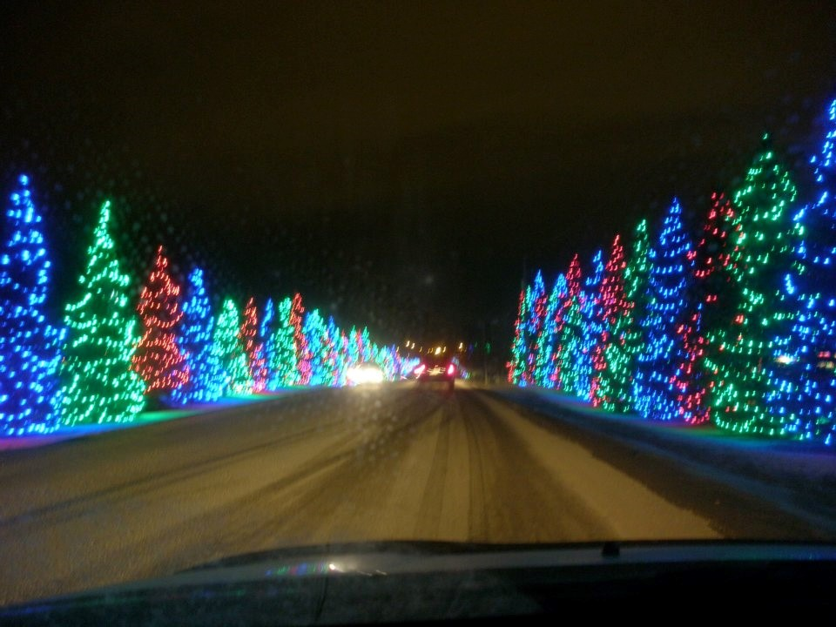

## “Cool” running bridge

This old bridge might not look like much but Disney filmed part of the movie "Cool Runnings" here (the Jamaican bobsled team pelts John Candy with snowballs).

“One dream. Four Jamaicans. Twenty below zero.”

For me it used to be the far apex of my old running route when I competed in school. It bring back some painful memories (the "bear" used to get me right around here and sometimes I'd be racing against aspiring members of the Olympic team).

