**World travels**

## Split rock

Confluence Park/Nose creek parkway: Calgary's version of Stonehenge!

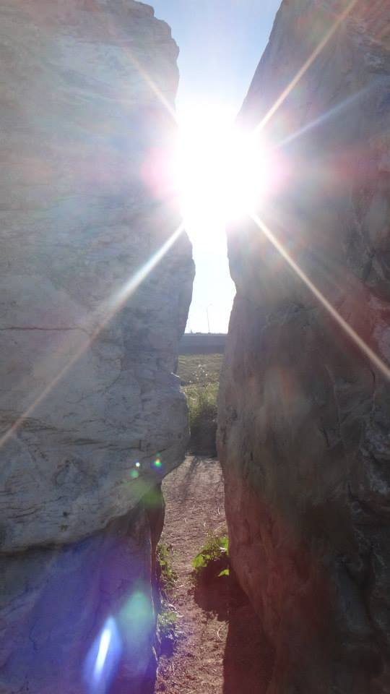

## Spruce Meadows

The festival of lights. It’s pretty. It’s held annually. Best of all it’s completely free, the only drawback is that it’s a bit of commute for some as it’s outside the southern city limits on Highway 22x.

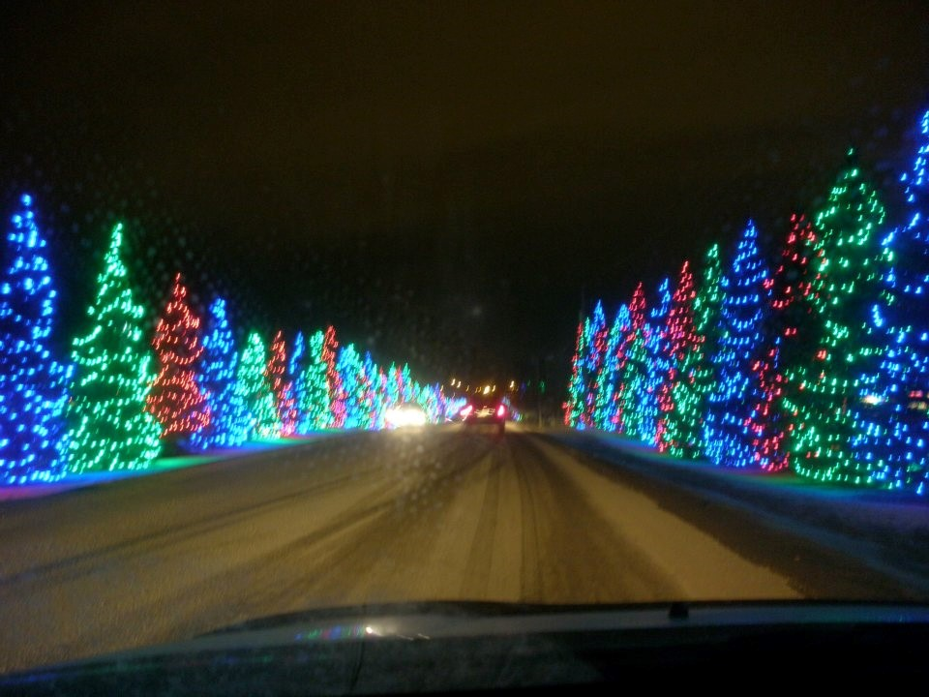

## “Cool” running bridge

This old bridge might not look like much but Disney filmed part of the movie "Cool Runnings" here (the Jamaican bobsled team pelts John Candy with snowballs).

“One dream. Four Jamaicans. Twenty below zero.”

For me it used to be the far apex of my old running route when I competed in school. It bring back some painful memories (the "bear" (painful abdominal cramps caused by physical exertion) used to get me right around here and sometimes I'd be racing against aspiring members of the Olympic team from running clubs such as “The Roadrunners” and “The Spartans”).

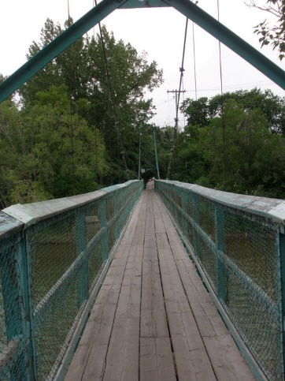

## Chillout

One can accurately describe this as a real cool nightclub, it’s all ice.

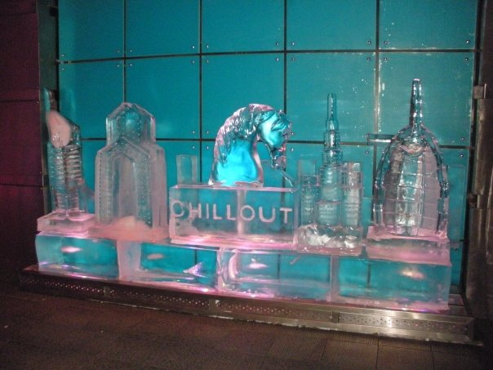

## Gold Souk:

There appears to be no limit to the different ways that you can spend your money here (and no limit to the amount of money that you can spend!)

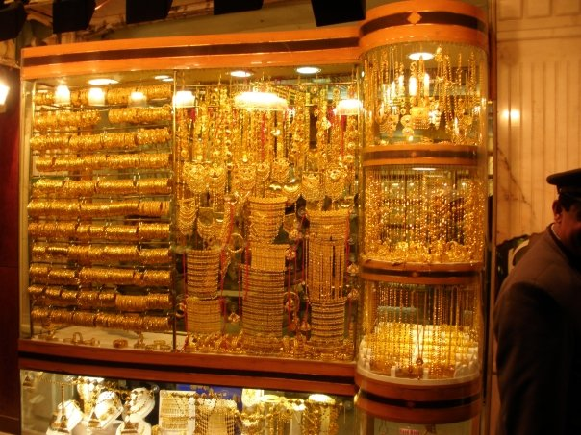

## Stark contrasts

Where else can people be sweating it out in +50 C heat outside but inside you’ve got a runny nose in an artificially generated sub-freezing ski resort (inside a shopping mall to boot). OK the picture is from the mail with in the indoor aquarium (Dubai mall) rather than the one that offers skiing (Mall of the Emirates) but I thought that this is a much cooler picture.

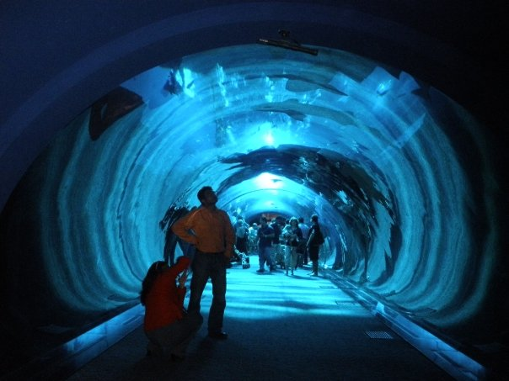

## Burj Al Arab

Sunset of a perfect day at the only seven star hotel in the world. Luxury starts at about $10,000 per night :O (CAD). There’s hotels cheaper than that but why bother? :P

