# Dubai

## Al Mamzar beach park

Someone must have passed on the word that I was coming, I appear to have the whole place to myself. :)

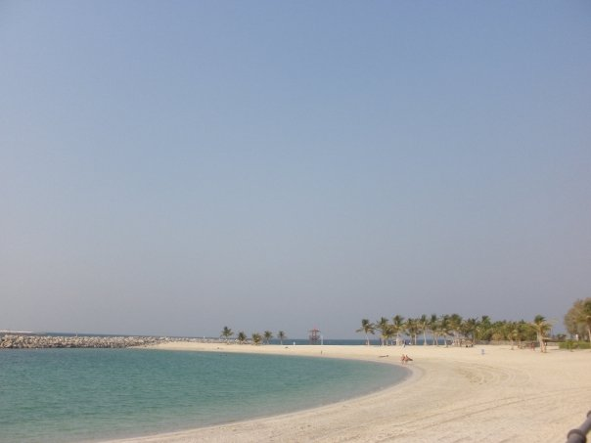

## Chillout

One can accurately describe this as a real cool nightclub, it’s all ice.

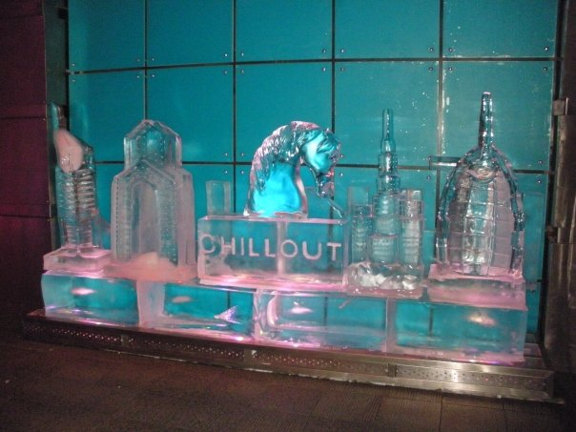

## [Burj Khalifa](http://www.burjkhalifa.ae/)

Former known as the Burj Dubai (before the bailout of Dubai by Abu Dhabi). The world’s tallest building standing at 828 meters (2,717 feet). This is a little less than double the height of Toronto’s CN Tower and over 4 times the height of the Calgary Tower.

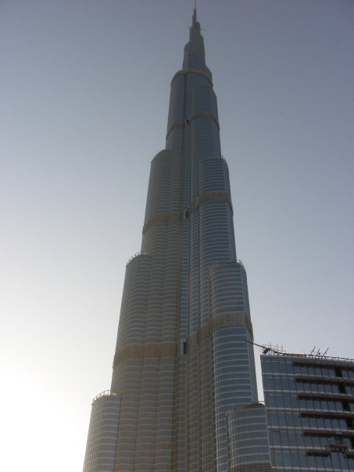

## Gold Souk:

There appears to be no limit to the different ways that you can send your money here.

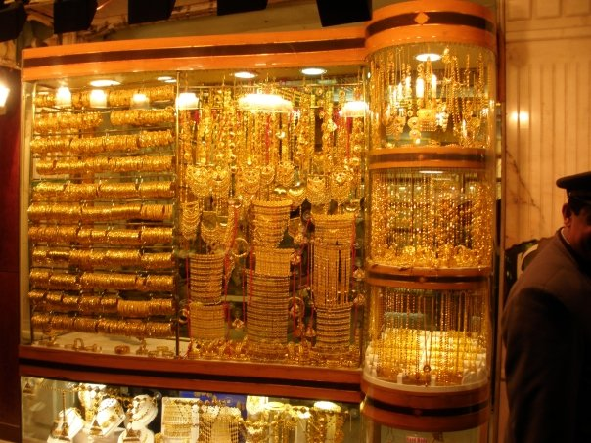

## Stark contrasts

Where else can people be sweating it out in +50 C heat outside but inside you’ve got a runny nose in an artificially generate sub-freezing ski resort (inside a shopping mall to boot). OK the picture is from the mail with in the indoor aquarium (Dubai mall) rather than the one that offers skiing (Mall of the Emirates) but I thought that this is a much cooler picture.

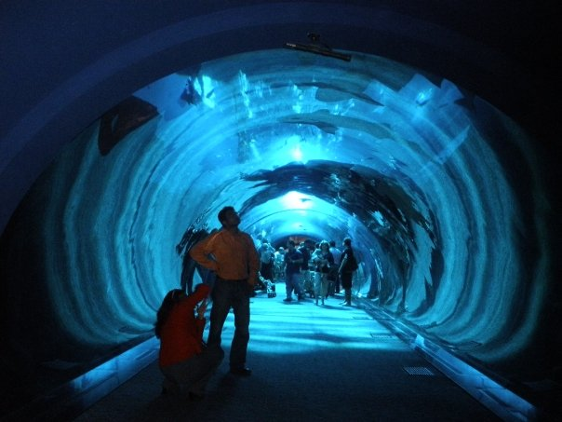

## Burj Al Arab

Sunset of a perfect day at the only seven star hotel in the world. Luxury starts at about $10,000 per night (CAD). There’s ones cheaper than that but why bother?

