Task Centered Design

Table of Contents

Topic Page

I) Table of contents…………………………………………………………. 1

II) What is the Task Centered Design Process all about………….……….. 2

- The Steps in the Task Centered Design Process
Outline of the steps…………………………………………………. 3

- Identification
- Introduction (Background, User Analysis, Work Contexts,
What will the system be used for, System constraints)……………… 4 - 11
- Task Analysis (How to get this information, What are the
characteristics of good task examples, Categories of
Task Examples)……………………………………………………… 11 - 20

- Requirements
- Deciding upon the user group……………………………………….. 21 - 22
- Choosing which tasks will be addressed by the interface…………… 22 - 25

- Design (Low fidelity prototypes)………………………………………. 26 - 33

- Evaluation (Walk throughs of the prototypes using Task Examples)…. 34 - 61

What is the Task Centered Design process all about?

Before you try to work what your system will look like and even before you think about what it functions it might have there are two basic things that you should look at. You should first try to figure out who will use your system. That is, you should try to get an idea of what you user group or user groups will be. Next you try to determine how they will be using it. This will be illustrated through a set of tasks. These tasks are representative examples of what your users will want to accomplish when using the system that you are about to create.

The idea of these tasks is to raise some possible design issues about your interface, to help when trying to make decisions about the design and to evaluate the design as it is being developed.

To help illustrate the different aspects of Task Centered Design, I will refer to a fictional company, Happy Dude’s Burger Barn. Each atomic (bottom level) step of the design process will consist of three sections.

- The first will describe what the step entails. This part will be labeled as “What does this step entail?”
- After that there will be a brief section that discusses how this step relates to the Happy Dude's example as well as how we might get the information for the section. This part will be labeled as, “How does it apply to the Happy Dude’s Burger Barn?”
- Finally there will be an example of how you might take the information and write it up for your portfolio. This part will be labeled as, “What could this section look like when we write it up in our portfolio?”

Steps in Task Centered Design Process

- Identification

- Introduction (Background, User Analysis, Work Contexts,
What will the system be used for, System constraints)

- Task Analysis (How to get this information, What are the
characteristics of good task examples, Categories of
Task Examples)

- Requirements

- Deciding upon the user group

- Choosing which tasks will be addressed by the interface

- Design (Low fidelity prototypes)

- Evaluation (Walk throughs of the prototypes using Task Examples)

- Identification (Introduction to the situation and getting the task related information)

The main thrust of this step is to figure out who will be using your system and how they will be using it (user and task analysis) as well the environment that all this will take place in (background, work context and any system constraints that may exist).

- Introduction

Don't under estimate the importance of this section. It will be the foundation for the rest of the process. The goal here is to provide an idea of what the current situation is like in the organization that you are developing a system for. It should start with a description of the organization and what it does. Next there should be some details about the users and their abilities as well as what their daily job is like. Finally it should say what the new system will actually do and if there are any system-related constraints that you should be aware of.

- Background

What does this step entail?

The main point of this section is a brief introduction into the organization into which your system will be inserted. It briefly describes the overall operations of the organization and why you are adding a computer system to it.

For a large company, you can get much of this information by talking with the some of the senior people in organization such as the top management staff. In smaller organizations, say something like a small corner convenience store you could probably get a lot of this information by talking to the not so senior staff like the cashier or the people who shelve the stock.

You can also get some background information from the typical literature that is provided by many organizations (annual reports, company brochures). This information can often be found on the websites of many companies. But you might have to take some of this information with a grain of salt as they tend to provide an overly optimistic picture of how things really are.

In all cases you should not only be looking to get an idea of what the company is about but also listen and look for other things as well. It doesn’t have to be obvious like criticisms that they have about the existing system that they currently have in place. It could be more subtle. Do they mention any areas that of particular importance to the organization? If so then you might have to take these things into consideration as you develop the new system.

e.g. – “Since we are developing a new interface for combat jet planes it is crucial that no mistakes be made. The difference between pushing the correct control when in a dog-fight could mean life or death for the pilot”.

In this case it is essential that controls not only be clearly labeled but that it is clear to the user (the pilot) what they mean. When developing an interface for such as system we cannot afford to have the user browsing through volume after volume of help files trying to figure things when they are flying through the air at super sonic speeds in the middle of a battle!

How does it apply to the Happy Dude’s Burger Barn?

To learn more about Happy Dude’s, we pick up one of their annual shareholder’s reports to get a rough idea of what type of business that this company is in. In addition to this, we spend some time interviewing some of the employees and management. They tell us that the company is looking to add an automated ordering system to their restaurants that will be used by the customers of Happy Dude’s.

One theme that we got out of their written corporate literature and from
the interviews is that the main edge that Happy Dude's has over the competition is speed. People perceive that no where else can you get a decent (although not necessarily outstanding) meal so quickly for a reasonable price.

What could this section look like when we write it up in our portfolio?

Happy Dude’s Burger Barn is an international chain of fast food restaurants. They have outlets in 66 countries and employ almost one million people. The reason for Happy Dude’s corporate success is simple, they serve food that is good enough for its customers but does so in a way that is far faster than any of its major competitors. Their slogan is, “When you come to Happy Dude’s it’s fast or it’s free!”.

So extra features that much slow down the service rate, such as allowing meals to be customized, are not a part of the Happy Dude's philosophy.

Consequently every single operation that involves interactions with customers is scrutinized closely by a team of experts in the area of Operations Management in order to try to reduce the amount of time required.

In their latest drive to save those “valuable seconds”, the top executives of Happy Dude’s want to try automating a part of the ordering process. They are hoping that by implementing a computer driven system that customers can use to place their orders whenever the front ordering counter is busy.

- User Analysis

What does this step entail?

The idea is not to view the user as some made-up person that you assume will have to adapt himself or herself to your system. Instead you are trying to find actual people who are excited about using your system. They have real world constraints and have their own goals to accomplish. You want to get to know more about these people so that the transition that they have to make when they start using your new system is as painless as possible.

If you can't figure out who your users are now then you should be worried.
If this were a system that you were creating for the "real world" it may mean that you will have trouble finding users when it comes time to market your product. (In terms of your assignment it may mean that you will have a much tougher job of making things as realistic as possible e.g. coming up with good task examples is more difficult). You should try looking again for some users - you probably just have to look a little harder.

Once you have found a potential user group or multiple potential user groups for your system, then you must then sit down and determine what are the most critical characteristics of the members of the group. What traits do they have that will make a difference between users when they will use your system? Some of the most common things that could make a difference include their training and experience with software that is similar to your system.

Understanding the background knowledge of the users will provide some
tangible benefits when you actually get to designing your software. It will help you answer questions such how to layout and structure your interface. You will have a better of idea of what type of wording that should you use when labeling icons and even what features that your system should provide. For example, if you are designing an application to be used with Windows then you should consider looking at how things are currently laid out in existing applications. Many of these programs have a consistent layout for where the menu options are placed. If your program moves these menu functions around, then your users may have a hard time trying to work your program because they don't know where they are.

However, "if all else fails" and you still can't seem to find a real set of users now, then to get started you can create a hypothetical set of users and set of expected tasks that they are to complete. Just make sure that you try to find some real users in order to verify these tasks with later!

How does it apply to the Happy Dude’s Burger Barn?

In the example of Happy Dude's finding the user group for new system is relatively easy. That has already been predetermined by the top executives in the company. The new system will be used by the customers of Happy Dudes.

What might a little more tricky is the fact that this group of users is potentially very diverse. Being able to design a system for such a disparate group of people can be very trick and we might have to set some limitations later (see the section called "Deciding upon the user group" under step 2a - requirements).

What could this section look like when we write it up in our portfolio?

As indicated in the previous section, the users of the new system will be some of the customers of Happy Dude's. Because the company is so successful and services people from many walks of life, the potential users of the system are quite diverse.

From speaking with the management of a local Happy Dude's we have been able to categorize these users into three major groups:

The first group consists of the professionals who often come into the restaurant for a quick bite to eat. Their work weeks are often much longer than forty hours so that they are always on the go. These people are well-educated and quite often familiar with other automated machines such as ATM's. When they come into a Happy Dude's it is often the case that are in the middle of a busy day and they just want a bite to eat for a minute and then it's back to work for them.

The second group consists of the teen-agers who can often be found hanging around the inside (and often outside) of a Happy Dude's. These kids are either in junior or senior high and most of them have some sort of part-time job. They have been raised as "The Simpsons and Nintendo" generation so that they are not only unafraid of new technologies they often look at it as "kinda cool".

Another major group of customers for Happy Dude's are the families who come in for a meal. This is the most diverse group of people which can range from a newly weds to a grand parent bringing taking their grand children out. According to one of Happy Dude's top executives the only characteristic that appears to be common to this group of customers is that they actually don't come into the restaurant in a big rush. Quite often this is part of some outing that they are already engaged in (like a movie night) and they don't mind as much as customers in the other two groups if their order has to take a little longer because they have to wait in line.

- Work Contexts

What does this step entail?

This section describes the work setting as well as typical situations that are faced by potential users of system that you are creating.

How does it apply to the Happy Dude’s Burger Barn?

We could get the information needed for this section in one of two ways. The first is to interview the staff and management of a local Happy Dude's and ask them what things are like for the different customers who come in. Or we could spend some time inside the restaurant making actual observations of actual Happy Dude customers. Ideally both methods should be employed.

Some things that we might be looking at is the sort of situation that these people face when they come in. Are things extremely hectic and busy (full restaurant) or do things look more relaxed and easy going (empty restaurant)? Partly the answers to these questions will be determine by which type of customer group we are currently observing (see the section called "User Analysis" above) as well as the current time of day (is it meal time or during a lull in the day).

What could this section look like when we write it up in our portfolio?

We found that there was a tremendous variation in the environment of the restaurant when different people came into a Happy Dude's. Depending on the time of day, customers might find the area in front of the ordering counter jam packed with people or they might find it relatively empty. However no matter what time of the day that a customer comes into a Happy Dude's there are some things that will never change.

The atmosphere of the restaurant was always the same, bright and upbeat. Not only was the lighting level always high but the color scheme of the furniture and walls could not only be described almost as cheery but as being "achingly happy". The type of music that they play in the background is always the same "bubbly and coy" (listen to the sounds of "Pop goes the weasel" or "Barney's top 10 greatest" while you wait for your food).

- What the system will be used for?

What does this step entail?

What should be included here is a brief description of what the users expect to be doing with the new system.

How does it apply to the Happy Dude’s Burger Barn?

Normally the best way that you would get this information is by talking to the potential users of the system. But because the users of the system are the customers of Happy Dude's, what they will be able to do with the new system will be limited by what services that Happy Dude's chooses to supply. Since the staff of Happy Dude's are very familiar with the company you can also spend some time discussing this topic with them as well.

What could this section look like when we write it up in our portfolio?

After briefly speaking with both the staff and customers of Happy Dude's, it was determined that the new system should act as alternative method of placing food orders. Instead of waiting in line to order their food, customers should be able to use the new system to choose the items that they wish to order. When they are sure of what they want to eat, the user can then place the order and they will have to pay for the order using the new system. Then a receipt will be printed out for the user and the monetary information related to the order will be sent to the central computer that exists in each Happy Dude's (see the "System Constraints" section below). We were told that either the customer could get a printed receipt for their order that they could take to the front counter and / or the order would automatically be forwarded to the kitchen staff that would start processing the order.

The main benefit to the customer for using the system is that they will (hopefully) be able to get their food faster when the restaurant is busy. If they already know what they want to eat then they don't have to wait in line to place the order. The only time that they have to wait is while their food is being prepared.

- System constraints

What does this step entail?

This section essentially acts a "reality check" for the design process. While it might be great to implement a system that can solve all of the problems of the company, there are still real-world limitations that must be considered such as budget size and having the new system be integrated into existing legacy systems.

How does it apply to the Happy Dude’s Burger Barn?

We would likely get information for this section by interviewing a manager of a local Happy Dude's restaurant. If this person did not know all the specific details that we required, then we might look to an executive of Happy Dude's who looks after technical matters such as these.

What could this section look like when we write it up in our portfolio?

In the case of Happy Dude's they do not currently have an automated ordering system. When customers wish to place an order they must go up to the counter and talk to the employee working there. However Happy Dude's does use the patented "Official Happy Dude's electronic cash system".

This system currently uses a Pentium III computer that keeps track of all sales in a Happy Dude's restaurant. In addition to storing information for the money coming in, the computer also automatically tracks data needed to generate the sales statistics so meticulously analyzed by the executives of the firm. Each of the four cash registers in a Happy Dude's communicates with this computer. This main computer acts as the "electronic brain center of a Happy Dudes".

The new system would somehow have to be able to interface with this computer. As orders are placed by the customer with the automated system, all information regarding that order would have to be sent to the main computer so that the day's income and sales performance could be tracked.

- Task Analysis

What does this step entail?

Performing a task analysis of your user group is essential for creating a successful system. If your system does not do what the users need it to do even though it is otherwise a great system it will still likely be a failure.

But your system should do more than just "what's needed". It should be developed so that it will fit within the user's workplace as seamlessly as possible. If getting adjusted to the new system is a long and painful process for the user then they may be asking themselves, "…what is the point of getting this upgrade, it's more trouble than it's worth." So any benefits that they might accrue from using your software will be negated by the bad feelings that they develop towards because of the large adjustment that is required.

In order to make the installation of the new system as seamless as possible, you must spend some time talking to the users and observing them at work (if it is possible). From these interviews and observations you will develop some concrete and detailed examples of the tasks that they are supposed to complete when they use your system.

How do you get the information needed to create the task examples?

- Interview the user. Given the time and opportunity you should always opt for this method. Your interview lets you determine why and how they do the things that they do as well as allowing you to determine what the users expect out of the new system. If at all possible you should observe them while they are going about their daily work, either during the interview or before or after it. The importance of getting to know what tasks that the user must do is related to another section ("user analysis") where you are trying to learn more about the users themselves.

- ii) Interview a representative of the user. For the times that you can't
get in to talk to user this may be a fairly reasonable alternative.
This would include talking to people such as the immediate supervisor of the user or maybe people who work at the help desk for the users. While you may get somewhat of a distorted picture of things (because you are getting your information second hand) it is at least better than the alternative method (listed below).

- Using the creative abilities of the design team. If can't get in
touch with real users and you can't find a reasonable alternative then the best option that you have left is to try and create some of the expected tasks yourselves. This is risky because you probably don't know much about what the user has do in their job on a daily basis so that you may come up with a set of rather unrealistic tasks.

But it is better than nothing and if you have a fair diverse design team then might at least be able to create a diverse set of tasks. However if you do follow this last method make sure that you at least try to validate your made-up tasks with some real users (described below).

Characteristics of Good Task Examples

- It indicates what the user wants to do but not how they will do it.

At such an early stage in the design process you don't want to make any assumptions about how the interface is supposed to look. You want to be able to compare potential designs in a fair and unbiased way. Note the difference in the following exerts from some task examples

Example One: "…and now that Mary has finished writing a letter to her mom she prints it out so that she can mail out later."

Example Two: "…and now that Mary had finished writing a letter to her mom she selects the menu option file and under that title she clicks on the menu item print.

In the first case, you are still open to a number of possible ways of implementing this design. In the second case you have already constrained yourself to using a menu-driven graphical user interface. One problem with limiting your possible design options so early in the development process is that you may miss out on using a truly innovative design.

- It is very specific.

A good task example says exactly what a user wants to do with the system. This is important because later on when you are trying to evaluate different designs you will know what information that you need to fill in.

For example if you have an address book program where the user is trying to look up some information on a friend consider the differences between the following two examples.

Example one: "Bob looks up his friend in his address book by using his friend's name"

Example two: "Bob looks up his friend, Barb Johnson, in his address book first by looking under last names under Johnson. Then under Johnson he looks under Barb."

Why is this important? By specifying exactly what information that is needed in the second example, later one when we are trying to evaluate competing designs one issue that may become relevant is how we handle searches. (e.g. Is the search bound by the first item that is first selected).

- It describes a complete job.

A task example is not just an itemized list of functions that the system should implement. Instead it should force you to consider how different features of the interface work together. When you are designing a system you will have different sub-goals that are tied to the different functions of the system. You must consider how these different sub-goals will interact.

For instance suppose that we are designing a paint program and want to test out how well the help system was implemented. If we create a task example where the user just looks up some function in the help system in isolation from doing anything else we may have missed something about how users may use this program in real life situations.

Suppose that the user was in middle of working with several different drawings and was doing some special effects on each. Then this person forgets how certain functions work and they try to look it up in the help system. One thing that you might learn about by testing out all of these functions together is the visual layout of your program. How does the screen look with all of those windows open? Is it so cluttered that the user can't even find the window with the last image that they were editing after they find out what they need to in the help system? By having several different functions being tested together, there are some issues raised about our system that we might have missed if we had only tested these functions separately.

Another important point seeing the information flow of inputs to and from the user while a task example progresses. In any interactive system there will be a lot information that will be displayed to the user (output from the system) and a lot information that the user enters in the computer (input to the system). Each separate function of the system that is being run through in a task example will only involve some of the inputs and outputs of the entire task example.

Running a complete task example may be valuable in visualizing this flow of information. Where does the user get the initial information to start the task? Will they know how and where to enter in information to get the computer to progress to the next stage of the interaction?

- It states who the users are.

The success of your design will be influenced by things like how closely does the information provided by the system match the knowledge level of the users, how closely do the tasks supported by the system support the tasks that users must actually carry out in their daily job.

For instance a system that is designed for use by expert computer programmers will likely be much different than one that is designed for novice computer users. In the case of the experts you might want to stress the creation of short-cuts to let the more experienced users more quickly perform their tasks. In the case of the novices you might have to emphasize help wizards or context sensitive help so that the users can just get started in using your program.

If at all possible you should name the names. What this means is that you should have specific user group named when trying to create task examples (e.g. - "This personal office assistant program is to be used by middle and top level corporate managers").

By naming names you can bring more detail into the task example later if you need to. Beyond that you should list all the characteristics of the users that you already know are important (such as their knowledge level and what their job is). This will help you find tasks that illustrate the functions of your system in the context of work that real users of the system will want to do. Before talking to the users you might have some preconceptions about what the system should do. You can verify if your assumptions are correct by verifying this with the users.

Categories of task examples:

For these three categories of tasks I will use as an example a clerk who works in a video store rental outlet. This store is a small corner video store that deals only in VHS videos and DVD's.

- Typical and routine tasks

These are things that both occur regularly during the user's work day and are an important part of their job.

For a video store clerk this could include duties such as checking movies in and out as customers rent ant return videos.

- Infrequently occurring but important tasks

These tasks don't occur very often but it is still important that the user be able to handle them.

In the video store example, an example of this type of task could include customers who come into the store wanting to special order a movie. While this might not happen on a daily basis, because it provides as much money for the store as several video rentals it is still important that the clerk be able to correctly handle the situation.

- Infrequently occurring and unimportant tasks

These types of tasks don't occur very often during the daily work of the user and it isn't really a very important part of their job. Perhaps this is because either the task is not a part of the user's job description or the organization that the user works for doesn't consider it to be particularly important (or both).

In our video store example, it might be the case that every so often
a person will come in and ask for computer game rentals. But because the store owner is ethically against this type of rental it isn't really all that important a task to be dealt with (aside from politely informing the person that the store doesn't deal in that type of rental).

However it is important that once you have created a set of task examples that you sit down with one or more of your potential users and you validate these tasks with them. You want these people to tell you if the task actually capture the essence of their work and what type of task it is (typical task, infrequent but important, infrequent and unimportant). In general you are looking for details that were omitted, corrections that need to be performed or clarifications of parts that were unclear to you. Then rewrite the tasks based upon the feedback that you got from these people.

It is especially important that you sit down with real users now if you didn't do so before! If you either met with some sort of representative of the user group (such as an immediate supervisor) or just used some creativity when creating the task examples this should be your reality check to verify that you made up task examples that capture the relevant aspects of your user's job.

How does it apply to the Happy Dude’s Burger Barn?

In order to get the information needed to create some task examples for the customers of Happy Dude's, you ideally should go into a restaurant and watch people as they buy their food. It might not be important to interview them in this case, since people don't typically think too hard about how they buy food in a fast food restaurant (they may not be able to tell you anything that is very insightful). Ideally you will observe the restaurant at different times of day in order to see how things may differ between when it is busy to when it is empty.

If for some reason that you can't talk to or observe the users then the people who might be counted as being representative of your user group would be the staff who work in a Happy Dude's restaurant. Through their own daily work, these people should have a good idea of what it is that people do when they come into the restaurant to order food. What the staff might not be able to tell you is that what features or functions that the Happy Dude's customers would want out of the automated system.

What could this section look like when we write it up in our portfolio?

Below are a few task examples used to represent some of the things that a typical customer at Happy Dude's might want to do when they come into the restaurant. These tasks were generated by interviewing the staff of a local Happy Dude's restaurant as well as through observations that we made of patrons in the establishment.

Task #1: Frequent and important
Maureen Edgar is comes into a Happy Dude's on her lunch break. She has walked over from the nearby sky-scraper where she works during the day. It's a very busy day for Maureen and she only has twenty minutes to order and eat before she has to get back to work.

Since Maureen eats here everyday she is intimately familiar with the menu. So while she is waiting in line to make her lunch order she doesn't even have to think about what she wants. After waiting in line for five minutes Maureen places her order for a Jolly burger, some Smiley fries for a side order and a Great Guffaw sized cup of coffee. She pays for the order with cash and then she walks over to the pickup counter to wait for her food. Two minutes later her order is filled and Maureen sits down at a table and proceeds to wolf it down.

Discussion: This scenario represents the most common type of scenario when a Happy Dude customer comes into a restaurant. As previously mentioned in the background section, the major reason why people come to Happy Dude's is because they can get fast food here faster than they can get elsewhere. Currently the system of placing orders manually has been adequate but the management of Happy Dude's wants to do better. So the new system must be able make the process at least marginally faster.

Task #2: Frequent and important

Ron Cox comes into a Happy Dude's restaurant on Saturday afternoon looking to buy himself some lunch. Since it is the noon hour, there is a bit of a line up in front of the counter and he has to wait in line. While he is waiting Ron is trying to decide what to order. When it is his turn in line Ron orders a Happy burger, a side order of Smirking fries and a Little Giggle sized orange juice.

Huey is the person working the cashier. As Huey is entering the information for the order but before he is finished, Ron changes his mind. Ron says that he feels really hungry and wants 2 Ecstatic burgers, a side order of Super Smiley fries and a Great Guffaw sized orange juice to drink instead. Since Huey hasn't confirmed the order yet, he cancels this order and starts to enter in the information for the changed order. Just before Huey finishes entering in the order, Ron changes his mind again.

He apologizes profusely to Huey and says that because he hasn't been working out so much this week he'd better have a lighter lunch instead. So rather than asking for his previous order, Ron says that he would instead like to have a Basic Merry burger and a Little Giggle sized cup of coffee instead. This time Huey repeats each item back to Ron as he asks for it and asks for a final confirmation before entering it all into the till. However Ron finally has made up his mind this time and does not change his order. Ron pays cash for his order and then goes to wait in line by the pickup counter. A minute and a half later Ron gets his order. He takes his food and jogs back home with it.

Discussion: Although the task scenario above was not directly witnessed while we were making our observations at Happy Dude's, the manager that we talked to told us that it was important part of the current ordering system that customers be able to change their orders prior to having it placed. Like he said, "…people are people and hey, we all change our mind from time to time or make mistakes so that we've gotta take this is account in how we run things around here."

In addition to this he added that the new ordering system must be able to let customers easily change or cancel their orders before placing it as well.

Task #3: Infrequent but important

Paul, James and Ben are a group of junior high school kids from the school across the street from a Happy Dude's. It's Friday evening and they are bored so they come into the restaurant to play a prank on the staff. They go up to the counter and proceed to order 6 Ecstatic burgers, 3 side orders of Super Smiley Fries and 12 Great Guffaw sized cokes.

The person who is taking the order, Sheelagh is a little suspicious of the situation and before actually punching the order in the till she asks the kids for payment. At this point the three kids see that this their little joke isn't going to work. They run out of the restaurant in search of some more mischief to get into.

Discussion: This scenario was one that we observed one evening while we sitting in a local Happy Dude's restaurant. Although we initially thought that it was something that didn't occur very often so it wasn't important, when we discussed the incident with the manager working that night we heard a different story. She had told us that the computer system that is tied into all of the cash registers in a Happy Dude's restaurant is extremely strict in handling money. Once you ring in an order into the till it requires a management authorization in order to cancel it. If the total dollar value for the cancellations for a day exceeds $200 then the manager who was working that day is brought in to see the middle management of that city's Happy Dude's and then they must explain what happened.

Since the new system must interface with the existing system that manages the money for each restaurant, it is imperative that there be some controls in place. These controls must not only allow customers to confirm their orders before they are placed, but it must also have some sort verification system to ensure that people do not abuse the new system by placing multiple bogus orders. The manager that we spoke to said that a good way of verifying if a customer was serious about their order, before logging it on the main computer, would be to make sure they paid for it first.

Task #4: Infrequent and unimportant

A young couple and their baby go into a local Happy Dude's. There is no one at the front counter so they immediately walk up to it and proceed to place their order. The ask the cashier for 2 Happy burgers with no onions and extra cheese. The cashier tells the couple that he is sorry but that Happy Dude's cannot process any orders that deviate from the standard fare. The couple reply that they understand and then they order two Happy burgers (with no special instructions). They pay for their food with a credit card and then walk over to the pickup counter to wait for their food. A minute later their food comes. The couple takes the burgers and heads home to eat it.

Discussion: We created this task example prior to actually going out to a Happy Dude's. (Prior to this none of our group members had actually ever eaten in one before). So initially we thought that being able to customize orders would be an important thing that a Happy Dude's customer should be able to do.

However after speaking with the manager of a local Happy Dude's we discovered that this was not something that they currently allowed customers to do. He told us that this was because Happy Dude's is known world-wide for how fast you can get your food. This is something that the top executives in the company felt was an important reason why the firm was so successful. Because it was felt that allowing customers the ability to customize their orders would slow things down when actually cooking the food, it is corporate policy not to allow this. Consequently the staff of Happy Dude's does not think that the new system should let customers customize their orders either.

It was decided to retain this as a task example simply as a guide as to how the new system should handle order types that Happy Dude's doesn't currently deal with. If a customer comes into the restaurant and tries to get a customized order at the front counter then they may try to do so with the automated system as well.

- Requirements

There are two major components in the requirements analysis step:
- Deciding upon the user group
- Choosing which tasks will be addressed by the interface.

- Deciding upon the user group

What does this step entail?

Quite often you might hear designers say something like, "My program is so good it can be used by any computer user not matter how much they know about computers. Why limit myself by supporting only one user group when I can support all user groups!"

The problem with this approach is that by trying to appeal to everyone you might often appeal to no one. A system that is designed for experts might very well look greatly different than one that is designed solely for beginners. In the former case you might allow for users to implement short-cuts in same way that operating systems like Unix work. In the latter case you might want to guide the user step by step through each operation so that they can just get up and running.

But you must have some way / reason for determining why you are catering to one user group over another. One way that you can use for determining this is if one group is already using an adequate program while another group is in dire need of a program. Whatever the criteria that you use for determining which user group to service make sure that you have a good reason for it.

How does it apply to the Happy Dude’s Burger Barn?

As already indicated in the section called "User Analysis" under step 1a,
determining the user group for the new system is easy to do, because the staff of Happy Dude's have already told us the answer. The users will be their existing customer base.

But since there are three user profiles what is needed next is to look for any characteristics of the people within the profiles to determine which
things might be important with regard to using the new system. What characteristics might make a difference and what characteristics might not make any difference.

What could this section look like when we write it up in our portfolio?

The staff at Happy Dude's have already told us that there are three main profiles that they have generated to categorize their customers: 1) Busy professional people 2) Teen age kids looking for a place to hang-out 3) Families.

The main characteristic that links the first and the second user group is that they aren't afraid of trying out new technologies. So it is likely that we would not have many problems getting these people to try out and use the new system. In addition to this the first user group is very concerned about the amount of time that passes before they can get their food. Therefore it is most likely that many of the users will come from the first and the second user group. However there may still be a need to address the concerns of the third user group who may not necessarily be technophiles and for whom time is not as much a pressing concern as with the first group of users.

- Choosing which tasks will be addressed by the interface.

What does this step entail?

Some of the tasks that are performed by the user are addressed by requirements in the system. In your task examples, you are trying to create some tasks that are representative of the tasks that the users must do in their job. However some of these tasks may have nothing to do with the system that you are going to implement. So you would not need to create a system requirement to address these tasks.

For instance if we were going to implement a word processing system for Executive Assistants to corporate executives we might have requirements that handled tasks such as typing up the minutes of a meeting or being able to create a form letter. But for tasks that may be important to our users, such as daily scheduling for the executive, but have nothing to do with the system that we are trying to create we would not list a requirement for that task. (It would be more appropriate for some sort of Office Assistant type of program).

Or it may be more important to address the needs addressed by one task that it is to address the needs addressed by another task. Because it is not always possible to address all tasks (even if they are related to the system that you are going to implement) you need some way of ranking the importance of tasks.

The possible rankings for tasks include: Absolutely must include, should include, could include and will exclude (from the system to be implemented).

This ranking is not merely a "shopping list" of tasks but has been ranked according to the concerns mentioned by the users. You should have a reason as to why a requirement is placed in the category that it was placed in. (Hint: one way that they can be ranked is according to the category e.g., routine tasks probably fall under the ‘must include’ category, infrequent and important tasks may fall under the ‘should include’ or ‘could include’ categories while the infrequent and unimportant tasks can probably be classified under the ‘exclude’ category. The introduction section may also provide some situation specific information that can be used a way of classifying requirements).

How does it apply to the Happy Dude’s Burger Barn?

Normally when trying to determine the importance of tasks, we would ask the user how important various task are. Based upon this ranking of tasks we would then be able to rank the requirements that let the user perform these tasks. However in the case Happy Dude's, we would also be relying heavily upon what a representative user (the staff of Happy Dude's) told us. As previously mentioned, this is because some of the possible tasks that users wanted to perform may be constrained by the current range of services that are provided in each restaurant.

For instance in section on "Task Analysis", step 1b, with the forth task (allowing customers to customize their meals), since Happy Dude's does not currently allow their customers to do this and because they have no plans to let them do this, then the system we are creating should not provide this functionality either.

What could this section look like when we write it up in our portfolio?

Requirements for the new system:

Absolutely Must Include
- Be able to take an order from a customer
- Be able to change an order before it has been placed
- Be able to take payment from a customer (in the form of cash, credit card or debit card).
- Print out a receipt for the order.

Discussion: The reason why these requirements must be implemented by the new system is because are all things that are currently required for a customer to order food in Happy Dude's. Since the new system is supposed to be an alternative (automated) way for people to order their meals, it must be able to perform these functions.

Should Include
- Be able forward the information for the order to the kitchen staff

Discussion: The reason that this function is an important one to implement is the time savings that you could get in processing an order. Instead of having the customer wait for a receipt to be printed and then taking that receipt over the counter staff that then passes the order the kitchen staff, the order could be processed as soon as they have placed the order and have paid for it. Although this savings in time might amount only to a few seconds, because the main competitive advantage that Happy Dude's is speed, it may be worthwhile to save those few extra seconds.

This requirement was not placed in the must include category because
the customer will already be able to save some time by using the automated system rather than waiting in line to place the order manually.
So the management at Happy Dude's thought it was more important to get the basic system working first.

Could Include
- The ability to buy the promotional items that Happy Dude's sells from time to time (such as action figures for a movie that is currently playing in theaters).

Discussion: The main source of income for Happy Dude's is the sale of fast food items. The temporary sale of promotional items actually provides only a marginal amount of income. The idea of selling these items in Happy Dude's is to get the customer in the restaurant where they can buy some food (in additional to the promotional item).

So the people at Happy Dude's told us that while it might be nice to allow customers to place an order for these little gimmick types of sales, the new system should first focus on food orders. Then if it is possible, expand the system so that you can also order the promotional items as well.

Exclude
- The ability to for customers to customize their orders.
- The ability to dispense food.

Discussion: The reason why the new system should not allow customers to tailor-make their orders is simple. You can't do it now at Happy Dude's and there are no plans to allow customers to do this in the future. So to make the new system consistent with the existing system, the new system should exclude this functionality as well.

The reason why food should not actually be dispensed from the automated system is two-fold: The first is due to practical considerations, it would be very difficult to construct an order taking machine that had the space to store enough food so that it didn't have to be constantly refilled. The second reason is related to health and quality related concerns. Unless the machine had refrigeration as well as food-preparation capabilities, the food stored in it would not be fresh and could even go bad if it were stored too long. So it is for this reason that the staff at Happy Dude's decide to still make the order-filling process manual and to exclude this functionality from the new system.

3) Design

What does this step entail?

At this point you now develop some low-fidelity prototypes (pictive or storyboard) that are tailored to the users who will be using these designs and the tasks that they must carry out on these designs. Your design must fulfill the needs in the list of requirements in order of priority from most important to least important.

How does it apply to the Happy Dude’s Burger Barn?

During our interview with the manager of a local Happy Dude's we were told that the new system should look still retain that "Happy Dude" look. No matter which Happy Dude restaurant that a customer may go into it will still generally have the same layout and décor. There is always that, "…Hap, Hap, Happy feeling in the air!"

So the layout of the automated ordering system should look about the same as the layout for the wall mounted menu that is used when customers want to go up to the counter and make their order. In as much as possible the prototypes provide the same information as the existing system. The only major difference was that the brief description of the ingredients for each burger was left out in the interests of space.

What could this section look like when we write it up in our portfolio?

Figure 1: The Existing System

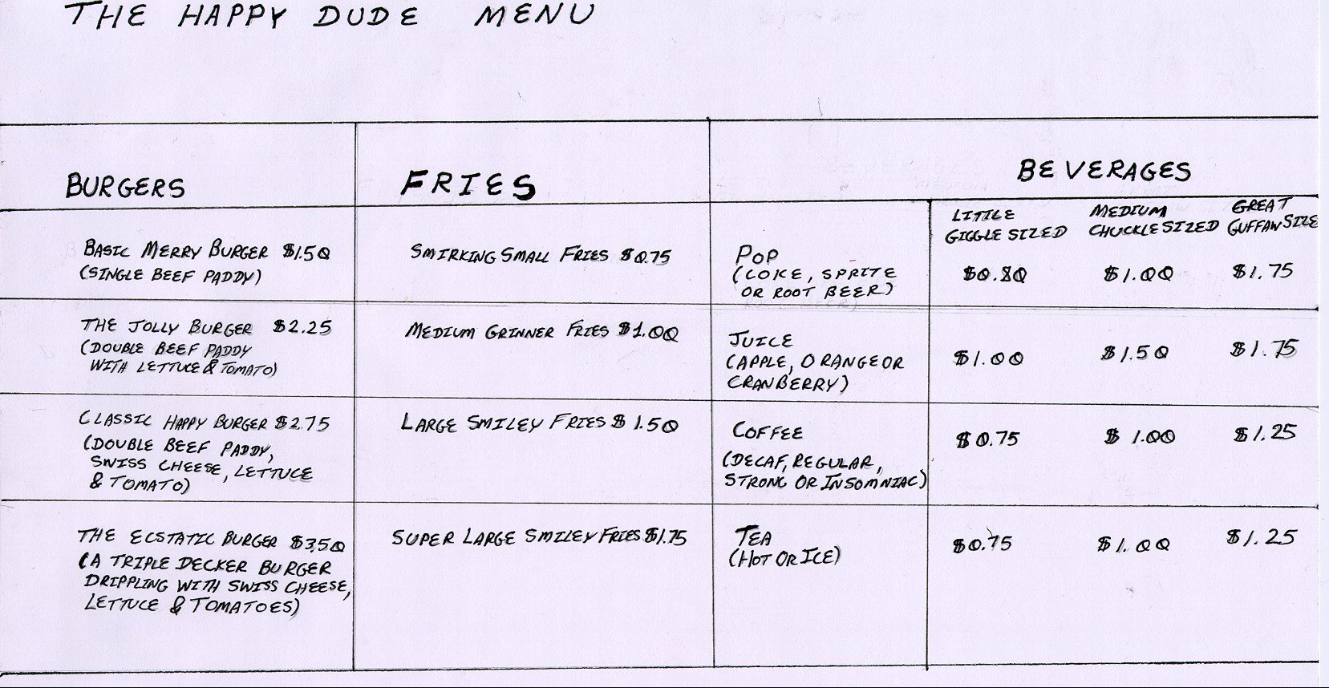

This is a picture of a menu from a typical Happy Dude's restaurant. Customers who come up to order counter will see it mounted on the wall just behind the ordering counter. Customers pick out the items that they want and when it is their turn in line they give their order to the cashier. After the customer has paid for their food they then wait in the line in front of the pickup counter until their food is ready.

Figure 2: Main Ordering Screen for the Proposed System

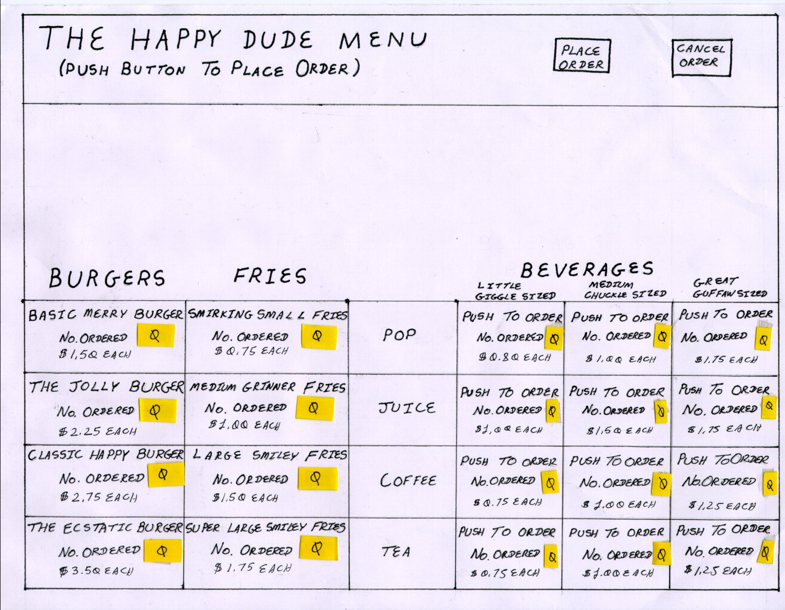

This will be the main screen ordering screen for the proposed system and will be the first screen that a user will see when they first go up to it. As previously mentioned, there were only a few differences made to the layout, which should make using the new system as easy as possible.

When a user wants to order an item a user will push the square labeled with the name of the item. Each time that they push a square the little yellow l.e.d. field will increase by one. If the person wants to cancel their order then they merely have to push the "cancel order" button near the top and all fields will be cleared. When the person is sure of what they want to order they can push to button labeled "place order" to be able to place an order.

Figure 3: Screen to confirm the order

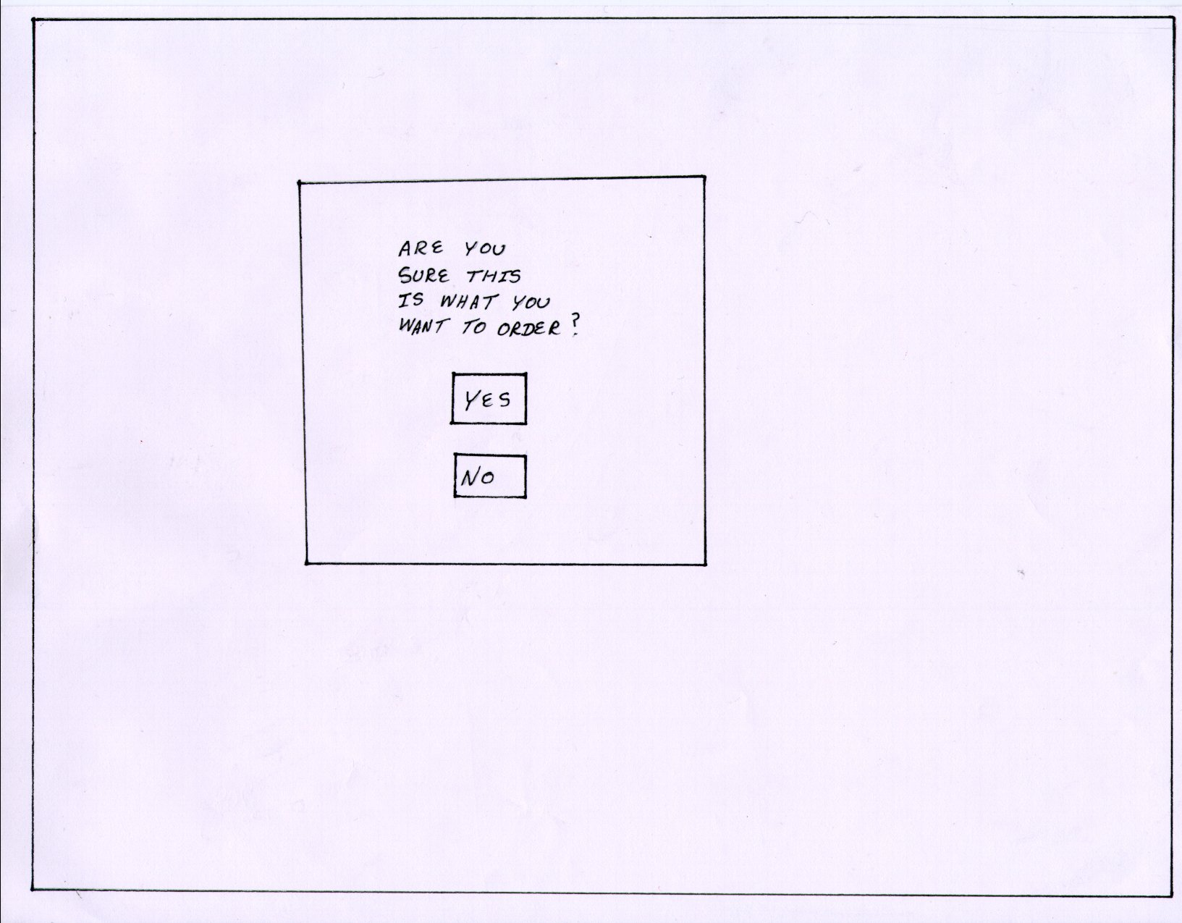

When the user pressed the "place order" button seen in figure 2, the ordering screen will clear and the screen shown in figure 3 will appear. It is simply a confirmation for the customer to check if they are really sure of their order or not. It was felt that this screen would be beneficial for the customers of Happy Dude's in case they accidentally pushed the "place order" button in the previous screen.

If the person hits the "no" button then the order will be cleared and the screen in figure 2 appears. This allows another person come up to the system and to place a new order. If the person hits "yes" then the screen shown in figure 4 appears.

Figure 4: Payment Screen
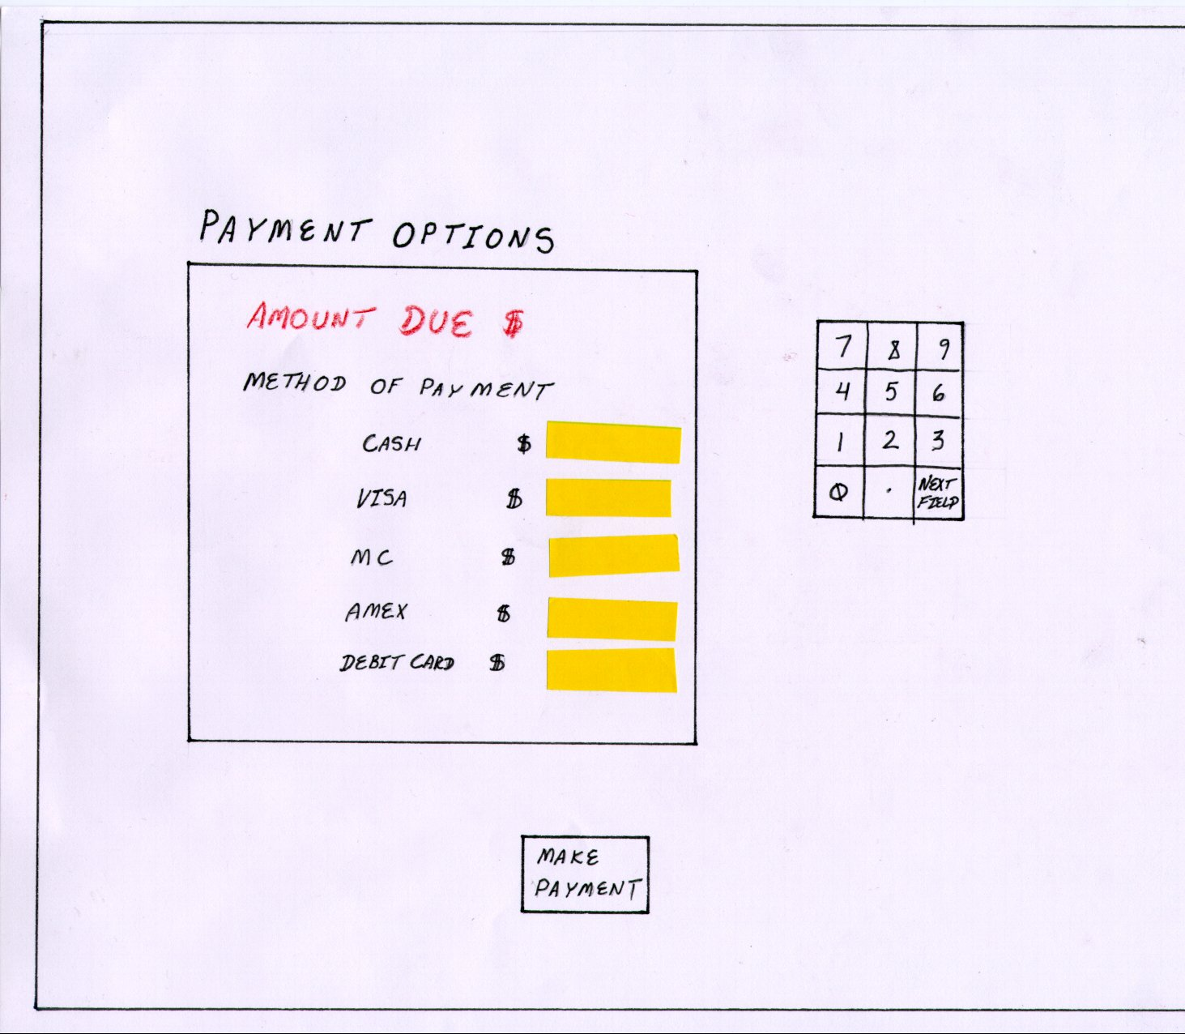

In order to stay compatible with the existing system, before the kitchen actually starts to prepare an order, the customer must first pay for it. Since this is the policy handed down from the head office of Happy Dude's the proposed system must follow it as well.

In this screen the user is allowed to pay for their order using four different methods in any possible combination. In the case of using a credit card or debit card the user will be prompted to insert their card in a standard ATM / Credit Card Reader machine that is beside the automated ordering system. If the customer wants to pay by cash, then there will be another machine nearby that will accept the person's money.

The total amount due from the order is shown at the top of the screen. When the person pushes the yellow L.E.D. field beside each payment option they can then type in the amount that they wish to pay with that method in the keyboard. To make a payment with the next method of payment they can either push the appropriate L.E.D. field or just hit the "next field" button on the keypad.

When the customer wishes to proceed with the order then they can hit "make payment" button. Assuming that the total amount in the different fields matches the value in the amount owing field then the person can proceed onto the next screen (shown in figure 5). If not then when the person pushes the "make payment" button nothing will happen. They will not be allowed to proceed until the amount that they owe matches the amount that they say that they will pay.

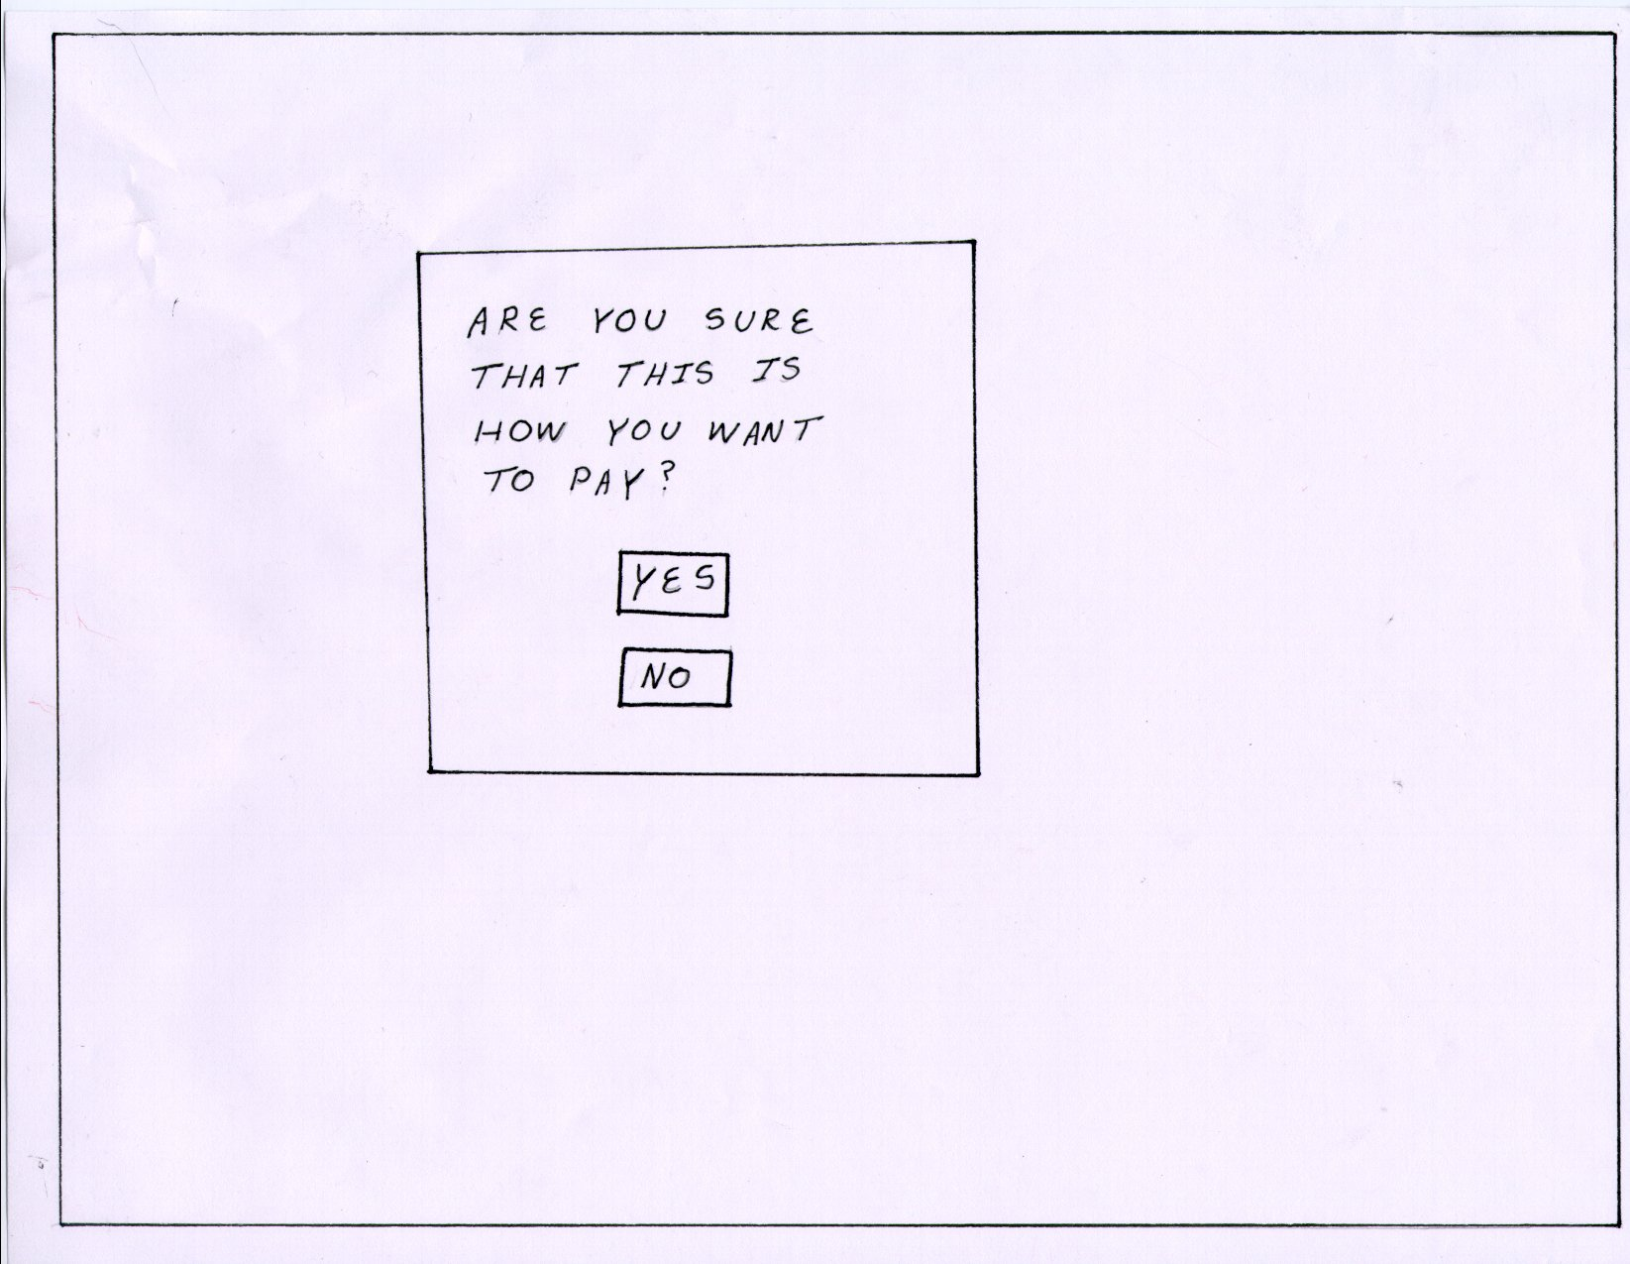
Figure 5: Screen to confirm payment

Again it is realized that people may make mistakes or want to change their minds. So after the customer types in how much that they wish to pay under each method of payment, another window will pop up and ask them to confirm if they are sure or not. If they push the no then they will be returned back to previous payment screen where they can re-enter their payment options again. If they push yes then this message screen will be cleared and they will go onto the final screen in the ordering process (shown in figure 6).

Figure 6: Final confirmation screen
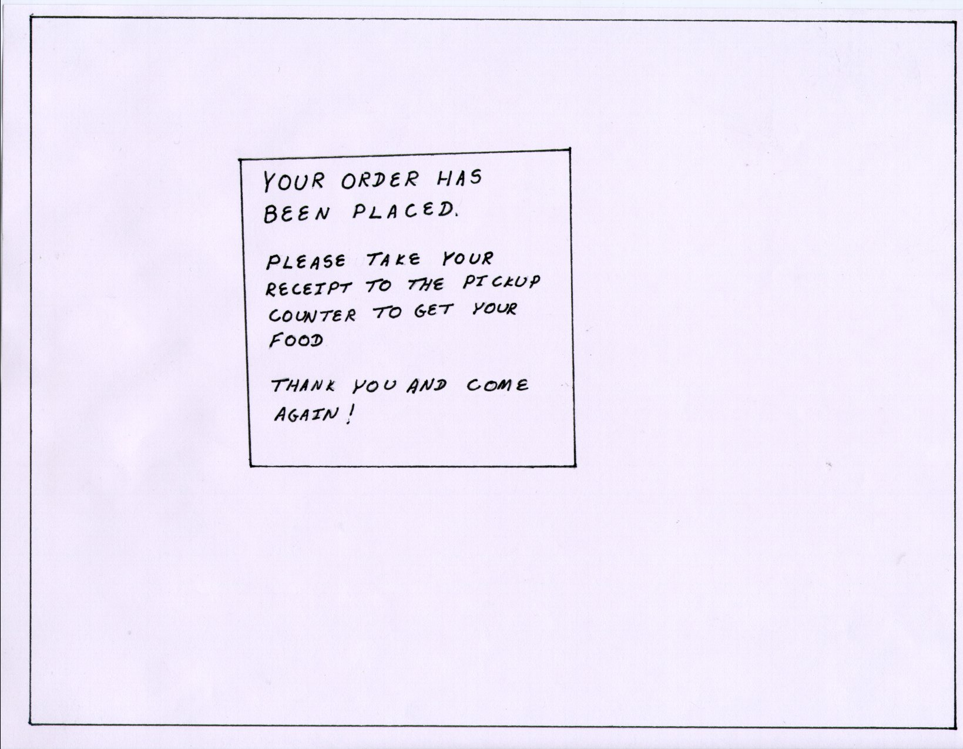

The purpose of this screen is to let the customer know that they have done everything that they need to do in order to place an order for their meal (a confirmation that the entire ordering process was successful). This message will stay on the screen for 10 seconds and then it will be replaced by the screen that shows the Happy Dude's menu (shown in figure 2).

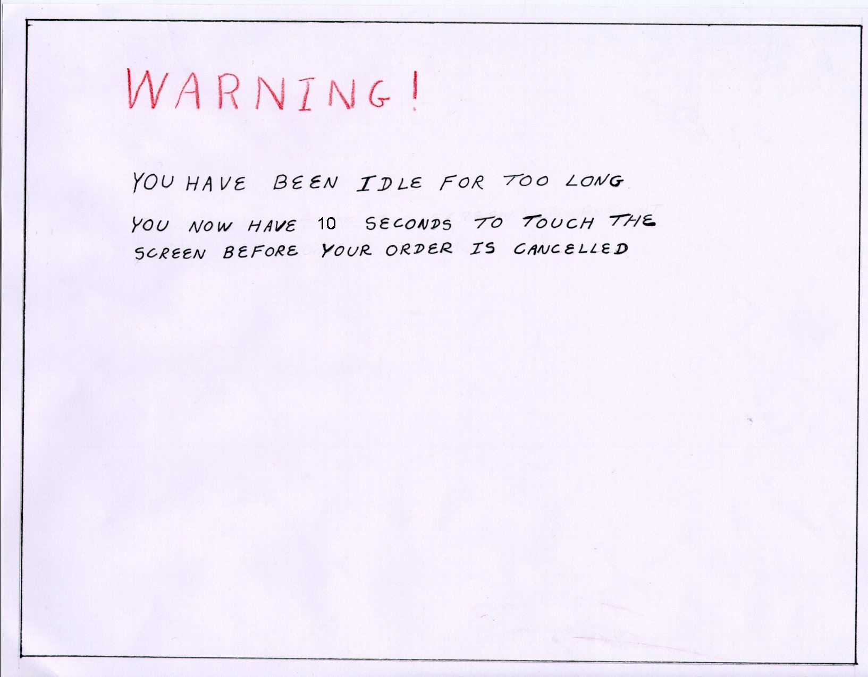
Figure 7: Inactivity Screen

The inactivity screen can occur at any time during the ordering process, except for when the order has already been processed (as shown in the final confirmation screen in figure 6). The message shown above will appear in all other cases if no one has touched the screen for 30 seconds. The ordering system will then display the inactivity screen for another 10 seconds. After this all ordering information will be cleared and the system will return to the screen that displays the Happy Dude's menu (shown in figure 2). The reason that the inactivity screen does not appear if screen 6, the final confirmation screen, is displayed simple. When the final confirmation screen appears it will already clear itself in 10 seconds irregardless of user input. So for the final confirmation screen there is no need to monitor the user's input.

4) Evaluation

What does this step entail?

Use your completed design to walk through the list of relevant and
important tasks. For each step needed to complete the task you must determine the answers to two questions:

- Is user knowledgeable enough to complete the task?
E.g. - Do you how to run the spell check function in a word processor?

- Is the user motivated to complete the task?
E.g. - Are interested in using the automated spell check function enough to read through all the documentation to figure out how to work it? (Or do you think that it's more trouble than it's worth so you will manually spell check your document).

If you answer no to one of the above questions then you have located some problem in the interface. Now in order to continue the test you must assume that the user has solved the problem and you go on to the next step of the test ask the same two questions again.

(A more precise method of evaluating your interface)

Note that the above questions are a fairly coarse way of evaluating your interface. You will get an idea if there are major usability problems with your system but there may be times that you want to refine the evaluation process and break down potential usability problems by asking more detailed questions. Some other questions that can be asked include:

- Will the users be able to achieve the right effect?
E.g. - Will the user be able to save the text document that they have just typed up in a word processor?

- Will users notice (or know) that the right action is available?
E.g.- The save function is available in a menu option in the word processor but will the user be able to find it? (Reasons why the user might not be able to find it is because it may be poorly labeled or that the function is nested within so many submenus that it is difficult to find).

- Will the user associate the correct action with the effect that they are striving for?
E.g.- If the user is trying to save a text document will the person know that this means that the document will be preserved on the computer so that they can get it again later without having to retype it all over again.

4) If the correct action is selected will they see that they are actually making progress towards their goal?
E.g. - The user actually finds the save function and then a new series of dialog boxes pops up that asks the person what file name they want to save the file under and the directory that they want to save it in. Will the user be able to see that these sub steps are needed to accomplish their main goal of storing the information that they just typed into the computer?

Irregardless of which method of evaluation that you choose to employ, always keep in mind that the point of doing a walk through is not to prove that you have just developed the perfect the system because you won't have. Even the people who are the most experienced in designing interfaces will have to at least modify their initial prototypes. This is because the main things that determine your ability to design a good interface not only comes with knowing the "rules of thumb" related to designing a good interface (which will come later in this course) but also with knowing the users and the tasks that they must do. You might think that this was the point of doing a task analysis and partly this is correct. However one cannot become an expert at all types of jobs so that as an outsider analyzing someone else's work, how you perceive that things are being done may be different from how they are actually done.

Furthermore, sometimes problems simply don't show up or don't become obvious until you actually try to do something with your interface. It may be one thing to visually look at it and think that everything is ok but it may be entirely different when you actually take that interface and try and do something with it. That is why you should perform a walk through of your potential designs.

Once you have some information from performing your walk through then you should take what you learned and improve your interface by redesigning your weak spots. If people are having trouble performing their tasks because they can't read the labels because they are too small then use a bigger font. If they can a function because the button wasn't in the places that they were searching then move button to the places that they were looking. Given time you can perform another walk through of the interface again in order to find more areas that need improvement although you may or may not have the time to do this for 481.

How does it apply to the Happy Dude’s Burger Barn?

As is the case when you created your task examples, it would be the ideal case to be able to test your prototypes of the system with the people who will be actually using the system that you are implementing. By having these people try to complete the task examples with your sample prototype(s) you are going to get the best idea of how well the system will work when it has been completed.

However the staff that work at Happy Dude's may also act as suitable substitutes for these people as well. Since they work in the restaurant they can be described as being fairly knowledgeable about the user group. But it must be kept in mind that the staff are likely to know more about Happy Dude's and its menu that the customers so that they may have a biasing effect on your test results.

Again if you are unable to find either customers or staff of Happy Dude's to actually perform a walk through of the low-fidelity prototype then you could use yourselves or at least use other classmates. The latter is actually preferred because all the members of your group are likely to be very familiar with the interface. By getting an outside person to try it out then you are more likely to find usability problems.

What could this section look like when we write it up in our portfolio?

Below is the section where we perform an evaluation of the prototype interface by running through some walk throughs of sample tasks that we have created. For the convenience of the reader the tasks are duplicated below;

Task #1: Frequent and important

Maureen Edgar is comes into a Happy Dude's on her lunch break. She has walked over from the nearby sky-scraper where she works during the day. It's a very busy day for Maureen and she only has twenty minutes to order and eat before she has to get back to work.

Since Maureen eats here everyday she is intimately familiar with the menu. So while she is waiting in line to make her lunch order she doesn't even have to think about what she wants. After waiting in line for five minutes Maureen places her order for a Jolly burger, some Smiley fries for a side order and a Great Guffaw sized cup of coffee. She pays for the order with cash and then she walks over to the pickup counter to wait for her food. Two minutes later her order is filled and Maureen sits down at a table and proceeds to wolf it down.

Steps 1 - 6 refer to the screen shown in figure 8.
Step 7 refers to the screen shown in figure 9.
Steps 8 - 11 refer to the screen shown in figure 10.
Step 12 refers to the screen show in figure 11.
Steps 13 - 15 refers to the screen shown in figure 12.

Figure 8: Main ordering screen for the proposed system.

Is the user Is the user
knowledgeable motivated enough
Description of Step enough to do the step? to do the step? Comments
1) Go up to new system. | Maybe | Yes | Initially customers may not notice the new system.
2) Scan menu for the items that she wants | Yes | Yes | Since the layout the menu is almost identical to the existing menu, reading it  Shouldn't be a problem.
3) Order a Jolly burger | Maybe | Yes | We found that sometimes during the walk through people would not know to touch the screen to place the order.
4) Order Smiley fries | Maybe | Yes | The same comments with the ordering of the Jolly burger also apply here since the process is similar.
5) Order Great Gaffaw sized cup of coffee | Maybe | Yes | It was found that either by this point people had gotten used to the touch screen interface or the additional description "push to order" for ordering drinks made it easier for people to understand that they had to push the screen to place an order.
6) Place the order | Yes | No | The placement of the button makes it awkward to find. Since most people read top-bottom, left-right and they are already looking near the bottom of the screen when ordering, they are usually not inclined to look up again when they are trying to actually place the order.

Figure 9: Screen to confirm the order

Is the user Is the user
knowledgeable motivated enough
Description of Step enough to do the step? to do the step? Comments
7) Reply to the order confirmation screen | Yes | Yes | Since this user already knows exactly what she wants, there will be no hesitation here. There is no need for her to see her order again.

Figure 10: Payment Screen

Is the user Is the user
knowledgeable motivated enough
Description of Step enough to do the step? to do the step? Comments
8) Notice the amount owing. | Yes | Yes | Since the total amount owed for the order is near the top of the screen and in bright red there should be no problems found in seeing and reading the value.
9) Enable cash as method of payment | No | Yes | Most people would automatically start to enter in a value in the keypad without first selecting a method of payment. The did not know that they had to first touch the yellow L.E.D. beside the payment method first to enable the keypad for that option first.
10) Enter in the amount of cash that will be paid | Yes | Yes | The keypad is already familiar interface for many people.
11) Confirm payment | Maybe | Maybe | It may be confusing after this as to what should be done. Some people might hit the next field button thinking that it acts like a return key. The "make payment" button is a bit far down on this screen so that people sometimes don't see it.

Figure 11: Screen to confirm payment

Is the user Is the user
knowledgeable motivated enough
Description of Step enough to do the step? to do the step? Comments
12) Reply to the payment confirmation screen | Yes | Yes | Since this user is sure of what she wants to order there should be no hesitation here. There is no need for her to see how she paid once again.

Figure 12: Final Confirmation Screen

Is the user Is the user
knowledgeable motivated enough
Description of Step enough to do the step? to do the step? Comments
13) Read the final  instructions | Yes | Maybe | Once people become more expert with the system and already know what to do they may not bother reading this screen (aside from a quick glance to make sure that it pops up).
14) Take receipt | Yes | Yes | There are instructions on the screen that tells them to take the receipt and they can hear the sound of the receipt being printed.
15) Go to pickup counter | Yes | Yes | A person who is familiar with the layout of any Happy Dude's will know where to go.

Task #2: Frequent and important

Ron Cox comes into a Happy Dude's restaurant on Saturday afternoon looking to buy himself some lunch. Since it is the noon hour, there is a bit of a line up in front of the counter and he has to wait in line. While he is waiting Ron is trying to decide what to order. When it is his turn in line Ron orders a Happy burger, a side order of Smirking fries and a Little Giggle sized orange juice.

Huey is the person working the cashier. As Huey is entering the information for the order but before he is finished, Ron changes his mind. Ron says that he feels really hungry and wants 2 Ecstatic burgers, a side order of Super Smiley fries and a Great Guffaw sized orange juice to drink instead. Since Huey hasn't confirmed the order yet, he cancels this order and starts to enter in the information for the changed order. Just before Huey finishes entering in the order, Ron changes his mind again.

He apologizes profusely to Huey and says that because he hasn't been working out so much this week he'd better have a lighter lunch instead. So rather than asking for his previous order, Ron says that he would instead like to have a Basic Merry burger and a Little Giggle sized cup of coffee instead. This time Huey repeats each item back to Ron as he asks for it and asks for a final confirmation before entering it all into the till. However Ron finally has made up his mind this time and does not change his order. Ron pays cash for his order and then goes to wait in line by the pickup counter. A minute and a half later Ron gets his order. He takes his food and jogs back home with it.

Steps 1 – 14 refer to figure 13
Step 15 refers to figure 14
Steps 16 – 19 refer to figure 15
Step 20 refers to figure 16
Steps 21 – 23 refer to figure 17

Figure 13: Main Ordering Screen for the proposed system.

Is the user Is the user
knowledgeable motivated enough
Description of Step enough to do the step? to do the step? Comments
1) Approach the new system | Maybe | Yes | Initially customers may not notice the new system.
2) Scan menu for items that he wants | Yes | Yes | Since the layout of the menu is almost identical to the existing menu, reading it should not be a problem.
3) Order a Happy burger | Maybe | Yes | The person may not know that this is a touch screen system.
4) Order Smirking fries | Maybe | Yes | The same comments with the ordering of the Happy burger may also apply here since the process is similar.
5) Order a Little Giggle sized orange juice. | Maybe | Yes | Either people may have gotten used to the touch screen system by now or else the description "push to order" for ordering drinks made it easier for them to understand that it was a touch screen system.
6) Cancel the order | Yes | Maybe | The "cancel order" button is placed somewhat in an out of the way location so that people may not be able to easily find it.
7) Order an Ecstatic burger | Yes | Yes | By this point most testers have already gotten used to the touch screen system.
8) Order a second Ecstatic burger | Yes | Yes | When the person orders one burger the little yellow L.E.D. lights up with the number of burgers that they ordered. So it should be clear that pushing the screen an additional number of times allows for the ordering of additional items.
9) Order Super Smiley fries | Yes | Yes | By this point most testers have already gotten used to the touch screen system.
10) Order a Great Guffaw sized Orange juice | Yes | Yes | By this point most testers have already gotten used to the touch screen system.
11) Cancel the order | Yes | Maybe | Again the placement of the "cancel order" button may make it hard to find.
12) Order a Basic Merry burger | Yes | Yes | By this point most testers have already gotten used to the touch screen system.
13) Order a Little Giggle sized cup of coffee | Yes | Yes | By this point most testers have already gotten used to the touch screen system.
14) Place the order | Yes | No | Again the placement of the "place order" button may make it hard to find. Customers may not necessarily be inclined to look so far up the screen for this function.

Figure 14: Screen to confirm the order

Is the user Is the user
knowledgeable motivated enough
Description of Step enough to do the step? to do the step? Comments
15) Reply to the order confirmation screen | Yes | Maybe | Since this particular customer is not always sure of what he wants to order, this person might have trouble deciding whether or not if they want to confirm their order or not unless they see it at the same time.

Figure 15: Payment Screen

Is the user Is the user
knowledgeable motivated enough
Description of Step enough to do the step? to do the step? Comments
16) Notice the amount owing | Yes | Yes | Since the total amount owed is near the top of the screen in bright red letters there should be no problem noticing and reading this value.
17) Set cash as the method of payment | No | Yes | Most people tend to automatically enter in the value in keypad without selecting a method of payment first. Not many of them know that they have to touch the yellow L.E.D. next the method of payment first to enable the keypad.
18) Enter in the amount of cash that will be paid | Yes | Yes | The keypad is an interface that is already familiar to most people.
19) Confirm payment | Maybe | Maybe | It may be somewhat confusing what should be done at this point. Some people may want to hit the "next field" button because they think that it acts like and "enter" key. Since the "make payment" button is a little far towards the bottom of the screen some people might not be motivated to look for it so far down.

Figure 16: Screen to confirm payment

20) Reply to the payment confirmation screen | Yes | Maybe | Although this customer was ok when they made the payment in the task example they be unsure of themselves because they cannot see the information on the payment options screen here.

Figure 17: Final Confirmation Screen

Is the user Is the user
knowledgeable motivated enough
Description of Step enough to do the step? to do the step? Comments
21) Read the final instructions | Yes | Maybe | Once people become more familiar with this system and know how it works then they may not bother reading this screen any more (other than glancing at it to make sure that it comes up).
22) Take receipt | Yes | Yes | There are instructions on the screen that they need to do this. Also they should be able to hear the sound of the receipt printing as well.
23) Go to the pickup counter | Yes | Yes | Any body that is familiar with the layout of any Happy Dude's restaurant should know that they have to go the pickup counter to get their food.

Task #3: Infrequent but important

Paul, James and Ben are a group of junior high school kids from the school across the street from a Happy Dude's. It's Friday evening and they are bored so they come into the restaurant to play a prank on the staff. They go up to the counter and proceed to order 6 Ecstatic burgers, 3 side orders of Super Smiley Fries and 12 Great Guffaw sized cokes.

The person who is taking the order, Shelaugh is a little suspicious of the situation and before actually punching the order in the till she asks the kids for payment. At this point the three kids see that this isn't going to work. They run out of the restaurant in search of some more mischief to get into.

Steps 1 – 25 refer to figure 18
Step 26 refers to figure 19
Steps 27 – 30 refer to figure 20
Step 31 refers to figure 21

Figure 18: Main ordering screen for the proposed system

Is the user Is the user
knowledgeable motivated enough
Description of Step enough to do the step? to do the step? Comments
1) Approach the new system | Maybe | Yes | Initially customers may not notice the new system`
2) Scan the menu for the items that they want | Yes | Yes | Since the layout of the menu is almost identical to the existing menu, reading it shouldn't be a problem.
3) Order the first Ecstatic burger | Maybe | Yes | Some people may not know it is a touch screen system.
4) Order the second Ecstatic burger | Maybe | Yes
5) Order the third Ecstatic burger | Maybe | Maybe | It may start to get a little tedious to order more than one or two items.
6) Order the third Ecstatic burger | Maybe | Maybe
7) Order the forth  Ecstatic burger | Maybe | Maybe
8) Order the fifth Ecstatic burger | Maybe | Maybe
9) Order the sixth Ecstatic burger | Maybe | Maybe
10) Order the first side order of Smiley fries | Maybe | Yes | The comments made about ordering the first Ecstatic burger may also apply here since the process is similar.
11) Order the second side order of Smiley fires | Maybe | Yes
12) Order the third side order of Smiley fries | Maybe | Maybe | Again after ordering more than just a few items may become tedious for the customer.
13) Order the first Great Guffaw sized coke | Maybe | Yes | Having the "push to order" instructions for drinks may make it easily for people to know that this is a touch screen system.
14) Order the second Great Guffaw sized coke | Maybe | Yes
15) Order the third Great Guffaw sized coke | Maybe | Maybe | Again the process of ordering multiple identical items may start to get tedious at this point.
16) Order the forth Great Guffaw sized coke | Maybe | Maybe
17) Order the fifth Great Guffaw sized coke | Maybe | Maybe
18) Order the sixth Great Guffaw sized coke | Maybe | Maybe
19) Order the seventh Great Guffaw sized coke | Maybe | Maybe
20) Order the eighth Great Guffaw sized coke | Maybe | Maybe
21) Order the ninth  Great Guffaw sized coke | Maybe | Maybe
22) Order the tenth Great Guffaw sized coke | Maybe | Maybe
23) Order the eleventh Great Guffaw sized coke | Maybe | Maybe
24) Order the twelfth Great Guffaw sized coke | Maybe | Maybe
25) Place the order | Yes | No | The "place order" is located in a place that makes it hard to find. Most people are not motivated to look up so far in the screen to find it after they have been reading the menu near the bottom of the screen for so long.

Figure 19: Screen to confirm the order

Is the user Is the user
knowledgeable motivated enough
Description of Step enough to do the step? to do the step? Comments
26) Respond to the order confirmation screen | Yes | Yes | In this case since the users are only playing a prank they don't particularly care what they order but a person who is making a genuine order that is large may want to recheck everything that they ordered before confirming it.

Figure 20: Payment Screen

Is the user Is the user
knowledgeable motivated enough
Description of Step enough to do the step? to do the step? Comments
27) Notice the amount owing | Yes | Yes | Since the total value of the order is located at the top of screen in red it should be easy for most people to find.
28) Enable the method of payment | No | Maybe | Since the kids are not serious about making an order, they may not be inclined to indicate how they will pay for their food. Even if they want to enter in a value they may not be aware that they have to enable a method payment before they can enter in a value in the keypad.
29) Enter in the amount that will be paid | Yes | Maybe | The keypad is already a very common interface so the kids should know how to enter the value. But again they may not be inclined to enter in something because they are not serious about their order.
30) Confirm payment | Maybe | Maybe | It may be confusing as to what should be done next. Some people might hit the "next field" key because they think that it acts like an "enter" key. The placement of the "make payment" button may not make it very noticeable. Again since the kids are not serious about placing an order they may not want to confirm payment here.

Figure 21: Screen to confirm the payment

Is the user Is the user
knowledgeable motivated enough
Description of Step enough to do the step? to do the step? Comments
31) Respond to the confirm payment screen | Yes | Maybe | The kids may know that they are supposed to hit yes if they want to proceed further but they may not be motivated to continue placing their prank order.  Even if they press "yes" at this point since the adjacent machine will then require them to insert their payment before their receipt is printed, the kids will not be able to proceed any further.

Analysis of Interface

(Overall recommendations)
Based upon all of the walk throughs, there are a number of overall improvements that could be made to the interface. Giving the buttons a three dimensional effect may make it more obvious that this is a touch screen type of system. Or in the case of the buttons for ordering burgers or fries putting some sort of label, “push to order” may make it more obvious to people as to what should be done.

Also there is no real need for the two extra confirmation screens to ask the customer if they are sure of their order and to ask the customer if they are sure of their method of payment. Prior to seeing this screen they already had to press a button on each screen in order to confirm their order and to confirm their method of payment so adding these screens is somewhat redundant. Furthermore by having the confirmation message appear again on a separate screen where they could no longer see the information that they were confirming may make it somewhat difficult to answer for some customers. Since they can no longer see what they ordered or their method of payment, it can be difficult to indicate whether or not if they want to make a confirmation.

Since there is already a lot of unused open space in the main ordering screen, the payment options screen could probably be integrated with it. That way as people are making their payments and making the final confirmations before placing their order they can see what they ordered as well as what it is costing them.

(Suggested changes to the first screen – the main ordering screen)

With regard to the first screen, one problem that was consistently found in all three walk throughs was the location of the “place order” button. Because it is located in near the top of the screen and must be accessed after the customer has be scanning near the bottom of the screen to pick out their order people may not always be inclined to look for this button in the current location. Moving this button and the “cancel” order button near the bottom may make these functions easier to find. In addition to this by moving these buttons near the to the bottom of the screen it may prevent customers from hitting the place order button before they have ordered anything. With the current location customers may see the place order button first and then think that they have to press this button first before doing anything else.

In addition to this it was noted that currently there is no capacity for a customer to cancel only a part of their order. For instance suppose a customer has already hit the buttons to order a dozen drinks, a couple of dozen fries and some drinks. Just before hitting the “place order” button they decide to change the order of fries from two dozen Medium Grinner fries to a dozen Large Smiley fries and a dozen Smirking Small fries. They would have to cancel the entire order and enter everything in again from scratch. There should be the ability to not only cancel the entire order but also the cancel the order for each type of item ordered as well.

Also, the system should provide the ability to enter in multiple items in a faster and more efficient method. Perhaps when someone hits the button to order an item like a Basic Merry burger, the system can ask the person how many of the item that they wish to order. As noted in the introductory section, since the main competitive edge of Happy Dude’s is speed, adding even a minor improvement in ordering efficiency may be beneficial.

Furthermore, it was noted that during the run through some of the group members (who again were not customers of Happy Dude’s) found that the layout for drinks was somewhat inconsistent with the layout for burgers and fries. For burgers and fries it was noticed that going from top to bottom the item gets larger in size. With drinks, however, when you go from up to down the size of the drink doesn’t increase but you instead iterate through the different types of drinks. Going from the top to bottom of the drink section you see “pop”, “juice”, “coffee” and “tea”. The reader must read side ways in order to see the different sizes of drinks. The reason that this was not noted as possible source of confusion in the walk throughs is because these three cases deal with people who are previous customers of Happy Dude’s and presumably these people are already familiar with the layout of the existing menu. New customers to Happy Dude’s may find the inconsistency of the layout of the drinks vs. the layout for burgers and fries confusing but they would also find the existing system equally confusing. So unless Happy Dude’s has plans to change the layout of the existing system, which existing customers are already used to, then the new system probably shouldn’t change it either.

(Analysis of the second screen – order confirmation)

As previously noted, it was found that there is no real need for this screen since the “place order” button already acts as a confirmation. Since this screen asks customers to confirm their order when they can no longer see their order, it could be difficult for customers to remember what they ordered.

(Analysis of the third screen – payment options).

The main thing that should be improved in this screen is the fact that people are required to enable the keypad by touching the L.E.D. for the type of payment first. Many people would start the payment step by first entering the amount in the keypad.

What might be better is to have the keypad not appear initially and in the payment options section have some instructions telling the person indicate how they will pay for their order by pressing the bright yellow button next to the method payment. Then the keypad could appear beside the payment options section. To further clarify matters the keypad could also be labeled to indicate that they are now entering payment for the method of payment that they just selected.

Since they can already move from payment type to payment type by selecting the yellow l.e.d. button next to the method of payment there is no need to have the “next field” button with the keypad.

Also since it was recommended that the payment options screen and the ordering menu screen be integrated, there is really no need to confirm the order with a “place order” button and confirm the payment with the “make payment” button. One large button, placed near the bottom of the screen to place the order should be sufficient. After this then the adjacent cash, credit / debit card machine would activate and ask for the person’s money at this point.

If the amount that owes does not match the amount that the person says that they will pay then when the person presses the "place order" button, then there should be some feedback from the system that these two amounts do not match. Under the currently proposed system, with the system refusing to proceed any further with the transaction, the user may be confused as to what is wrong with the system.

(Analysis of the fourth screen – confirm payment)

As noted previously there is no need to reconfirm payment with this screen since it can already be done in one main screen. So this screen should be deleted from the next design.

(Analysis of the fifth screen – confirm ordering process)
This screen is the final screen that a customer sees when they make an order. After they have placed an order and their method of payment has been confirmed there will be a brief message telling the person that the ordering process has succeeded and instructions on what to do next. In all three walk throughs there were no problems found with this screen and it should probably be retained in the next design.

(Analysis of the sixth screen – the inactivity screen)
Although this screen never appeared in any of the three walk throughs it is still important to retain it in the final system. Because it is possible that a person using the system may decide that they no longer want to place an order using the automated system (either because they want to do it manually or they just don’t want to order any more) there must be a way to reset the system for the next person using it.

Because the inactivity sensor provides a 10 second warning message to the customer prior to clearing their order, there is still time for someone to touch the screen before they lose all of their ordering information. So even should there be the case where the customer is standing in front of the system and trying to make up their mind, they still have the opportunity to abort the process to reset the order.

