CPSC 331 Fall 2004
Assignment 2: Sorting Algorithms and Linked Lists

Due: 18 October 2004, 4:00PM

The goal of this assignment is to write a Java program that arranges a list of words into separate lists of anagrams. Your program should be named “As2” and will be called from the command line as follows:
$java As2 < file
“File” is text file which will be the input to your program and contains a list of words to be sorted into anagrams. It will be read by the program through standard UNIX input. The number of words in the input is arbitrary but the last word will be followed by a blank line. The program should print to the standard output the lists of anagrams in the following way:
- All the words that are anagrams of each other are displayed all on one line; words with no anagrams will be displayed alone.
- The words on each line should be in alphabetical order.
- Lines of words are sorted alphabetically according to the first word of a line.
- Each word on a line should be separated by a space but otherwise there should be no spaces.
For example, this input file
car
dog
bed
stop
god
pots
arc
tops
Should yield the output file
arc car
bed
dog god
pots stop tops
You are required to use linked lists in your program to deal with the arbitrary number of anagrams in a line. Use an array of references to keep track of all the linked lists (see the following diagram). You are to use an insertion sort on the linked list of words (e.g. arc car …). Note that the input file can be large so attention to the efficiency of the algorithms is essential, thus you should use a quick sort on the array of references.

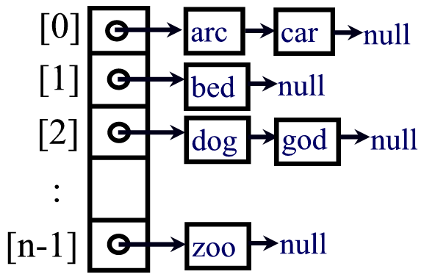

To streamline and speed up marking there will be specific requirements on the format of your output provided by your TAs. If your output file does not match the correct format, you will lose some marks. Some test files are available on the course web page. You should write your own implementation of linked lists and sorting algorithms rather than using calls to a Java library. You may, however, use your text or other sources of information as guidance, but be sure to cite them. One way to determine if two words are anagrams is to sort the letters in both words. If the two sorted words are the same, then the original two words are anagrams of each other; for example, “’dog” and “god” will both appear as “dgo” when the characters in each word are sorted.

Questions
- Justify your choice of data structures and selection of algorithms for the program.
- What is the worst case complexity of your algorithm when checking if two words are anagrams of each other, if the number of letters in each word is k?
- Let N be the number of words in the input word list and L be the maximum length of any word. What is the big-O running time of your program? Justify your answer using both theoretical as well as experimental analysis.

Bonus question: Can you provide a linear algorithm to determine if two words are anagrams of each other? If yes, provide an algorithm. If not, explain why.

Hand In
- A cover sheet with your name, course number, and assignment number stapled to your typed answers to the above questions handed in the assignment boxes for your tutorial section in this course. Keep your answers short and to the point. The maximum length for a report is 2 pages.
- Submit your all your source code with a README file and the answers to the above questions using the submit system.

Collaboration
The assignment must be done individually so everything that you hand in must be your original work, except for the code copied from the text or other sources (which must be clearly referenced). If you copying another student’s work or using some else’s code without a proper reference will be deemed as academic misconduct. Contact your TA if you have problems getting your code to work.

