Dark Patterns: Additional Examples

Zurich airport zoetrope
Moving visual art is shown in Zurich Airport’s underground people mover during transit using displays mounted to the walls of the tunnel that act as a zoetrope. According to Wikipedia: “The separate frames are displayed along the length of the tunnel, with 160 static frames per 100 m (330 ft), creating the illusion of motion. As of 2009 a brief movie about Heidi is being shown in the running tunnel normally used by arriving passengers but in 2011, this movie has been replaced by a man throwing a Swiss flag. In the other tunnel, departing passengers are shown images of the Matterhorn.”
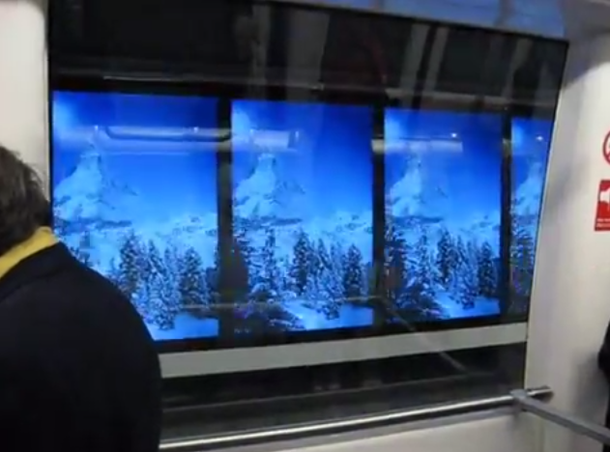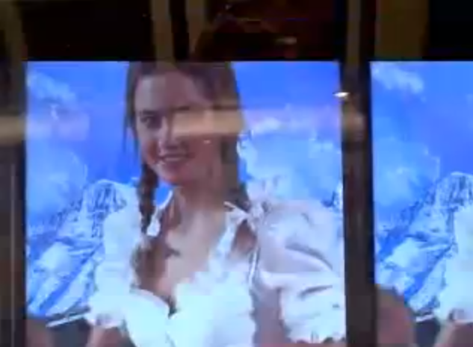

Applies to
- The Attention Grabber: definitely grabbing attention, the flickering of the images might even be deliberate
- The Captive Audience: since you can’t leave the train

Links
- Wikipedia: http://en.wikipedia.org/wiki/Skymetro
- YouTube: https://www.youtube.com/watch?v=I3g1Zf4ZkRU (Matterhorn video)
- YouTube: https://www.youtube.com/watch?v=kHPn4yaZOQk (Heidi video)
- http://www.myswitzerland.com/en/home/summervacations/hiking1/switzerland-alpinism/cable-railways/zuerich-airport-skymetro-to-terminal-e.html

Somewhat similar: ad e-motion (Zurich Airport)
Also in Zurich Airport, they use a couple of slightly slanted displays that show animated ads while people are walking by.
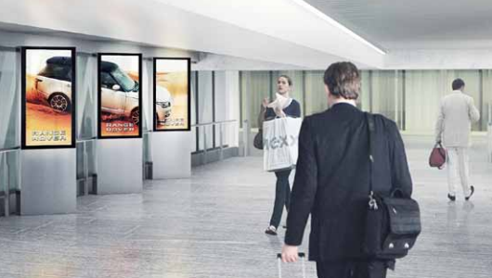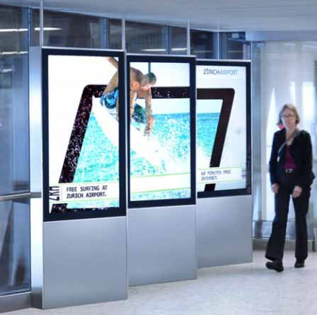

Applies to
- The Attention Grabber and The Captive Audience

Links
- PDF: http://www.clearchannel.ch/tl_files/content/downloads%20airport/131205_ad-e-motion_SalesFoder%20Terminal%202_E_kleine%20Aufloesung.pdf
- http://blog.hslu.ch/outofhomedisplays/2010/09/27/e-advertising-fuhrt-epanel-ein/

Coca-Cola sticky advertising
Coca-Cola advertised its new easy to grip bottle with posters in in bus stops that were made out of hook-and-loop fasteners (‘Velcro’). The posters literally ‘grab attention’ by making consumers that are standing near the poster ‘stick’ to it.
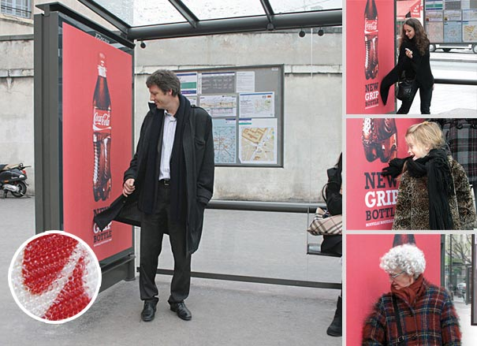

Applies to
- The Attention Grabber
- The Captive Audience

Links
- Blog post/articles
  - http://erikapiscatello.wordpress.com/2012/10/19/coca-cola-interactive-advertising/
  - http://whatstrending.com/2013/06/ingenious-coca-cola-bus-stop-advertisement/
  - http://gizmodo.com/5403505/velcro-bus-ads-are-bound-to-end-in-disaster
- Images:
  - http://whatstrending.com/wp-content/uploads/2013/06/bus-stop-ad.jpg
  - http://img.gawkerassets.com/img/18mnds5xk7g3mjpg/ku-xlarge.jpg
- YouTube: http://www.youtube.com/watch?v=KPwp_c78USY

Vibrating train windows
BBDO Düsseldorf developed a transmitter that can be attached to windows in trains or buses. When commuters rest their head against the window, they suddenly hear an advertisement, as if there’s a voice in their head. The transmitter sends out high-frequency vibrations through the window and relies on the principle of bone conduction to transmit inaudible sound only to the passenger touching the window.
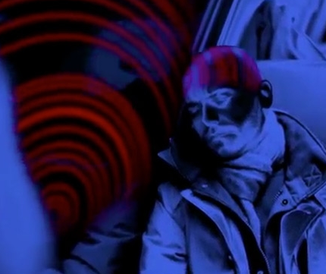

Applies to
- The Captive Audience
- (The Attention Grabber)

Links
- AdWeek: http://www.adweek.com/adfreak/vibrating-train-windows-will-soon-transmit-ads-directly-your-skull-150936
- YouTube: http://www.youtube.com/watch?v=azwL5eoE5aI

ATM advertisements
Several ATM machines use advertisements during transactions. As the consumer is waiting for their cash or card, they cannot leave. This is another typical example of the captive audience. ATMs could also deliberately make the waiting time longer to show more or longer advertisements.
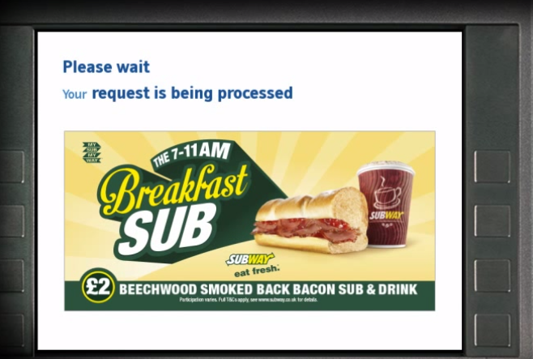

Applies to
- The Captive Audience

Links
- YouTube example: http://www.youtube.com/watch?v=lG-XUryeWBk
- YouTube example (targeted to advertisers): http://www.youtube.com/watch?v=mC4UM369kXs

JCDecaux alfa romeo moving billboard
JCDecaux built a moving billboard that followed people around to promote Alfa Romeo cars around the strapline “Endearing, this Alfa Romeo” (In Dutch: “laat je niet los”, literally “it won’t let go of you”, which is an expression meaning you keep thinking about it.
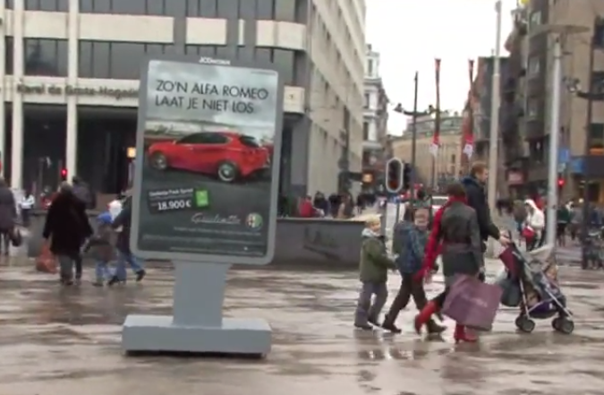

Applies to
- The Captive Audience
- (The Attention Grabber)

Links
- YouTube example: http://www.youtube.com/watch?v=oSDwmdNCeM0

Mind reader reveals his ‘gift’: browsing publicly available information
In a marketing campaign to make people aware of the personal information they share on the internet, random people in Brussels were asked to have their mind read by ‘Dave’, a mind reader who, as they were told, would star in an upcoming TV program. Afterwards, the mind reader showed the innocent how he did it, and revealed a number of ‘hackers’ browsing the publicly available information on their social media profiles.

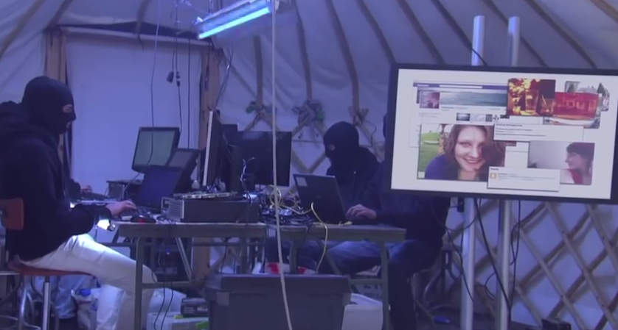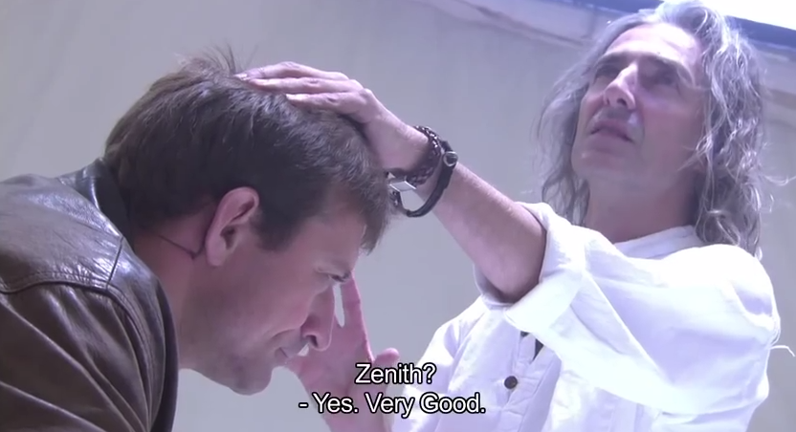

Applies to
- None

Could be Used in
- We Never Forget or The Social Network of Proxemic Contacts: Not a direct example, but we might use it to indicate how people don’t realize what information they share online. ‘Frictionless sharing’ or building up a profile of proxemic relationships, cfr. Facebook’s shadow profiles (http://www.digitaltrends.com/social-media/what-exactly-is-a-facebook-shadow-profile/) — where Facebook builds up a profile of you even if you don’t create one on the site).

Links
- YouTube: http://www.youtube.com/watch?v=F7pYHN9iC9I

Aware-live technologies: look
Look is a software and hardware computer vision solution that allows digital signage to quickly identify characteristics of their users, such as gender, approximate age, categorization in marketing classifications (e.g., Generation X, Baby Bloomers), participation via face detection (active vs. passive bodies), JPEG video feeds, and data dashboards.
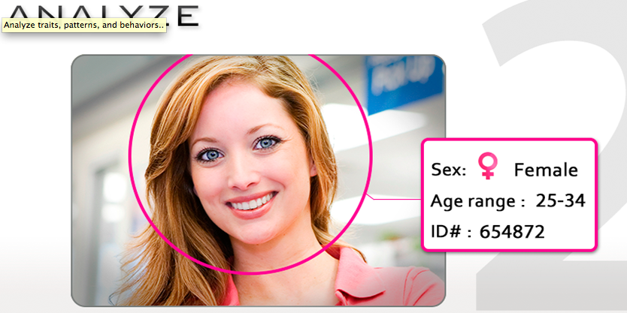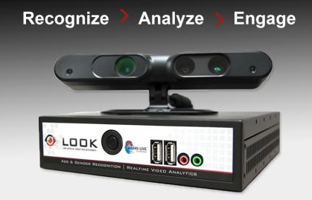

Applies to
- Disguised Data Collection: this is the main pattern for this one, although not in the paper
- We Never Forget: building a rich user profile
- (The Social Network of Proxemic Contacts)

Links
- http://www.aware-live.com/
- http://www.aware-live.com/Products/Look%E2%84%A2/tabid/90/Default.aspx
- Features: http://www.aware-live.com/Products/Look/Features/tabid/92/Default.aspx
- Somewhat similar system: http://www.digitalsignageexpo.net/cube26-consumer-retail-engagement-metric

