Dark Patterns and Anti-Patterns in Proxemic Interactions:
A Critical Perspective
1st Author Name  Affiliation  Address  e-mail address  Optional phone number | 2nd Author Name  Affiliation  Address  e-mail address  Optional phone number | 3rd Author Name  Affiliation  Address  e-mail address  Optional phone number

ABSTRACT
In submission to ACM DIS 2014.
This paper has not been submitted elsewhere.

.

Author Keywords
Dark patterns, proxemic interactions.

ACM Classification Keywords
H.5.m. Information interfaces and presentation (e.g., HCI): Miscellaneous.

INTRODUCTION
Authors of human-computer interaction papers concerning innovative design ideas tend to forward their central idea in a positive – often highly idyllic – light. True critical perspectives are rarely offered. When they are, they tend towards a few cautionary lines in the discussion, or relegated to future work where its actual use would be examined. The problem is that many of our new innovations involve designing for ubiquitous computing situations that are extremely sensitive to intentional or unintentional abuse (e.g., privacy, distraction and intrusion concerns). Rather than wait until some future field study of our technology (where it may be too late to address emerging concerns), we should consider the ‘dark side’ of our technologies at the outset.
The particular innovation we are concerned with is proxemic interactions, which was inspired by Hall’s Proxemic theory [Hall]. The theory explains people’s understanding and use of interpersonal distances to mediate their social interactions with others. In proxemic interactions, the intent is to design systems that will let people exploit a similar ‘social’ understanding of their proxemic relations with their nearby digital devices to facilitate more seamless and natural interactions [Greenberg & Marquardt, 2011]. This is especially important as we become immersed in ubiquitous computing ecologies, i.e., where we carry and are surrounded by myriads of devices, all potentially capable of interacting with one another. Examples include: mobile devices that understand their spatial relations to mediate information exchange between nearby devices [Kortuem; Marquardt, Hinckley et. al.]; large displays that sense people’s position relative to them, where they dynamically adjust what is shown and how people can interact with them [Vogel, Ju, Marquardt & Ballendat]; public art installations that respond to the movement and proximity of people within its sphere to affect what is shown [Snibbe]; application areas such as home media players that monitor the distance and orientation of its viewers to dictate what is shown [Ballendat], and information visualizations that tune their visuals to people’s position relative to them [Isenberg]. The literature also includes more general essays about the role of proxemics, such as how it can address well-known challenges in Ubicomp design [Marquardt & Greenberg].
Yet it is clear, at least intuitively, that there is a dark side to proxemic interactions. For example, the systems above rely on sensing people and their devices within the surrounding environment. Indeed, [Greenberg & Marquardt, 2011] describe several sensed dimensions that would be valuable to system design: distance, orientation, and movement of entities relative to one another, the identity of these entities, and contextual information about the location. While their purposes are honorable, such sensing – as well as the inevitable inaccuracy of interpreting and translating that information into action – immediately raises concerns by experts and non-experts alike about privacy, errors, distraction and intrusion. In addition, dystopian visions of the future hint at abuses of such technologies – a well-known example is the movie Minority Report that illustrates how a character is selectively bombarded by targeted advertisements as he moves through a public hallway.
In this paper, we revisit the idea of proxemic interactions, where our goal (and contribution) is to present a critical perspective – the dark side – of this technology. Our method is to articulate potential dark patterns indicating how we think this technology can be – and likely will be – abused, and anti-patterns in which the resulting behavior occurs as an unintended negative side effect. To avoid being overly broad, we focus our scope somewhat to people’s proxemic interactions with large (and mostly public) displays, although we do illustrate other examples as needed.

Dark Patterns and anti-patterns
Architect Christopher Alexander introduced the notion of design patterns, where a pattern is a documented reusable and proven solution to an architectural design problem [Alexander]. Design patterns are typically derived by examining existing solutions to design problems (which may include ‘folk’ solutions) and generalizing them. Design patterns were later advocated as a way of describing common solutions to typical software engineering problems [Gamma], and to interaction design problems [Borchers].
Patterns usually comprise several elements [Gamma]:
- A pattern name that meaningfully describes the design problem, where the set of names create a vocabulary that eases discussion and communication;
- A problem that explains the problem and its context, and thus when the pattern should be applied to it;
- A solution that is an abstract description of how the problem is solved;
- Consequences that are the results and tradeoffs of applying the pattern.
A dark pattern [Brignull] is a special kind of pattern, defined by as:
“a type of user interface that appears to have been carefully crafted to trick users into doing things [where] they are carefully crafted with a solid understanding of human psychology, and they do not have the user’s interests in mind” [Brignull et. al.].
[Brignull et. al.] created a web-based library of dark patterns concerning intentionally deceptive e-commerce practices. Their specific goal was to recognize and name these practices so that people would be aware of dark patterns in an interface, and to shame the companies using them. For example, they describe a ‘hidden cost’ pattern that “occurs when a user gets to the last step of the checkout process, only to discover some unexpected charges have appeared”, illustrated by how several named companies use that pattern [Brignull et. al.].
An anti-pattern is another kind of pattern that indicates a design failure or non-solution [Koenig], or an otherwise bad design choice that unintentionally results in a negative experience or even harm [Zagal].
In the remainder of this paper, we combine the notion of dark patterns and anti-patterns somewhat more broadly. We articulate not only possible deceptions and misuses of proxemic interactions (dark patterns), but also problems that may appear even when the designer has reasonable intentions (anti-patterns). Unlike true patterns that are based on analyzing a broad variety of existing solutions, we construct patterns based on several sources. We consider the dark side of existing commercial and research products directly or indirectly related to proxemic interactions, dark portrayals of such technologies foreshadowed by the popular literature and cinema, and our own reflections of where misuses could occur. That is, our patterns are a mix of those that describe existing abuses and that predict possible future ones. We do not differentiate whether a particular pattern is dark vs. anti: as our pattern examples suggest, the difference between the two often arises from the designer’s intent rather than a feature of a particular design. That is, the same pattern – depending on the designer’s intent – can viewed as either a dark pattern or an anti-pattern.
While the novelty of proxemic interaction systems make pattern elicitation somewhat of a thought exercise (albeit grounded in existing examples where possible), we believe this approach to be appropriate for forecasting – and ideally mitigating – the dark side of our future technologies before actual deceptive patterns become widespread in practice. As part of our investigation, we revisited [Brignull et.al’s] dark pattern library to see if and how they could be applied to proxemic interactions (possibly as variations). We also looked at emerging uses of proxemics in commercial and experimental products, and considered concerns raised in the literature or in related areas.
We now turn to our patterns. Afterwards, we will discuss how many of our dark patterns share and arise from several foundational issues.

1. The Captive Audience
The person enters a particular area to pursue an activity that takes a given time, and that does not involve the system. The system senses the person at that location, and begins an unsolicited (and potentially undesired) action based on the fact that the person is now captive.
Unlike desktop computers, technology can be spatially located in an environment to leverage a person’s expected routines. When done for beneficial purposes, the technology enhances or supports what the person normally does at that location – indeed, this is one of the basic premises of embodied interaction [Dourish]. The captive audience pattern instead exploits a person’s expected patterns and routine for its own purposes, where the system knows that the person cannot leave without stopping what they otherwise intended to do.
Commercial products already exist that use the captive audience pattern. Novo Ad (www.novoad.com), for example, produces advertising mirrors that display video ads on mirror-like screens ranging in size from 21–52”. The Novo Ad web site on its Advertising Mirror page states:
“the system serves as a mirror screen which identifies figures standing in front of it and switches itself automatically on. At start-up the screen displays a 6 second long ad on a full screen, which is later reduced to ¼ of the screen”. [www.novoad.com]

Figure 1. Novo Ad screenshot, YouTube id: PXwbacfAwnY
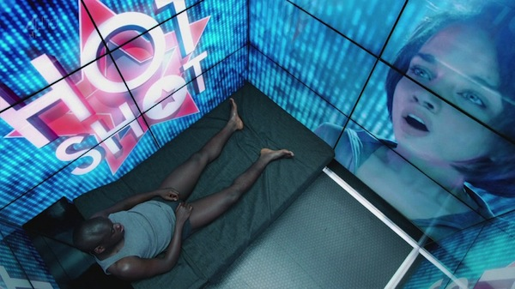
Figure 3. From Episode 2, Season 2 of Black Mirror, BBC.
Novo Ad identifies public washrooms as one of the prime locations for their displays, and even created a promotional video showcasing their technology in a woman’s washroom as illustrated in Figure 1. The woman becomes the captive audience, as her primary task is to use the sink and mirror for grooming. The video ad, which starts on her approach, is the unsolicited system action. Other captive locations listed by Novo Ad include dressing rooms and elevators.
Captive Media, a British company, takes this one step further [www.captivemedia.co.uk]. They estimate that a man using a urinal is captive for ~55 seconds. They place screens directly above the urinal (Figure 2, left), and use proximity and ‘stream’ sensors “to detect the position of a man’s stream as he pees” (Figure 2, right). This information is then used to activate advertising-sponsored pee-controlled games as illustrated in Figure 2.
‘15 Million Merits’, an episode of the dystopian Black Mirror BBC television series, also includes several examples of the captive audience pattern. It portrays a future where each person’s bedroom is built out of display walls that are always on when that person is present (Figure 3). They can only be turned off temporarily when a person makes a payment, or by leaving the room.

2. The Attention Grabber
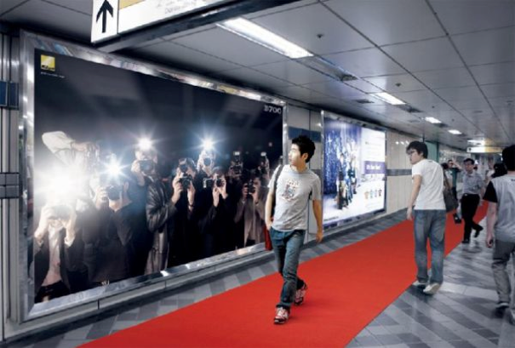
Figure 4. The Nikon D700 Billboard. From http://www.thecoolhunter.net/architecture/70
The person happens to pass by the field of view of a strategically located system. The system takes deliberate action to attract and keep that person’s attention.
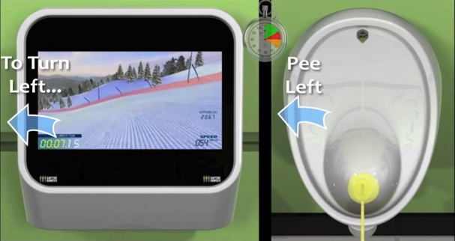
Figure 2. Captive Media screenshot, YouTube id: XLQoh8YCqo4#t=44
Attracting attention of a passerby is an exceedingly common strategy used by anyone selling a product or service: the goal is to turn the passerby into a customer. Carnival barkers, greeters in establishment doorways, aggressive street peddlers − all verbally address a passerby to try to get them to enter into a conversation and ultimately into a sales transaction. Establishments use storefronts and windows to advertise their wares. Flashing lights and myriads of public signage and billboards (some electronic and digital) commonly compete for the passerby’s attention.
Proxemic-aware public devices are perfectly poised to grab attention of passersby. Like barkers and greeters, they can sense the passerby as an opportunity, as well as gauge how well their attention-getting strategies are working by how the person respond. For example, turning to face the device, or stopping, or approaching the display all suggest that a person’s attention is momentarily acquired.
The dystopian future depicted in the movie ‘Minority Report’ contains a scene that popularized this scenario. Multiple advertising walls detect the protagonist John Anderton moving through a crowded hallway. All walls vie for his attention in a visual and audio cacophony. The ad wall for Guinness Draught, for example, shouts his name along with a directed message: “John Anderton, you could use a Guinness right about now”.
An example of an existing simple but compelling public display in this genre is the Nikon D700 Guerrilla-Style Billboard (Figure 4). Located in a busy subway station in Korea, it displays life-size images of paparazzi that appear to be competing for the passerby’s attention. When the passerby is detected in front of the billboard, lights flash (as in Figure 4) to simulate flashing cameras. The red carpet leads to a store that sells the type of cameras being used.
Within advertising and marketing, this pattern is commonly referred to as AIDA, an acronym for: attract Attention, maintain Interest, create Desire, and lead customers to Action [Strong]. [Wang et al.] extended AIDA to digital displays by their Peddler Framework, itself an extension of the Audience Funnel [Michaelis]. The framework covers six interaction phases a person may be in, all of which can be inferred by the proxemics measures of distance, motion, and orientation. Each phase indicates increasing (or decreasing) attention and motivation of the passerby [Wang et al.].
- Passing by relates to anyone who can see the display.
- Viewing & reacting occurs once the person shows an observable reaction.
- Subtle interaction happens if the person intentionally tries to cause the display to react to their movement and gestures.
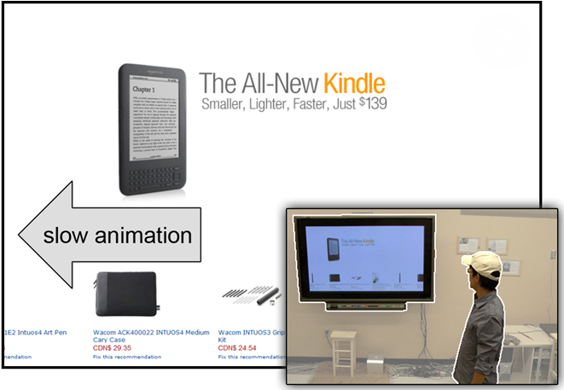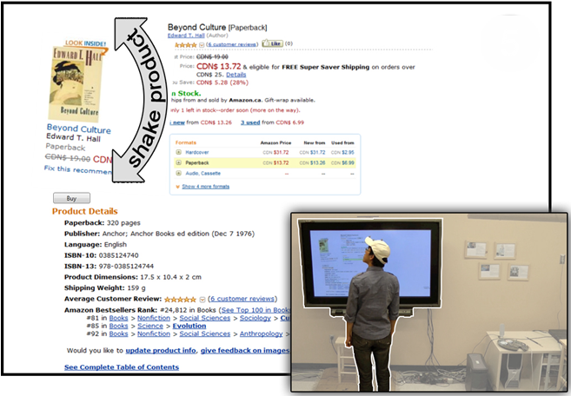
Figure 5. Proximic Peddler. Left: Attention-attracting animation slows if passerby gazes at display. Right: Product graphic shakes to re-attract attention if person turns away.

- Direct interaction occurs when the person moves to the center of the display and engages with it in depth.
- Digressions and loss of interest occur when a person either looks away from the display, or starts moving away from it.
- Multiple interactions occur when the person re-engages with the display.
- Follow-up actions happen after interactions with the display are completed.
[Wang et al.] then illustrate a proxemic-aware public advertising display for selling books. It exploits the phases above to attract and retain the attention of a passerby. For example, the initial attention of a passerby is attracted by rapid animation of a pictorial product list; once the passerby looks at the display, the animation slows down to become readable (Figure 5, left). If the person approaches the display, various products are featured by growing in size. If the system detects him looking or moving away, it tries to regain the passerby’s attention using subtle animation (where particular displayed products shake) (Figure 5, right) and by displaying other potentially interesting products.
Commercial interest in attention-grabbing systems are increasing. For example, Apple’s iBeacon is an experiment that recognizes a person (via that person’s iPhone) at specific locations in an Apple store, where it sends notifications about a particular nearby product to that person’s phone.
While the above examples illustrate how proxemic displays can grab attention in an entertaining and perhaps subtle manner, they can also be obnoxious. An earlier version of the Peddler system [Wang 2012] displayed flashing graphics and shouted out loud audio messages to the passerby, and. The more the display was ignored, the more insistent it became. The Black Mirror episode mentioned previously includes an extreme example of a fascist Attention Grabber pattern within the context of a Captive Audience pattern: the display wall shown in Figure 3 detects when the person is trying to shut out the displayed information by sensing if that person’s eyes are closed, or turned away; if so, it plays increasingly annoying sounds and messages to force the person to look at the content.

3. Bait and switch
The system baits the viewer with something that is (from the viewer’s perspective) desirable, but the system then switches it to something else after the person directs his or her attention to it and moves closer.
[Brignull et al.] characterize this bait and switch pattern as follows:
“The user sets out to do one thing, but a different, undesirable thing happens instead. This is one of the oldest tricks in the book, and it is very broad in nature…”
Consider the case where a public display has gained a viewer’s attention because the viewer is in fact interested in the ‘bait’ being displayed (e.g., an apparently incredible offer). The viewer ‘opts-in’ by approaching the display. In turn, the display recognizes the viewer’s interest and offers further enticing details concerning its content. The viewer’s attention becomes increasingly focused. Once the viewer is fully drawn in, the system then switches to something else. A typical ‘switch’ would be to an inferior or more costly product purportedly because the initially advertised product is no longer available. Another switch may require the viewer to sign up to some otherwise unwanted service before the viewer can proceed (which could also become a security issue). Yet another switch is the introduction of other content (i.e., unexpected advertising) in this process. An example is Captive Media’s urinals mentioned above: the ‘bait’ is the game, but the ‘switch’ is an advertisement for Vodka shown with one’s score at game’s end.
A compelling (and in this case useful) bait-and-switch example was developed by Amnesty International, where they created a bus-stop display that detects when people are looking at it. When no-one’s gaze is directed at it, it displays a scene showing domestic violence, which is viewable out of the corner of one’s eye (Figure 6a). Yet when a person turns to look at the display directly, it changes into a photo of the couple pretending to be happy (Figure 6b). A slight delay is introduced so that people can get a glimpse of the switch-over. This example is also relevant to the Attention Grabber pattern.
Bait and switch also exists in other proxemic-aware systems that do not use public displays. Consider public wireless networks such as those at airports. They detect travelers within its range, and offer the bait of what appears to be free-of-charge wireless. Yet once a traveler is apparently connected, the network may require the traveler to give up information by signing into some service, or the offered ‘free’ service may be so slow that the alternate higher quality pay service is the only realistic offering.
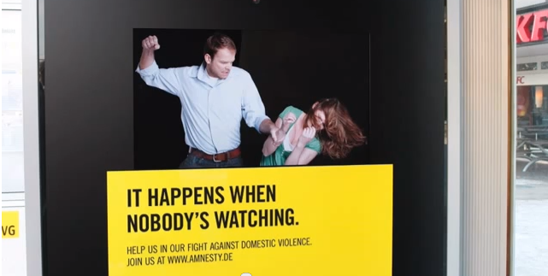
- Bait: the scene visible out of the corner of one’s eye
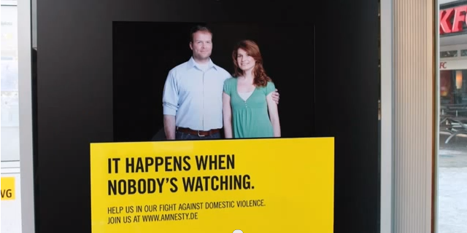
- Switch: the scene visible when one looks directly at it
Figure 6. Amnesty International Eye Tracking, youtube id: DQl_pnuNskQ

4. MAKING PERSONAL INFORMATION PUBLIC
As the person enters a particular area, the system makes that person’s personal information publicly visible.
One of the appeals of proxemic interactions is to make personal information readily available on nearby devices. For example, [Vogel et. al]’s original work on ambient displays illustrated how a large public ambient display reveals both public and personal information as a person approaches it. Personal information includes calendars, notifications, and directed messages, which can then be manipulated by that person.
Their system is intended to be helpful. Yet the basic issue is that other onlookers can see that personal information. [Vogel et. al.] tried to mitigate this by describing how the person’s body could physically shield personal information presented directly in front, and how the person could hide information through an explicit gesture.
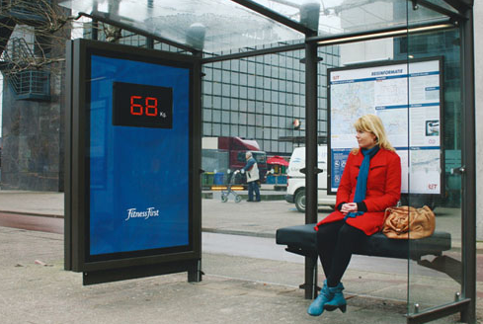
Figure 7. The Fitness First health club display. From www.thecoolhunter.net/article/detail/1504/fitness-first--wait-watching, by Dutch ad agency N=5.
The previously mentioned scene from ‘Minority Report’, with its myriads of advertising walls, make passerby’s private information public as a byproduct of their clamor for the attention of the passerby. We see the Guinness advertising wall (amongst others) publicly identify the protagonist by shouting out his name. In that scene, another advertising wall for a credit card visually displays both the protagonist’s name and personal information about him (that he has been a member of since 2037).
Making personal information public could be an intentional design goal rather than an unintended side effect. An example is the guerilla-style bus stop display produced for the Fitness First health club chain in Rotterdam (Figure 7). The bench nearby the display contains a weight sensor, where the unsuspecting commuter’s weight is then publicly displayed on the bus stop’s wall. Its purpose is purportedly to embarrass people to join the health club by intentionally publicizing their weights.

5. We Never forget
In day-to-day life, proximity is an ephemeral phenomenon. The proxemic relationship between parties dissolves as soon as they separate. In contrast, systems can tag any proxemic interactions as indicating a permanent, persistent (and perhaps undesirable) relationship that is never forgotten.
The ‘we never forget’ pattern occurs when systems maintain a history of peoples’ past proxemic connections, where that history is used to re-establish connections, to trigger information exchange, and/or to recreate prior contexts (e.g., showing the last-displayed information). When used beneficially, the idea is to remember details that make it easy to pick up where one has left off. Unfortunately, this might be completely inappropriate in a different context.
For instance, mobile devices – when brought into range of other devices – typically remember any entered credentials (such as a passphrase) that allows both to connect to one another. This can be a tremendous convenience: when that device comes back into range, those credentials are reused automatically to re-establish the connection, minimizing user load. Remembered WiFi hotspots automatically reestablish network connections when a device returns to a location, while Bluetooth pairings ease device to device interconnections, such as how a person’s mobile phone is linked to a hands-free system in that person’s car. Similarly, various interaction techniques trigger pairings and information exchange when proxemics-aware devices are brought close together, e.g., by bringing mobile devices together [Hinckley 2003][Hinckley 2004][Marquardt, Ballendat 2012].
On the other hand, this approach can fail for several reasons. First, people may do a one-off connection to a device they otherwise do not control or trust (e.g., a one-time transaction with a public display). If that person happens to pass by that other device at a later time, there is no reason for that connection to be re-established (particularly if there is some risk involved). Second, security is compromised. If (say) one’s mobile phone is stolen, the thief may be able to explore nearby locations to see if he or she can access other devices or networks without entering any credentials.
Third, circumstances change even with trusted devices. For example, a person that previously used a conference room display to show some personal photos on his phone to visiting friends could have these photos reappear inappropriately on the display while walking past it with her work colleagues. Or, consider the case of cell phones paired to one’s Bluetooth car system, where it automatically displays incoming calls and redirects audio to the car’s speakers. We can easily imagine what could happen on a family trip when a call comes in from one’s secret lover. As yet another example, a manager and an employee may be working physically close together, where they pair their laptops to work on a project report. A week later, the manager and employee sit next to each other in a meeting discussing the team’s progress. As their laptops get close to each other once again, the manager’s laptop automatically shares the currently opened document, which, in this case, is a sensitive spreadsheet with the wages of all team members.
Fourth, a person may be unaware that he or she is again sharing his or her device’s data with another person that they had previously shared with. This absence of reciprocity (if you share with me, I should know that I share with you) is a known problem in groupware, where one of the parties may be unaware that one’s data is being shared with others. To remedy this, such systems should provide awareness of other users and their actions [Bellotti01]. When proxemic connections are established, the system needs to inform its users about what information is being shared and when, and to whom this information is made available (who is making a connection? [Peirce]). Likewise, users need to know what will happen to their information once it is shared [Bellotti01], and what happens once the connection is destroyed.
Fifth, credentials obtained in one setting may be remembered by the system and inappropriately applied to other settings. This “one login for all” is an increasingly common practice in other systems, such as Facebook or Google. The danger, of course, is that a person who has established a single proxemic connection to (say) a particular display may not want that connection to occur when they happen to pass by other associated displays.
Finally, this pattern can become an especially dark pattern when the system exploits the user’s proxemic history to build a rich user profile. This is already done in so-called ‘loyalty’ cards that track and exploit a person’s shopping behaviors. As an equivalent, a system could track the user’s location when they walk past (and perhaps connect to) different displays and locations, where the personal profile is both constructed and shared between displays.

6. THE SOCIAL NETWORK OF PROXEMIC CONTACTS or UNINTENDED RELATIONSHIPS
The system tracks your proxemic relations with others and constructs a social network on the assumption that you are somehow socially related, when in fact there is no relationship whatsoever.
Proxemics assume that increasing social engagement (and thus a social relationship) is typically accompanied by decreasing physical distance, mutual orientation, etc. That is, social engagement leads to people adjusting these factors to their mutual benefit. Proxemic interaction systems do this somewhat backwards. They assume that some sensed phenomena (decreasing physical distance, mutual orientation, etc.) signals a social relationship, i.e., it treats the sensed phenomenon as causal. This assumption is not always correct. In real life, for instance, strangers may approach and even glance at each other, but no social relationship exists between them. Moreover, not all relationships are reciprocal: while one person believes they have a relation to another, the other may not reciprocate at the same strength, if at all.
The assumption that all proxemic interactions imply a social relationship is problematic for a variety of reasons. Perhaps the most worrisome is that the underlying system may be trying to infer one’s social network from proxemic events between two people, where strangers are included. This scenario is not at all farfetched. In 2013, Edward Snowden revealed the US National Security Agency’s controversial practice of tracking phone call metadata records (the number dialed, a cell phone’s location, time and duration of call, etc.). They used this information to compile sophisticated social network diagrams of Americans, ostensibly to identify and target terrorist networks. Even if one accepts this practice, innocent parties may be inadvertently included as ‘false positives’ in one’s social network, perhaps due to erroneous calls (wrong numbers) or innocuous calls.
It would be just as straightforward to create an equivalent social network by sensing one’s proximity to others. These too could easily include unintended relationships. For example, matches between location and time information in cell phone metadata records can be used to determine those people in the same proxemic vicinity. Eagle et. al. (2009) compared observational data from mobile phones with self-report data, and concluded that they could accurately infer 95% of friendships based on observational data alone. This also means that 1 in 20 are not friendships, i.e., they are false positives. Other technologies can provide even more accurate data of one’s proximity to another, e.g., facial recognition systems identifying co-located people in public place. Similarly, the co-presence by multiple people passing by or in front of a device (such as a large display) may be recorded as a relationship.
Once created, the social network could be used for a variety of dark purposes. The social network could be exploited by authorities to identify potential ‘suspects’ by their inferred association to an unsavory character. Marketers could use that social network to identify a potential target audience by their association with a known demographic fitting that profile. Spammers and phishers could exploit it for their own deceptive purposes. In all these cases, the agencies involved may not care that ‘false positives’ are included, where they may be treated as collateral damage or simply as noise.
While algorithms could perhaps detect and minimize the number of false positives, the social network will always include some unintended relationships.

The Milk Factor
The proxemics system forces you to move through or go to a specific location in order to get a service.
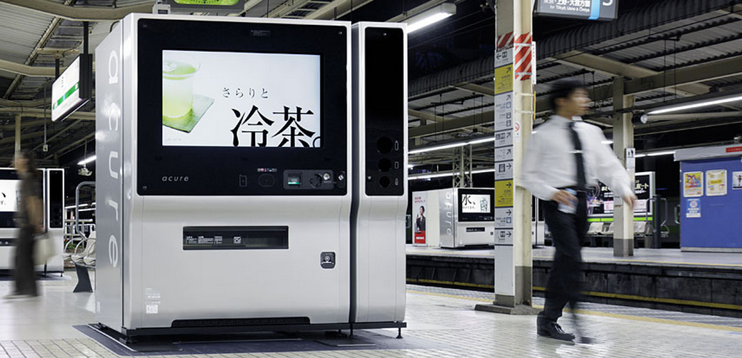 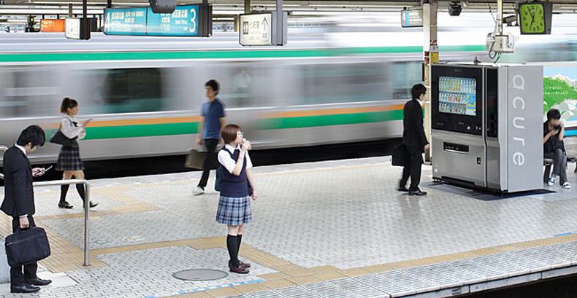
Figure 8. Proxemic Vending Machine. Left: A potential customer choosing drinks at the vending machine, close enough for his face to be scanned and analysed. Right: The vending machine in advertisement mode: passersby are distant and the drink menu is not visible. From www.design-ss.com/products/2010/09/01/vending-machine.html?ctg-jp]

The rules of proxemic interactions, which we use in our everyday lives, can be misused to force people to move to or from a specific location. In non-computer scenarios, this can be seen in the design of supermarket shopping spaces. Products that are purchased frequently (e.g. milk or baked goods) are located in distant areas of the store. Thus shoppers are forced to walk through isles with goods, which leads to increased visibility of promoted items and impulse purchases.
Proxemic interaction systems can force people to position themselves in specific places by limiting access to functionality to particular locations. For example, all zone-based proxemic displays invoke certain types of interactions at specific distances. While most research systems do this with good intensions (e.g., [Vogel 2004, Ballendat 2010, Wang 2012, Dostal 2013, Roussel 2004], all require its user to stand within specific boundaries.
This can have unintended consequences. The MirrorSpace [Roussel 2004] is a video conferencing system that mitigates privacy: images are blurred when the person is far away and only become sharp and identifiable when they stand close to the display. Yet if the person needs to be in another corner of the room while talking over the link, they lose fidelity. In the video player by [Dostal 2013], the motivation for limiting visibility of information is to allow some viewers to watch a film with subtitles from a position on the right side of the sitting area, while simultaneously allowing others to watch the same film without the subtitles on the left side of the sitting area. This forces people to sit in particular locations if they want to see a movie a particular way (vs. for example, sitting on the floor).
A commercial example that exploits people having to go to a specific location is the Design Studio S vending machine in Japan. When potential customers are far, the vending machines show advertising images tailored to the season, time of day and temperature (Figure 8, left). However, to see what drinks are available for purchase, the potential customer must approach the area in front of the vending machine, which shows a drinks menu (Figure 8, right). However, at that point the vending machine uses it camera to covertly perform a computer vision based analysis of the nearby customer to establish their approximate age and gender. This data is used to “subtly” offer targeted drinks selections. Demographic and sales data is uploaded (without consent) to the company’s servers for further analytics and marketing use. This is a clear example of a dark pattern: the customer cannot even see the range of drinks for sale, which forces them to move close enough to the machine to make covert data collection possible.

DISCUSSION
The patterns above are just a sampling rather than exhaustive. Even so, we can reflect on the patterns listed earlier, we were able to identify several common root problems that promote side-effects leading to anti-patterns, or that can be exploited as dark patterns.
Opt-in / opt-out choices are particularly problematic in proxemic-aware systems. The overall problem is that a person implicit opts-in simply by entering and approaching the proxemic-aware entity, regardless of whether the person actually intends to opt into the situation. Opt-out requires the person to leave the area, which may not be a reasonable choice for that person (e.g., as in the Captive Audience).
Physical space is imbued with dual meanings. Peoples’ practices and expectations of the physical space can be quite different from the meaning and practice applied by the technology. This means that a person may approach a location for one reason, but as a consequence they are exposed to the system exploiting their approach for another reason.
Ownership of the physical space is ambiguous. Ownership of physical space is subtle. A person looking for a quiet corner may consider that space as temporarily their own, but if this happens in a public area, their presence can still be exploited. A public display may consider the space around itself as its own, where anyone’s use of that space becomes fair game. While people have social rules that dictate what happens in private / personal / public space interactions, technology can easily violate those rules.
Attention is inherently sought after in proxemic interactions. The gradual engagement design pattern [Marquardt] suggests that proxemic interaction gradually reveals information as entities approach one another. Whether done subtly or blatantly (as in the attention grabber pattern), attention of the person is demanded.
The Midas touch problem occurs when any approach action is interpreted as the beginning of a proxemic relationship. If the approach is due to another reason (e.g., a happenstance passing by), there is no easy way to distinguish that.
Accidental proxemics is related to the midas touch problem; just because you come close to something doesn’t mean you wanted to enter the relationship.

DONE UNTIL HERE – See Text after references for additional potential material

ACKNOWLEDGMENTS
This work originated from a breakout session held at the Proxemics in Human-Computer Interaction seminar at Schloss Dagstuhl, Germany. The original attendees included the authors as well as <LIST HERE> - we thank them hugely for their insight and intellectual contributions to this work.

REFERENCES
- Alexander, C. A Pattern Language: Towns, Buildings, Construction. Oxford University Press, (1977)
- Ballendat, T., Marquardt, N. & Greenberg, S. Proxemic Interaction: Designing for a Proximity and Orientation Aware Environment. Proc. ACM ITS (2010), 121-130
- Bellotti, V. & Edwards, K. (2001). Intelligibility and Accountability: Human Considerations in Context-Aware Aystems. Human–Computer Interaction, 16(2-4), 193-212.
- Borchers, J. A Pattern Approach to Interaction Design. AI & Society, 12:359-376, Springer. (2001)
- Brignull, H. Dark Patterns: Deception vs. Honesty in UI Design. Interaction Design, Usability, Issue 338, (2011)
- Brignull, H., Miquel, M. & Rosenberg, J. Dark Patterns Library. http:darkpatterns.org. Retrieved Nov. 2013
- Dostal, J., Kristensson, P. & Quigley, A. Multi-view Proxemics: Distance and Position Sensitive Interaction. ACM Proc. Pervasive Displays, (2013), 1-6.
- Dourish, P. Where the Action Is: The Foundations of Embodied Interaction. MIT Press (2004)
- Eagle, N., Pentland, A. & Lazer, D. Inferring Friendship Network Structure by Using Mobile Phone Data. Proc. Nat’l Academy of Science, 106:36, (2009) 15274-8.
- Gamma, E., Helm, R., Johnson, R. & Vlissides, J. Design Patterns: Elements of Reusable Object-Oriented Software. Pearson. (1994)
- Greenberg, S., Marquardt, N., Ballendat, T., Diaz-Marino, R. & Wang, M. Proxemic interactions: the new ubicomp? ACM interactions, 18, (2011), 42–50.
- Hall, E.T. The Hidden Dimension. Doubleday, N.Y, 1966.
- Hinckley, K. Synchronous Gestures for Multiple Persons and Computers. Proc. ACM UIST (2003), 149-158.
- Hinckley, K., Ramos, G., Guimbretiere, F., Baudisch, P., & Smith, M. Stitching: pen gestures that span multiple displays. ACM Proc AVI, (2004). 23-31.
- Isenberg, P., Dragicevic, P., Willett, W., Bezerianos, A. & Fekete, JD. Hybrid-Image Visualization for Large Viewing Environments. IEEE TVCG, 19(12), (2013).
- Ju, W., Lee, B. & Klemmer, S. Range: exploring implicit interaction through electronic whiteboard design. Proc. ACM CSCW, (2008), 17-26.
- Koenig, A. "Patterns and Antipatterns". J. Object-Oriented Programming, 8 (1): 46–48. (1995)
- Kortuem, G., Kray, C. & Gellersen, H. Sensing and visualizing spatial relations of mobile devices. Proc. ACM UIST, (2005), 93-102
- Marquardt, N., Ballendat, T., Boring, S., Greenberg, S. & Hinckley, K. Gradual Engagement between Digital Devices as a Function of Proximity: From Awareness to Progressive Reveal to Information Transfer. Proc. ACM ITS, (2012), 31-40.
- Marquardt, N. & Greenberg, S. Informing the Design of Proxemic Interactions. IEEE Pervasive Computing, 11(2):14-23, (2012).
- Marquardt, N., Hinckley, K. & Greenberg, S. (2012) Cross-Device Interaction via Micro-mobility and F-formations. Proc. ACM UIST (2012), 13-22.
- Michelis, D. & Müller, J. The Audience Funnel: Observations of Gesture Based Interaction with Multiple Large Displays in a City Center, Int. J. HCI, 27 (6), (2011)
- Pierce, J. S., Mahaney, H. E., & Abowd, G. D. (2003). Opportunistic Annexing for Handheld Devices: Opportunities and Challenges. Proc. HCIC (2003).
- Roussel, N., Evans, H. and Hansen, H. Proximity as an interface for video communication. IEEE Multimedia, 11(3):12-16, (2004).
- Snibbe, S. & Raffle, H. Social Immersive Media: Pursuing Best Practices for Multi-User Interactive Camera/Projector Exhibits. Proc. ACM CHI, (2009), 1447–1456.
- Strong, E. The Psychology of Selling and Advertising, McGraw-Hill NY, (1925).
- Vogel, D. & Balakrishan, R. Interactive Public Ambient Displays: Transitioning from Implicit to Explicit, Public to Personal, Interaction with Multiple Users. Proc. ACM UIST, (2004), 137-146.
- Wang, M., Boring, S. & Greenberg, S. Proxemic Peddler: A Public Advertising Display that Captures and Preserves the Attention of a Passerby. Proc. ACM Pervasive Displays. (Porto, Portugal), 10 pages, (2012)
- Zagal, J., Bjork, S. & Lewis, C. Dark Patterns in the Design of Games. Proc. Foundation of Digital Games, http://www.fdg2013.org/program/ (2013).

The columns on the last page should be of approximately equal length.
Remove these two lines from your final version.
So far, there seem to be two main ways for proxemic systems to manipulate users into specific positions. The approach depends on whether the system is static or if it has active agents.

Proxemic systems, which have active agents, may use those agents to manipulate users’ position. For example, Kastanis et al. [Kastanis 2012] used an agent-based system operating within an immersive virtual environment to train a virtual agent to force user’s movement to a specific position within the environment. There is some evidence that this approach could be used in human-robot interactions too as humans seem to compensate for robot proxemic behavior even more strongly than for human proxemic behavior, although the compensatory behavior may not be the same as with humans [Sadar 2012].

DISGUISED DATA COLLECTION
The system collects data about you as a function of your proximity to it
e.g., snapshots of face for future reuse in personalized ads
e.g., IDs of mobile phones, data extracted from mobile devices, etc.
The vending machine example applies here too as data is used for feature analysis and future marketing purposes.
Additional references for this section:
[
[Kastanis 2012] Iason Kastanis and Mel Slater. Reinforcement learning utilizes proxemics: An avatar learns to manipulate the position of people in immersive virtual reality. ACM Trans. Appl. Percept. 9, 1, Article 3 (March 2012), 15 pages. http://doi.acm.org/10.1145/2134203.2134206

[Sadar 2012] Aziez Sardar, Michiel Joosse, Astrid Weiss, and Vanessa Evers. Don't stand so close to me: users' attitudinal and behavioral responses to personal space invasion by robots. In Proc. of HRI ‘12. ACM (2012), 229-230. http://doi.acm.org/10.1145/2157689.2157769
- [Pering] Pering, T., Ballagas, R., & Want, R. (2005). Spontaneous marriages of mobile devices and interactive spaces. Communications of the ACM, 48(9), 53-59.

Design Studio S vending machines:
[FIGURE V. Images in the wiki. Source of images: http://www.design-ss.com/products/2010/09/01/vending-machine.html?ctg-jp]
http://en.akihabaranews.com/76569/hands-on/jr-east-water-businesss-smart-marketing-vending-machines
video: http://vimeo.com/17389606
http://www.examiner.com/article/smart-vending-machines-tokyo-train-station-recognize-age-sex
http://www.engadget.com/2010/08/11/japan-takes-vending-machines-to-their-logical-47-inch-extreme/
- Bellotti, V., & Sellen, A. Design for Privacy in Ubiquitous Computing Environments. Proc. ECSCW, Springer Netherlands (1993) 77-92.

ROACH MOTEL / FORCED FOLLOW-THROUGH / BLACKMAILING
System forced you to complete its proxemics relations as you approach
Example: Information about you is displayed, but won’t be wiped until you follow the dialog to its completion
ACCIDENTAL PROXEMICS
[JO?]Exploits midas touch problem; just because you come close to something doesn’t mean you wanted to enter the relationship.
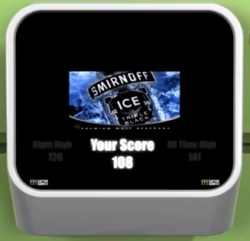
Figure 6. The game in Figure 2 (the bait) is followed by the switch to advertisement displayed at its end. Captive Media screenshot, youtube id: XLQoh8YCqo4#t=44
• "Imagine, for example, that homeowners wake one weekend, and come downstairs looking forward to their first cup of coffee and Cartalk on NPR. To their surprise, no sound emerges from their speakers. The reason is that their neighbors have purchased new Bluetooth-enabled speakers which, when first installed, associate themselves with the nearest sound source; in this case, the original homeowners' Bluetooth- enabled stereo. Meanwhile, the neighbors are abruptly awakened to tales of car repair." [quote from Keith Edwards' 2001 paper "At Home with Ubiquitous computing: seven challenges"]
• Proximity-aware car (first-hand experience): some Ford models take into account the proximity of car keys to automatically open the door when the key is nearby (e.g., in your pocket). This breaks the mental model of being able to check whether you’ve locked the car by trying to open the door (if it doesn't open, it's locked properly). In this case, the door will always open due to the proximity of the key in your hand or pocket.

Web site descriptions, quotes, images, and videos are based on material retrieved in January 2014.

