Dark Patterns and Anti-Patterns in Proxemic Interactions:
A Critical Perspective
1st Author Name  Affiliation  Address  e-mail address  Optional phone number | 2nd Author Name  Affiliation  Address  e-mail address  Optional phone number | 3rd Author Name  Affiliation  Address  e-mail address  Optional phone number

ABSTRACT
Copyright notice.

.

Author Keywords
Dark patterns, proxemics interactions.

ACM Classification Keywords
H.5.m. Information interfaces and presentation (e.g., HCI): Miscellaneous.

INTRODUCTION
Authors of human computer interaction papers concerning innovative design ideas tend to forward their central idea in a positive – often highly idyllic – light. True critical perspectives are rarely offered. When they are, they tend towards a few cautionary lines in the discussion, or relegated to future work where its actual use would be examined. The problem is that many of our new innovations involve designing for ubiquitous computing situations that are extremely sensitive to intentional or unintentional abuse (e.g., privacy, distraction and intrusion concerns). Rather than wait until some future field study of our technology (where it may be too late to address emerging concerns), we should be considering the ‘dark side’ of our technologies at the outset.
The particular innovation we are concerned with is proxemic interactions, which was inspired by Hall’s Proxemic theory [Hall]. The theory explains people’s understanding and use of interpersonal distances to mediate their interactions with others. In proxemic interactions, the intent is to design systems that will let people exploit a similar understanding of their proxemic relations with their nearby digital devices to facilitate more seamless and natural interactions [Greenberg & Marquardt, 2011]. This is especially important as we become immersed in ubiquitous computing ecologies, i.e., where we carry and are surrounded by myriads of devices, all potentially capable of interacting with one another. Examples include: mobile devices that understand their spatial relations to mediate information exchange between nearby devices [Kortuem; Marquardt, Hinckley et. al.]; large displays that react to people’s position relative to them to adjust what is shown and how people interact with it [Vogel, Ju, Marquardt & Ballendat]; public art installations that respond to the movement and proximity of people within its sphere to affect what is shown [Snibbe]; application areas such as home media players that monitors the distance and orientation of its viewers to dictate what is shown [Ballendat], and information visualizations that tune their visuals to people’s position relative to them [Isenberg IEEE TVCG?]. The literature also includes more general essays about the role of proxemics, such as how it can address well-known challenges in Ubicomp design [Marquardt & Greenberg].
Yet it is clear, at least intuitively, that there is a dark side to proxemics interactions. For example, the systems above rely on sensing information about people, their devices, and the surrounding environment. Indeed, [Greenberg & Marquardt, 2011] describe several sensed dimensions that would be valuable to system design: distance, orientation, and movement of entities relative to one another, the identity of these entities and contextual information about the location. While their purposes are honorable, such sensing immediately raises concerns about privacy by experts and non-experts alike. As well, dystopian visions of the future hint at abuses of such technologies – a well-known example is the movie Minority Report that illustrates how a character is bombarded by targeted advertisements as he moves through a public hallway.
In this paper, we revisit the idea of proxemic interactions, where our goal (and contribution) is to present a critical perspective – the dark side – of this technology. Our method is to articulate potential dark patterns indicating how we think this technology can be – and likely will be – abused, and anti-patterns where the resulting negative behavior is an unintended side effect. To avoid being overly broad, we focus our scope somewhat to people’s proxemic interactions with large (and mostly public) displays, although we do illustrate other examples as needed.

Dark Patterns and anti-patterns
Architect Christopher Alexander introduced the notion of design patterns, where a pattern is a documented reusable and proven solution to an architectural design problem. Design patterns are typically derived by examining existing solutions to design problems (which may include ‘folk’ solutions) and generalizing them. Design patterns were later advocated as a way of describing common solutions to typical software engineering problems [Gamma], as well as interaction designs [Borchers].
Patterns usually comprise several elements [Gamma]:
- A pattern name that meaningfully describes the design problem, where the set of names create a vocabulary that eases discussion and communication;
- A problem that explains the problem and its context, and thus when the pattern should be applied to it;
- A solution that is an abstract description of how the problem is solved;
- Consequences that are the results and tradeoffs of applying the pattern.
A dark pattern is a special kind of pattern, defined by [Brignull et. al.] as:
“a type of user interface that appears to have been carefully crafted to trick users into doing things [where] they are carefully crafted with a solid understanding of human psychology, and they do not have the user’s interests in mind”.
Brignull et. al. created a web-based library of dark patterns concerning intentionally deceptive e-commerce practices, Their specific goal was to recognize and name these practices so that people would be aware of a dark pattern in an interface, and to shame the companies using them. For example, they describe a ‘hidden cost’ pattern that “occurs when a user gets to the last step of the checkout process, only to discover some unexpected charges have appeared, e.g. delivery charges, tax, etc.”, where they provide several specific examples (and name companies) that use that pattern [Brignull et. al.].
An anti-pattern is another kind of pattern that indicates a design failure or non-solution [Koenig], or an otherwise bad design choice that unintentionally results in a negative experience or even harm [Zagal].
In the remainder of this paper, we combine the notion of dark patterns and anti-patterns somewhat more broadly. We articulate not only possible deceptions and misuses of proxemics interactions (dark patterns), but problems that may appear even when the designer has reasonable intentions (anit-patterns). Unlike true patterns that are based on analyzing a broad variety of existing solutions, we construct patterns based on several sources. We consider the dark side of existing commercial and research products directly or indirectly related to proxemics interactions, dark portrayals of such technologies foreshadowed by in the popular literature and cinema, and our own reflections of where misuses could occur. That is, our patterns are a mix of those that describe existing abuses and that predict possible future ones. We do not differentiate whether a particular pattern is dark vs. anti: as our pattern examples show, the difference between the two often arises from the designer’s intent rather than a feature of a particular design. That is, the same pattern– depending on the designer’s intent – can viewed as either a dark pattern or an anti-pattern.
While the newness of proxemics interaction systems make pattern elicitation somewhat of a thought exercise (albeit grounded in existing examples where possible), we believe this approach appropriate for forecasting – and ideally mitigating – the dark side of our future technologies before actual deceptive patterns become widespread in practice. As part of our investigation, we revisited Brignull’s dark patterns to see if and how they could be applied to proxemic interactions (possibly as variations). We also looked at emerging uses of proxemics in commercial and experimental products, and considered concerns raised in the proxemics literature or in related areas.
As we will see, there are several common issues that are common to many of our dark patterns,
- Opt-in can happen implicitly by simply entering a space;
- Physical space is imbued with dual meanings, i.e., peoples’ practices and expectations of the physical space can be quite different from the meaning and practice applied by the technology;
- Ownership of the physical space is ambiguous;
- Attention is inherently sought after in proxemics interactions;
- …

1. The Captive Audience
The person enters a particular area to pursue an activity that takes a given time, and that does not involve the system. The system senses the person at that location, and begins an unsolicited (and potentially undesired) action based on the fact that the person is now captive.
Unlike desktop computers, technology can be spatially located in an environment to leverage a person’s expected routines. When done for beneficial purposes, the technology enhances or supports what the person normally does at that location – indeed, this is one of the basic premises of embodied interaction [Dourish]. The captive audience dark pattern instead exploits a person’s expected patterns and routine for its own purposes, where the system knows that the person cannot leave without stopping what they otherwise intended to do.
Commercial products already exist that use the captive audience pattern. Novo Ad (www.novoad.com), for example, produces advertising mirrors that display video ads on mirror-like screens ranging from 21 – 52”. Their web site states:
“the system serves as a mirror screen which identifies figures standing in front of it and switches itself automatically on. At start-up the screen displays a 6 second long ad on a full screen, which is later reduced to ¼ of the screen”. [www.novoad.com]
Novo Ad identifies public toilets as one of the prime locations for their displays, and even created a promotional video showcasing their technology in a woman’s toilet as illustrated in Figure X below. The woman becomes the captive audience, as her primary task is to use the sink and mirror for grooming. The video ad, which starts on her approach, is the unsolicited system action. We have also experienced a similar system placed atop of men’s urinals, where there is even less option for the unwilling participant to walk away. Other captive locations listed by Novo Ad include dressing rooms and elevators.

Figure X. Novo Ad screenshot, youtube id: PXwbacfAwnY
Captive Media, a British company, takes this one step further [www.captivemedia.co.uk]. They estimate that a man using a urinal is captive for ~55 seconds. Their above-urinal screen (Figure X, left) uses proximity and ‘stream’ sensors “to detect the position of a man’s stream as he pees” (Figure Y, right). This information is then used to activate advertising-sponsored pee-controlled games as illustrated in Figure Y.
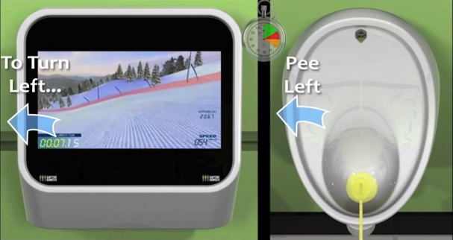
Figure Y. Captive Media screenshot, youtube id: XLQoh8YCqo4#t=44
The 2nd episode (“15 million merits”) of the dystopian Black Mirror BBC television series also illustrates several examples of the captive audience pattern. Each person’s bedroom is built out of display walls that are always on when that person is present (Figure Z). They can only be turned off temporarily by making a payment, or by leaving the room.
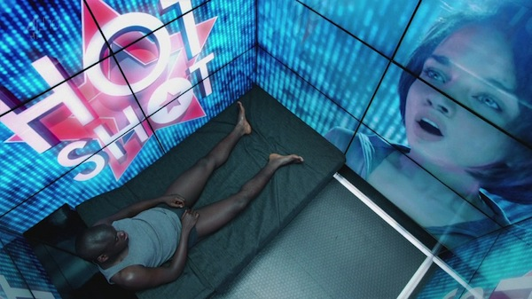
Figure Z. From Episode 2, Season 2 of Black Mirror, BBC.

2. The Attention Grabber
The person happens to pass by the field of view of a system (which may be strategically located), where the system takes deliberate action to attract and keep that person’s attention.
Attracting attention of a passer-by is an exceedingly common strategy used by anyone selling a product or service, where the goal is to turn the passerby into a customer. Carnival barkers, greeters in establishment doorways, aggressive street peddlers all verbally address a passer-by to try to get them to enter into a conversation. Establishments use storefronts and windows to promote their wares. Flashing lights and myriads of public signage and billboards (some electronic and digital) all compete for the passerby’s attention.
Proxemic aware public devices are perfectly poised to grab attention of passersby. Like barkers and greeters, they can sense the passerby as an opportunity, as well as gauge how well their attention-getting strategies are working by how the person responds (e.g., orientation indicating their attention is momentarily acquired, stopping movement, approaching, etc.)
The anti-utopian future depicted in the movie ‘Minority Report’ contains a scene where protagonist John Anderson is moving through a crowded hallway with multiple advertising walls that detect his presence. Each vies for his attention visually and audibly. For example, the ad wall for Guinness Draught shouts his name along with a directed message: “John Anderson, you could use a Guinness right about now”.

An example of a simple but compelling public display in this genre is the Nikon D700 Guerrilla-Style Billboard (Figure A). Located in a busy subway station in Korea, it displays life-size images of paparazzi that appear to be competing for the passerby’s attention. When the passerby is detected in front of the billboard, lights flash (as in the Figure below) to simulate flashing cameras. The red carpet leads to a store that sells the cameras being used.
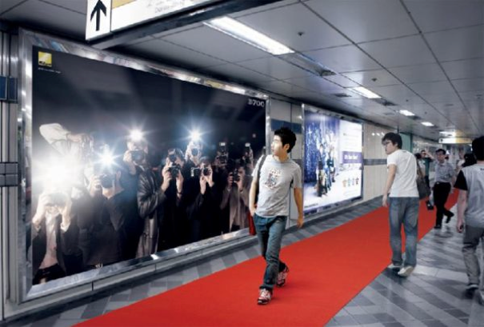
Figure A. The Nikon D700 Billboard. From http://www.thecoolhunter.net/architecture/70
Within advertising and marketing, this strategy is commonly referred to as AIDA, an acronym for: attract Attention, maintain Interest, create Desire, and lead customers to Action [Strong].
The Peddler Framework [Wang], itself an extension of the Audience Funnel [Michaelis], covers six interaction phases a person may be in, all which can be inferred by the proxemics measures of distance, motion, and orientation. Each phase indicates increasing (or decreasing) attention and motivation of the passerby.
- Passing by relates to anyone who can see the display.
- Viewing & reacting occurs once the person shows an observable reaction.
- Subtle interaction happens if the person intentionally tries to cause the display to react to their movement and gestures.
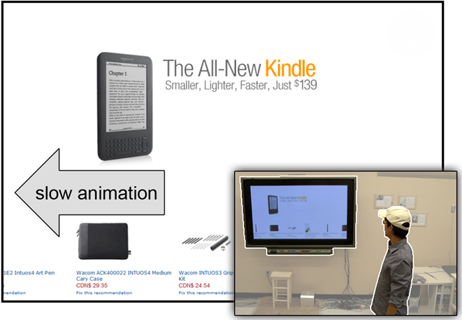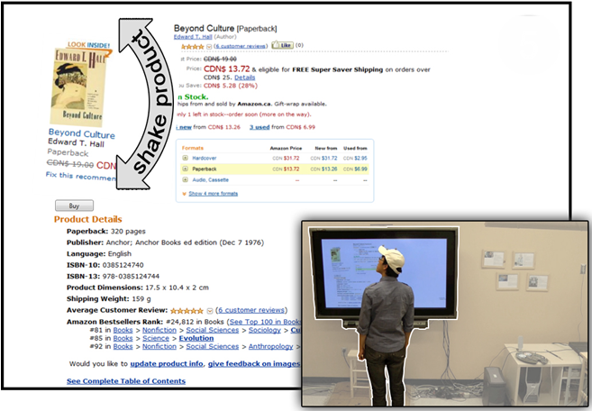
Figure B. Proximic Peddler. Left: Attention-attracting animation slows if passerby gazes at display. Right: Product graphic shakes to re-attract attention if person turns away.

- Direct interaction occurs when the person moves to the center of the display and engages with it in depth.
- Digressions and loss of interest occurs when a person either looks away from the display, or starts moving away from it.
- Multiple interactions occur when the person re-engages with the display.
- Follow-up actions happen after interactions with the display are completed.
Wang et. al. [Wang 2012] illustrate a proxemics-aware public advertising display for selling books. It exploits the phases above to attract and retain the attention of a passerby. For example, the initial attention of a passerby is attracted by rapid animation of a book list; once the passerby looks at the display, the animation slows down to become readable (Figure B, left). If the person approaches the display, various products are featured by growing in size. If the system detects them looking or moving away, it tries to regain the passerby’s attention using subtle animation (where particular displayed products shake) (Figure B, right) and by displaying other potentially interesting products.
While the above examples illustrate how proxemics displays can grab attention in an entertaining and perhaps subtle manner, they can also be obnoxious. An earlier version of the Proxemic Peddler would shout out loud audio messages to the passerby, and show flashing graphics. The more the display was ignored, the more insistent it became. The Black Mirror episode mentioned above shows an extreme example of a fascist Attention Grabber pattern within the context of a Captive Audience pattern: the display wall detects when the person is trying to shut out the displayed information by sensing if that person’s eyes are closed, or turned away; if so, it plays increasingly annoying sounds to force the person to look at the content.

3. Bait and switch
The system baits the viewer with something that is (from the viewer’s perspective) desirable, but the system then switches it to something else after the person directs his or her attention to it and moves closer.
Brignull et. al. characterizes this bait and switch dark pattern as follows:
“The user sets out to do one thing, but a different, undesirable thing happens instead. This is one of the oldest tricks in the book, and it is very broad in nature – many dark patterns involve some kind of bait & switch.” [Brignull et. al.]
Consider the case where a public display has gained a viewer’s attention because the viewer is in fact interested in the ‘bait’ being displayed (e.g., an apparently incredible offer). The viewer ‘opts-in’ by approaching the display. In turn, the display recognizes the viewer’s interest and offers further enticing details concerning its content. The viewer’s attention becomes increasingly focused. Once the viewer is fully drawn in, the system then switches to something else. A typical ‘switch’ would be to an inferior or more costly product purportedly because the initially advertised product is no longer available. Another switch may require the viewer to sign up to some otherwise unwanted service before the viewer can proceed (which could also become a security issue). Yet another switch is the introduction of other content (i.e., unexpected advertising) in this process. An example is Captive Media’s urinals mentioned above, where the ‘bait’ is the game, but the ‘switch’ is the advertising shown at the end of the game.

Figure DD: The ‘switch’ is the advertisement displayed at the end of the game depicted by the ‘bait’ in Figure Y above. Captive Media screenshot, youtube id: XLQoh8YCqo4#t=44
The overall problem is that users implicitly opt in by approaching the display. At the same time (and once users notice that they opted into something), there is only a possible recovery from that: moving away – meaning that all previously directed attention was useless.
Bait and switch also exists in other proxemic-aware systems that do not use public displays. Consider public wireless networks such as those at airports. They detect travelers within its range, and offer the bait of what appears to be free of charge wireless. Yet once a traveler is apparently connected, the network may require the traveler to give up information by signing in to some service, or the offered ‘free’ service may be so slow that the alternate higher quality pay service becomes enticing.

4. MAKING PERSONAL INFORMATION PUBLIC
As the person enters a particular area, the system makes that person’s personal information publicly visible.
One of the appeals of proxemic interactions is to make personal information readily available on nearby devices. For example, Dan Vogel’s original work on ambient displays illustrated how a large public ambient display reveals both public and personal information as a person approaches it, such as calendars, notifications, and messaging information [Vogel], which can then be manipulated by that person.
Vogel’s system is intended to be helpful. Yet the basic issue is that other onlookers can see that personal information. Vogel tried to mitigate this by describing how the person’s body could physically shield personal information presented directly in front, and how the person could hide information through an explicit gesture.
The previously mentioned scene from ‘Minority Report’ with the myriads of advertising walls make passerby’s private information public as a side effect of their clamor for the attention of passerby’s. We see the Guinness advertising wall (amongst others) publicly identify the protagonist by shouting out his name. Another advertising wall for what appears to be a credit card visually displays both the protagonist’s name and personal information about him (that he has been a member since 2037).
Making personal information public could be a design goal rather than a side effect. An example is the guerilla-style bus stop display produced for the Fitness First health club chain in Rotterdam (Figure B). The bench nearby the display contains a weight sensor, where the unsuspecting commuter’s weight is then publicly displayed on the bus stop’ wall. Its purpose is purportedly to embarrass people to join the health club by intentionally publicizing their weights.
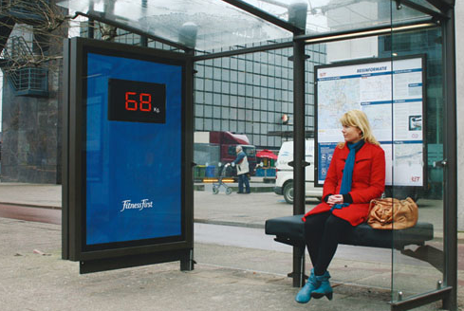
Figure B. The Fitness First health club display. From http://www.thecoolhunter.net/article/detail/1504/fitness-first--wait-watching, by Netherland N=5 ad agency.

5. We Never forget or Friends we would rather not have
In day to day life, proximity between people can be accidental. The relationship between parties – if any – may be momentary, where it dissolves as soon as the parties leave In contrast, systems can tag any proxemic interactions as indicating a permanent, persistent (and perhaps undesirable) relationship that is maintained after people leave.
There is a tremendous convenience in only having to enter the credentials for WiFi hotspots once on our devices, after which they are remembered forever. Nowadays, Android phones even sync these passwords to Google’s servers, so we can immediately connect our newly purchased devices to our favorite hotspots without having to enter a passphrase. Likewise, we expect to pair our phones once to our car’s hands-free Bluetooth system and from then on, have it automatically detected whenever we get into the car.
Bringing proxemics-aware devices close to each other can be a natural way of establishing a connection and exchanging information. Several interaction techniques have been proposed to exploit this idea. Connections can be made by bringing mobile devices together [Hinckley Bumping, Hinckley Stitching, Connectables], or by pointing at large displays from mobile devices [Ballendat2010]. Just like with pairing Bluetooth devices, users might prefer to just set up a connection once and have it maintained in the future.
While proxemic connections might allow us to easily connect to a multitude of devices to share data in a serendipitous way, many of these connections will be made to devices we do not control and will only be used once, unlike our trusted Bluetooth car audio system. Moreover, devices can be in proximity to each other (again) without the intention of setting up a connection.
The “we never forget” anti-pattern inadvertently uses users’ past connection history to automatically share their data when they are again in proximity to one of the previously connected devices. Unfortunately, this might be completely inappropriate in a different context.
For example, a user that previously used a public display to show some photos to friends, could have these photos inappropriately shared on the display again while walking past it with her colleagues. As another example, imagine a manager and an employee who bring their laptops close to each other to exchange a project report. A week later, the manager and employee sit next to each other in a meeting discussing the team’s progress. As their laptops get close to each other once again, the manager’s laptop automatically shares the currently opened document, which, in this case, is a sensitive spreadsheet with the wages of all team members.
This pattern is an anti-pattern, as it usually occurs as an unintended side effect of a lack of awareness about device connections and data exchange, and a lack of user control (implicit sharing).
The absence of reciprocity (if you share with me, I share with you) makes it easy to forget that we are sharing data with others, a common problem in groupware [Bellotti93]. This means that especially in the case of one-way sharing, additional feedback is needed. Bellotti et al. [Bellotti01] propose that systems that mediate between users should support accountability; they should provide awareness of other users and their actions [SpeakEasy Casca]. Proxemics sharing systems need to inform users about what information is being shared and when, and to whom this information is made available (who is making a connection? [Peirce]). Likewise, users need to know what will happen to their information once it is shared [Bellotti01], and what happens once the connection is destroyed.
Users should be provided with sufficient control over what they share. While implicit sharing is convenient and appropriate for some use cases, sharing via proximity paired with an explicit action [Hinckley Stitching, SyncTap, Pering] offers improved security and privacy.
This pattern can also turn into a dark pattern when the proxemics system exploits the user’s history in proxemic connections to other devices to automatically obtain personal information and build a rich user profile. Similar to the “one login for all” approach used by social networks such as Facebook or Google, public proxemics-aware displays could provide users with an option to easily connect to all displays when they connect to one of them.
Displays could track the user’s location when they walk past different displays and build rich personal profiles that could be shared between displays around the world. For example, Apple’s iBeacon indoor location technology (http://www.theverge.com/2013/12/6/5182938/apple-ibeacon-location-aware-shopping-hands-on) is already being deployed in retail stores and could be used to allow public displays to identify users. Additionally, the displays could expose personal information publicly in advertisements (e.g., a flashing message saying “Welcome back from your trip to Paris, John! You’re looking great! AirX, the only airline where you walk out more relaxed than before.”), similar to the “making personal information public” dark pattern.

DONE UNTIL HERE – THE FOLLOWING TEXT IS JUST NOTES OF THINGS WE MAY CONSIDER.

DISGUISED DATA COLLECTION
The system collects data about you as a function of your proximity to it
e.g., snapshots of face for future reuse in personalized ads
e.g., IDs of mobile phones, data extracted from mobile devices, etc.

The Milk Factor
The proxemics system forces you to move through or go to a specific location in order to get a service.
[JACKUB TO DO] The system, because of its location, requires the person to go to and move through a physical area that presents other options. E.g getting milk in a store…
THE SOCIAL NETWORK OF PROXEMIC CONTACTS or UNINTENDED RELATIONSHIPS
The system tracks your proxemics relations with others and constructs a social network on the assumption that you are somehow socially related, when in fact there is no relationship whatsoever.
Proxemics assumes that increasing social engagement (and thus a social relationship) is typically accompanied by decreasing physical distance, mutual orientation, etc. That is, social engagement leads to people adjusting these factors to their mutual benefit. Proxemic interaction systems does this somewhat backwards. They assume that same sensed phenomenon (decreasing physical distance, mutual orientation, etc.) signals social relationship, i.e., it treats the sensed phenomenon as causal. This assumption is not always correct. For example, in real life strangers may approach, and even glance at each, but no social relationship exists between them.
The assumption that all proxemic interactions imply a social relationship is problematic for a variety of reasons. Perhaps the most worrisome is that the underlying system may be trying to infer one’s social network from proxemic events between two people, where strangers are included. This scenario is not at all farfetched. In 2013, Edward Snowdon revealed the US National Security Agency’s controversial practice of tracking phone call metadata records (the number dialed, a cell phone’s location, time and duration of call, etc.). They used this information to compile sophisticated social network diagrams of Americans, ostensibly to identify and target terrorist networks. Even if one accepts this practice, innocent parties may be inadvertently included as ‘false positives’ in one’s social network, perhaps due to erroneous calls (wrong numbers) or innocuous calls.
It would be just as straightforward to create an equivalent social network by sensing one’s proximity to others. These two could easily include unintended relationships. For example, matches between location and time information in cell phone metadata records can be used to determine those people in the same proxemic vicinity, albeit coarsely. Other technologies can provide even more accurate data of one’s proximity to another, e.g., facial recognition systems identifying people in an environment. Similarly, concurrent presence by multiple people in front or passing by a device (such as a large display) may record that as a relationship.
Once created, the social network could be used for a variety of dark purposes. The social network could be exploited by authority to identify potential ‘suspects’ by their inferred association to an unsavory character. Marketers could use that social network to identify a potential target audience by their association with a known person fitting that profile. Spammers and phishers could exploit it for their own deceptive purposes. In all these cases, the agencies involved may not care that ‘false positives’ are included, where they may be treated as collateral damage or simply as noise.
While algorithms could perhaps detect and minimize the number of false positives, the social network will always include unintended relationships.
ROACH MOTEL / FORCED FOLLOW-THROUGH / BLACKMAILING
System forced you to complete its proxemics relations as you approach
Example: Information about you is displayed, but won’t be wiped until you follow the dialog to its completion
ACCIDENTAL PROXEMICS
[JO?]Exploits midas touch problem; just because you come close to something doesn’t mean you wanted to enter the relationship.
• "Imagine, for example, that homeowners wake one weekend, and come downstairs looking forward to their first cup of coffee and Cartalk on NPR. To their surprise, no sound emerges from their speakers. The reason is that their neighbors have purchased new Bluetooth-enabled speakers which, when first installed, associate themselves with the nearest sound source; in this case, the original homeowners' Bluetooth- enabled stereo. Meanwhile, the neighbors are abruptly awakened to tales of car repair." [quote from Keith Edwards' 2001 paper "At Home with Ubiquitous computing: seven challenges"]
• Proximity-aware car (first-hand experience): some Ford models take into account the proximity of car keys to automatically open the door when the key is nearby (e.g., in your pocket). This breaks the mental model of being able to check whether you’ve locked the car by trying to open the door (if it doesn't open, it's locked properly). In this case, the door will always open due to the proximity of the key in your hand or pocket.

DISCUSSION

ACKNOWLEDGMENTS
This work originated from a breakout session held at the Proxemics in Human-Computer Interaction seminar at Schloss Dagstuhl, Germany. The original attendees included the authors as well as <LIST HERE> - we thank them hugely for their insight and intellectual contributions to this work.

REFERENCES
- Alexander, Christopher (1977). A Pattern Language: Towns, Buildings, Construction. Oxford University Press
- Ballendat, T., Marquardt, N., and Greenberg, S. Proxemic Interaction: Designing for a Proximity and Orientation Aware Environment. Proc. of ITS'10, ACM (2010).
- [Bellotti93] Bellotti, V., & Sellen, A. (1993, January). Design for privacy in ubiquitous computing environments. In Proceedings of the Third European Conference on Computer-Supported Cooperative Work 13–17 September 1993, Milan, Italy ECSCW’93 (pp. 77-92). Springer Netherlands.
- [Bellotti01] Bellotti, V., & Edwards, K. (2001). Intelligibility and accountability: human considerations in context-aware systems. Human–Computer Interaction, 16(2-4), 193-212.
- Borchers, J. A Pattern Approach to Interaction Design. AI & Society, 12:359-376, Springer. (2001)
- Brignull, H. Dark Patterns: Deception vs. Honesty in UI Design. Interaction Design, Usability (Issue 338). Nov. (2011)
- Brignull, H., Miquel, M. and Rosenberg, J. Dark patterns Library. http:darkpatterns.org. Retrieved November, 2013
- Dourish, P. Where the Action Is: The Foundations of Embodied Interaction. MIT Press (2004)
- [Speakeasy Casca] Edwards, W. K., Newman, M. W., Sedivy, J. Z., Smith, T. F., Balfanz, D., Smetters, D. K., ... & Izadi, S. (2002, November). Using speakeasy for ad hoc peer-to-peer collaboration. In Proceedings of the 2002 ACM conference on Computer supported cooperative work (pp. 256-265). ACM.
- Gamma, E., Helm, R., Johnson, R. and Vlissides, J. Design Patterns: Elements of Reusable Object-Oriented Software. Pearson. (1994)
- Greenberg, S., Marquardt, N., et al. Proxemic interactions: the new ubicomp? interactions 18, ACM (2011), 42–50.
- Hall, E.T. The Hidden Dimension. Doubleday, N.Y, 1966.
- [Hinckley bumping] Hinckley, K. (2003, November). Synchronous gestures for multiple persons and computers. In Proceedings of the 16th annual ACM symposium on User interface software and technology (pp. 149-158). ACM.
- [Hinckley stitching] Hinckley, K., Ramos, G., Guimbretiere, F., Baudisch, P., & Smith, M. (2004, May). Stitching: pen gestures that span multiple displays. In Proceedings of the working conference on Advanced visual interfaces (pp. 23-31). ACM.
- Ju, W., et al. Range: exploring implicit interaction through electronic whiteboard design. Proc. of CSCW'08, ACM (2008).
- Koenig, Andrew (March/April 1995). "Patterns and Antipatterns". Journal of Object-Oriented Programming 8 (1): 46–48.
- Kortuem, G., et al. Sensing and visualizing spatial relations of mobile devices. Proc. of UIST'05, ACM (2005), 93-102
- Marquardt, N., Ballendat, T., Boring, S., Greenberg, S. and Hinckley, K. (2012) Gradual Engagement between Digital Devices as a Function of Proximity: From Awareness to Progressive Reveal to Information Transfer. In Proceedings of Interactive Tabletops a& Surfaces - ACM ITS. (Boston, USA), ACM Press, 10 pages, November 11-14.
- Marquardt, N. and Greenberg, S. (2012) Informing the Design of Proxemic Interactions. IEEE Pervasive Computing, 11(2):14-23, April-June.
- Marquardt, N., Hinckley, K. and Greenberg, S. (2012) Cross-Device Interaction via Micro-mobility and F-formations.. In ACM Symposium on User Interface Software and Technology - UIST'2012. (Cambridge, MA, USA), ACM Press, pages 13-22, October 7-10.
- Michelis, D. and Müller, J. The Audience Funnel: Observations of Gesture Based Interaction with Multiple Large Displays in a City Center, Int. J. HCI, 27 (6), 2011
- [Peirce] Pierce, J. S., Mahaney, H. E., & Abowd, G. D. (2003). Opportunistic annexing for handheld devices: Opportunities and challenges. In Proceedings of HCIC 2003.
- [Pering] Pering, T., Ballagas, R., & Want, R. (2005). Spontaneous marriages of mobile devices and interactive spaces. Communications of the ACM, 48(9), 53-59.
- [Synctap] Rekimoto, J., Ayatsuka, Y., & Kohno, M. (2003). SyncTap: An interaction technique for mobile networking. In Human-Computer Interaction with Mobile Devices and Services (pp. 104-115). Springer Berlin Heidelberg.
- Snibbe, S.S. et al. Social immersive media: pursuing best practices for multi-user interactive camera/projector exhibits. Proc. of CHI '09, ACM (2009), 1447–1456.
- E. K. Strong, The psychology of selling and advertising, New York: McGraw-Hill, 1925.
- [Connectables] Tandler, P., Prante, T., Müller-Tomfelde, C., Streitz, N., & Steinmetz, R. (2001, November). Connectables: dynamic coupling of displays for the flexible creation of shared workspaces. In Proceedings of the 14th annual ACM symposium on User interface software and technology (pp. 11-20). ACM.
- Vogel, D. et al. Interactive public ambient displays: transitioning from implicit to explicit, public to personal, interaction with multiple users. Proc. of UIST'04, ACM (2004).
- Wang, M., Boring, S. and Greenberg, S. (2012) Proxemic Peddler: A Public Advertising Display that Captures and Preserves the Attention of a Passerby. In Proceedings of the International Symposium on Pervasive Displays. (Porto, Portugal), ACM Press, 10 pages, June 4 - 5.
- Zagal, J., Bjork, S. and Lewis, C. Dark Patterns in the Design of Games. Proc. Foundation of Digital games, http://www.fdg2013.org/program/, May, 2013.

The columns on the last page should be of approximately equal length.
Remove these two lines from your final version.

