Dark Patterns in Proxemic Interactions:
A Critical Perspective
1st Author Name  Affiliation  Address  e-mail address  Optional phone number | 2nd Author Name  Affiliation  Address  e-mail address  Optional phone number | 3rd Author Name  Affiliation  Address  e-mail address  Optional phone number

ABSTRACT
Copyright notice.

.

Author Keywords
Dark patterns, proxemics interactions.

ACM Classification Keywords
H.5.m. Information interfaces and presentation (e.g., HCI): Miscellaneous.

INTRODUCTION
Authors of human computer interaction papers concerning innovative design ideas tend to forward their central idea in a positive – often highly idyllic – light. True critical perspectives are rarely offered. When they are, they tend towards a few cautionary lines in the discussion, or relegated to future work where its actual use would be examined. The problem is that many of our new innovations involve designing for ubiquitous computing situations that are extremely sensitive to intentional or unintentional abuse (e.g., privacy, distraction and intrusion concerns). Rather than wait until some future field study of our technology (where it may be too late to address emerging concerns), we should be considering the ‘dark side’ of our technologies at the outset.
The particular innovation we are concerned with is proxemic interactions, which was inspired by Hall’s Proxemic theory [Hall]. The theory explains people’s understanding and use of interpersonal distances to mediate their interactions with others. In proxemic interactions, the intent is to design systems that will let people exploit a similar understanding of their proxemic relations with their nearby digital devices to facilitate more seamless and natural interactions [Greenberg & Marquardt, 2011]. This is especially important as we become immersed in ubiquitous computing ecologies, i.e., where we carry and are surrounded by myriads of devices, all potentially capable of interacting with one another. Examples include: mobile devices that understand their spatial relations to mediate information exchange between nearby devices [Kortuem; Marquardt, Hinckley et. al.]; large displays that react to people’s position relative to them to adjust what is shown and how people interact with it [Vogel, Ju, Marquardt & Ballendat]; public art installations that respond to the movement and proximity of people within its sphere to affect what is shown [Snibbe]; application areas such as home media players that monitors the distance and orientation of its viewers to dictate what is shown [Ballendat], and information visualizations that tune their visuals to people’s position relative to them [Isenberg IEEE TVCG?]. The literature also includes more general essays about the role of proxemics, such as how it can address well-known challenges in Ubicomp design [Marquardt & Greenberg].
Yet it is clear, at least intuitively, that there is a dark side to proxemics interactions. For example, the systems above rely on sensing information about people, their devices, and the surrounding environment. Indeed, [Greenberg & Marquardt, 2011] describe several sensed dimensions that would be valuable to system design: distance, orientation, and movement of entities relative to one another, the identity of these entities and contextual information about the location. While their purposes are honorable, such sensing immediately raises concerns about privacy by experts and non-experts alike. As well, dystopian visions of the future hint at abuses of such technologies – a well-known example is the movie Minority Report that illustrates how a character is bombarded by targeted advertisements as he moves through a public hallway.
In this paper, we revisit the idea of proxemic interactions, where our goal (and contribution) is to present a critical perspective – the dark side – of this technology. Our method is to articulate potential dark patterns indicating how we think this technology can be – and likely will be – abused. To avoid being overly broad, we focus our scope somewhat to people’s proxemic interactions with large (and mostly public) displays, although we do illustrate other examples as needed.

Dark Patterns
Architect Christopher Alexander introduced the notion of design patterns, where a pattern is a documented reusable and proven solution to an architectural design problem. Design patterns are typically derived by examining existing solutions to design problems (which may include ‘folk’ solutions) and generalizing them. Design patterns were later advocated as a way of describing common solutions to typical software engineering problems [Gamma], as well as interaction designs [Borchers].
Patterns usually comprise several elements [Gamma]:
- A pattern name that meaningfully describes the design problem, where the set of names create a vocabulary that eases discussion and communication;
- A problem that explains the problem and its context, and thus when the pattern should be applied to it;
- A solution that is an abstract description of how the problem is solved;
- Consequences that are the results and tradeoffs of applying the pattern.
A dark pattern is a special kind of pattern, defined by [Brignull et. al.] as:
“a type of user interface that appears to have been carefully crafted to trick users into doing things [where] they are carefully crafted with a solid understanding of human psychology, and they do not have the user’s interests in mind”.
Brignull et. al. created a web-based library of dark patterns concerning intentionally deceptive e-commerce practices, Their specific goal was to recognize and name these practices so that people would be aware of a dark pattern in an interface, and to shame the companies using them. For example, they describe a ‘hidden cost’ pattern that “occurs when a user gets to the last step of the checkout process, only to discover some unexpected charges have appeared, e.g. delivery charges, tax, etc.”, where they provide several specific examples (and name companies) that use that pattern [Brignull et. al.].
In the remainder of this paper, we apply this notion of dark patterns somewhat more broadly. We articulate not only possible deceptions and misuses of proxemics interactions, but problems that may appear even when the designer has reasonable intentions. Unlike true patterns that are based on analyzing a broad variety of existing solutions, we construct patterns based on several sources. We consider the dark side of existing commercial and research products directly or indirectly related to proxemics interactions, dark portrayals of such technologies foreshadowed by in the popular literature and cinema, and our own reflections of where misuses could occur. That is, our dark patterns are a mix of those that describe existing abuses and that predict possible future ones. While the newness of proxemics interaction systems make pattern elicitation somewhat of a thought exercise (albeit grounded in existing examples where possible), we believe this approach appropriate for thinking about – and ideally mitigating – the dark side of our future technologies before actual deceptive patterns appear in practice. As part of our investigation, we revisited Brignull’s dark patterns to see if and how they could be applied to proxemic interactions (possibly as variations). We also looked at emerging uses of proxemics in commercial and experimental products, and considered concerns raised in the proxemics literature or in related areas.
As we will see, there are several common issues that are common to many of our dark patterns,
- Opt-in can happen implicitly by simply entering a space;
- Physical space is imbued with dual meanings, i.e., peoples’ practices and expectations of the physical space can be quite different from the meaning and practice applied by the technology;
- Ownership of the physical space is ambiguous;
- Attention is inherently sought after in proxemics interactions;
- …

The Captive Audience
The person enters a particular area to pursue an activity that takes a given time, and that does not involve the system. The system senses the person at that location, and begins an unsolicited (and potentially undesired) action based on the fact that the person is now captive.
Unlike desktop computers, technology can be spatially located in an environment to leverage a person’s expected patterns and routines. When done for beneficial purposes, the technology enhances or supports what the person normally does at that location – indeed, this is one of the basic premises of embodied interaction [Dourish]. The captive audience dark pattern instead exploits a person’s expected patterns and routine for its own purposes, where the system knows that the person cannot leave without stopping what they otherwise intended to do.
Commercial products already exist that use the captive audience pattern. Novo Ad (www.novoad.com), for example, produces advertising mirrors that display video ads on mirror-like screens ranging from 21 – 52”. Their web site states:
“the system serves as a mirror screen which identifies figures standing in front of it and switches itself automatically on. At start-up the screen displays a 6 second long ad on a full screen, which is later reduced to ¼ of the screen”. [www.novoad.com]
Novo Ad identifies public toilets as one of the prime locations for their displays, and even created a promotional video showcasing their technology in a woman’s toilet as illustrated in Figure X below. The woman becomes the captive audience, as her primary task is to use the sink and mirror for grooming. The video ad, which starts on her approach, is the unsolicited system action. We have also experienced a similar system placed atop of men’s urinals, where there is even less option for the unwilling participant to walk away. Other captive locations listed by Novo Ad include dressing rooms and elevators.

Figure X. Novo Ad screenshot, youtube id: PXwbacfAwnY
Captive Media, a British company, takes this one step further [www.captivemedia.co.uk]. They estimate that a man using a urinal is captive for ~55 seconds. Their above-urinal screen (Figure X, left) uses proximity and ‘stream’ sensors “to detect the position of a man’s stream as he pees” (Figure Y, right). This information is then used to activate advertising-sponsored pee-controlled games as illustrated in Figure Y.
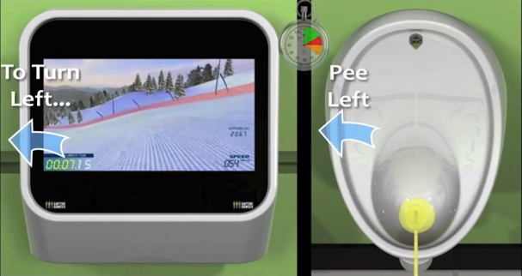
Figure Y. Captive Media screenshot, youtube id: XLQoh8YCqo4#t=44
The 2nd episode (“15 million merits”) of the dystopian Black Mirror BBC television series also illustrates several examples of the captive audience pattern. Each person’s bedroom is built out of display walls that are always on when that person is present (Figure Z). They can only be turned off temporarily by making a payment, or by leaving the room.
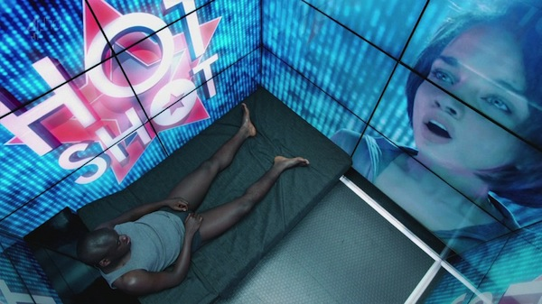
Figure Z. From Episode 2, Season 2 of Black Mirror, BBC.

The Attention Grabber
The person happens to pass by the field of view of a system (which may be strategically located), where the system takes deliberate action to attract and keep that person’s attention.
Attracting attention of a passer-by is an exceedingly common strategy used by anyone selling a product or service, where the goal is to turn the passerby into a customer. Carnival barkers, greeters in establishment doorways, aggressive street peddlers all verbally address a passer-by to try to get them to enter into a conversation. Establishments use storefronts and windows to promote their wares. Flashing lights and myriads of public signage and billboards (some electronic and digital) all compete for the passerby’s attention.
Proxemic aware public devices are perfectly poised to grab attention of passersby. Like barkers and greeters, they can sense the passerby as an opportunity, as well as gauge how well their attention-getting strategies are working by how the person responds (e.g., orientation indicating their attention is momentarily acquired, stopping movement, approaching, etc.)
An example of a simple but compelling public display in this genre is the Nikon D700 Guerrilla-Style Billboard (Figure A). Located in a busy subway station in Korea, it displays life-size images of paparazzi that appear to be competing for the passerby’s attention. When the passerby is detected in front of the billboard, lights flash (as in the Figure below) to simulate flashing cameras. The red carpet leads to a store that sells the cameras being used.
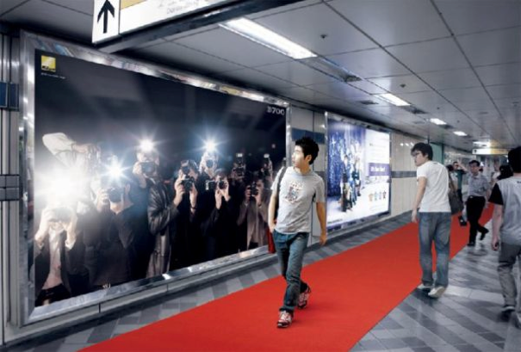
Figure A. The Nikon D700 Billboard. From http://www.thecoolhunter.net/architecture/70
Within advertising and marketing, this strategy is commonly referred to as AIDA, an acronym for: attract Attention, maintain Interest, create Desire, and lead customers to Action [Strong].
The Peddler Framework [Wang], itself an extension of the Audience Funnel [Michaelis], covers six interaction phases a person may be in, all which can be inferred by the proxemics measures of distance, motion, and orientation. Each phase indicates increasing (or decreasing) attention and motivation of the passerby.
- Passing by relates to anyone who can see the display.
- Viewing & reacting occurs once the person shows an observable reaction.
- Subtle interaction happens if the person intentionally tries to cause the display to react to their movement and gestures.
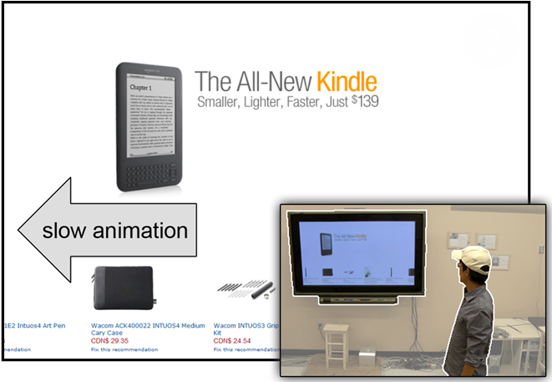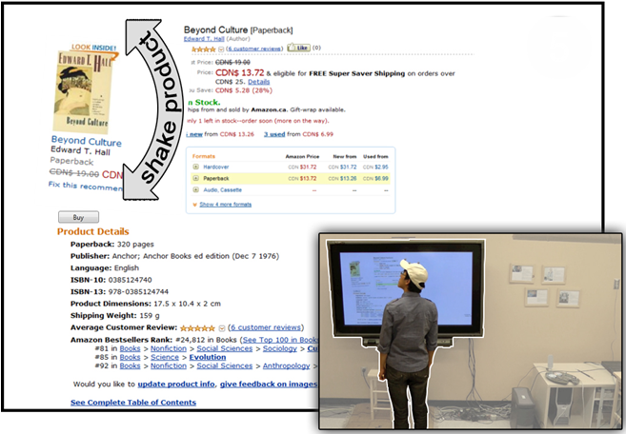
Figure B. Proximic Peddler. Left: Attention-attracting animation slows if passerby gazes at display. Right: Product graphic shakes to re-attract attention if person turns away.

- Direct interaction occurs when the person moves to the center of the display and engages with it in depth.
- Digressions and loss of interest occurs when a person either looks away from the display, or starts moving away from it.
- Multiple interactions occur when the person re-engages with the display.
- Follow-up actions happen after interactions with the display are completed.
Wang et. al. [Wang 2012] illustrate a proxemics-aware public advertising display for selling books. It exploits the phases above to attract and retain the attention of a passerby. For example, the initial attention of a passerby is attracted by rapid animation of a book list; once the passerby looks at the display, the animation slows down to become readable (Figure B, left). If the person approaches the display, various products are featured by growing in size. If the system detects them looking or moving away, it tries to regain the passerby’s attention using subtle animation (where particular displayed products shake) (Figure B, right) and by displaying other potentially interesting products.
While the above examples illustrate how proxemics displays can grab attention in an entertaining and perhaps subtle manner, they can also be obnoxious. An earlier version of the Proxemic Peddler would shout out loud audio messages to the passerby, and show flashing graphics. The more the display was ignored, the more insistent it became. The Black Mirror episode mentioned above shows an extreme example of a fascist Attention Grabber pattern within the context of a Captive Audience pattern: the display wall detects when the person is trying to shut out the displayed information by sensing if that person’s eyes are closed, or turned away; if so, it plays increasingly annoying sounds to force the person to look at the content.

DONE UNTIL HERE – THE FOLLOWING TEXT IS JUST NOTES OF THINGS WE MAY CONSIDER.

Bait and switch
The system baits the viewer with something that is (from the viewer’s perspective) desirable, but the system then switches it to something else after the person directs his or her attention to it and moves closer.
“The user sets out to do one thing, but a different, undesirable thing happens instead. This is one of the oldest tricks in the book, and it is very broad in nature – many dark patterns involve some kind of bait & switch.” [Brignull et. al.]
Issue. By approaching something you are automatically opting in, where the information misleads you to opting into something you don’t want.
Example: Public display with children’s cartoons that switches to selling cartoon caricatures when you get closer.

DISGUISED DATA COLLECTION
The system collects data about you as a function of you attending to it (orientation and distance), i.e., misdirection or hiding as to its purpose
http://www.thecoolhunter.net/article/detail/1504/fitness-first--wait-watching
e.g., snapshots of face for future reuse in personalized ads
e.g., IDs of mobile phones, data extracted from mobile devices, etc.

The Milk Factor
The proxemics system forces you to move through or go to a specific location in order to get a service.
The system, because of its location, requires the person to go to and move through a physical area that presents other options. E.g getting milk in a store…

We Never forget or the cookie syndrom OR Friends we would rather not have
Whereas proximity implies a transient relationship, the system retains that information to create a permanent (perhaps undesirable) relationship.i.e we expect to opt out by leaving, but in fact we cannot.
e.g., data sharing between mobile devices or with a large display in one case, leads to automatic sharing when its approached next
THE SOCIAL NETWORK OF PROXEMIC CONTACTS / DATA MINING / Unintended relationships?
The system tracks your proxemics relations with others and constructs a social network on the assumption that you are somehow socially related.
Example: Virus Spam, disease transmission like existing social networks (ads, data mining)
Example: joint use of a proxemics device (e.g., particular public display) creates a social network of its users.
ROACH MOTEL / FORCED FOLLOW-THROUGH / BLACKMAILING
System forced you to complete its proxemics relations as you approach
Example: Information about you is displayed, but won’t be wiped until you follow the dialog to its completion
ACCIDENTAL PROXEMICS
Exploits midas touch problem; just because you come close to something doesn’t mean you wanted to enter the relationship.

DISCUSSION

ACKNOWLEDGMENTS
This work originated from a breakout session held at the Proxemics in Human-Computer Interaction seminar at Schloss Dagstuhl, Germany. The original attendees included the authors as well as <LIST HERE> - we thank them hugely for their insight and intellectual contributions to this work.

REFERENCES
- Alexander, Christopher (1977). A Pattern Language: Towns, Buildings, Construction. Oxford University Press
- Ballendat, T., Marquardt, N., and Greenberg, S. Proxemic Interaction: Designing for a Proximity and Orientation Aware Environment. Proc. of ITS'10, ACM (2010).
- Borchers, J. A Pattern Approach to Interaction Design. AI & Society, 12:359-376, Springer. (2001)
- Brignull, H. Dark Patterns: Deception vs. Honesty in UI Design. Interaction Design, Usability (Issue 338). Nov. (2011)
- Brignull, H., Miquel, M. and Rosenberg, J. Dark patterns Library. http:darkpatterns.org. Retrieved November, 2013
- Dourish, P. Where the Action Is: The Foundations of Embodied Interaction. MIT Press (2004)
- Gamma, E., Helm, R., Johnson, R. and Vlissides, J. Design Patterns: Elements of Reusable Object-Oriented Software. Pearson. (1994)
- Greenberg, S., Marquardt, N., et al. Proxemic interactions: the new ubicomp? interactions 18, ACM (2011), 42–50.
- Hall, E.T. The Hidden Dimension. Doubleday, N.Y, 1966.
- Ju, W., et al. Range: exploring implicit interaction through electronic whiteboard design. Proc. of CSCW'08, ACM (2008).
- Kortuem, G., et al. Sensing and visualizing spatial relations of mobile devices. Proc. of UIST'05, ACM (2005), 93-102
- Marquardt, N., Ballendat, T., Boring, S., Greenberg, S. and Hinckley, K. (2012) Gradual Engagement between Digital Devices as a Function of Proximity: From Awareness to Progressive Reveal to Information Transfer. In Proceedings of Interactive Tabletops a& Surfaces - ACM ITS. (Boston, USA), ACM Press, 10 pages, November 11-14.
- Marquardt, N. and Greenberg, S. (2012) Informing the Design of Proxemic Interactions. IEEE Pervasive Computing, 11(2):14-23, April-June.
- Marquardt, N., Hinckley, K. and Greenberg, S. (2012) Cross-Device Interaction via Micro-mobility and F-formations.. In ACM Symposium on User Interface Software and Technology - UIST'2012. (Cambridge, MA, USA), ACM Press, pages 13-22, October 7-10.
- Michelis, D. and Müller, J. The Audience Funnel: Observations of Gesture Based Interaction with Multiple Large Displays in a City Center, Int. J. HCI, 27 (6), 2011
- Snibbe, S.S. et al. Social immersive media: pursuing best practices for multi-user interactive camera/projector exhibits. Proc. of CHI '09, ACM (2009), 1447–1456.
- E. K. Strong, The psychology of selling and advertising, New York: McGraw-Hill, 1925.
- Vogel, D. et al. Interactive public ambient displays: transitioning from implicit to explicit, public to personal, interaction with multiple users. Proc. of UIST'04, ACM (2004).
- Wang, M., Boring, S. and Greenberg, S. (2012) Proxemic Peddler: A Public Advertising Display that Captures and Preserves the Attention of a Passerby. In Proceedings of the International Symposium on Pervasive Displays. (Porto, Portugal), ACM Press, 10 pages, June 4 - 5.

The columns on the last page should be of approximately equal length.
Remove these two lines from your final version.

