Worked Example of Results Synthesis

What we need before starting
This worked example of results synthesis follows the heuristic evaluation of the TravelWeather interface from [6] Nielsen, J. (1993). Usability Engineering, p 273-274, as shown below. The referenced pages give a description of how the TravelWeather interface works.
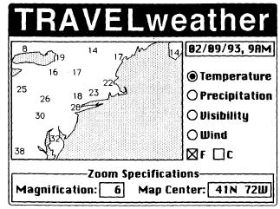

From the heuristic evaluation, we should have the following as input to results synthesis:
- Raw data fragments of individual problems found in the interface (and recommended courses of action if available) by the individual evaluators participating in heuristic evaluation
  - Each raw problem description should be written on a single index card, with the title of which heuristic it belongs to at the top, big enough to see from a few meters away. (This allows for visibility when many people are working together to rearrange and group the raw data).
- We will have the original interface (ie. TravelWeather) to reference to
- We should have at least the original evaluators that participated in heuristic evaluation to participate in results synthesis. The more participants that are involved, such as end users, developers, documentation specialists, etc, the more successful this process will be.

Materials to do the exercise
For this exercise, we assume that results synthesis will be done in a paper-based environment. The materials required for this exercise may vary, depending on the specific location that results synthesis will be conducted. Materials include:

- Markers, pens/pencils to annotate and mark the workspace
- Sticky notes that contain raw data fragments from heuristic evaluation
- A whiteboard or a round table to use as the workspace
  - Using a whiteboard allows everyone to see without orientation issues (unlike the use of a table) and allows participants to mark up the workspace

Timeline
To demonstrate the process of results synthesis, at least an hour is needed to show the idea of how discussion and interpretation forms through the process of emergence. However, for the purposes of our class, we will attempt to complete the exercise in approximately 15-20 minutes. Please keep this in mind when performing the exercise.

Participants
All students in the class will act as participants in the process of results synthesis. For participants, we should at least have the original evaluators that performed the heuristic inspection. In addition, some participants can be assigned the role of end users and some the role of developers.

The Exercise
As input, we will use the raw problems gathered from heuristic evaluation by the individual evaluators of the TravelWeather interface. As output, we will generate a final report containing a unified list of concise problem descriptions, their severity and recommended courses of action.

The following illustrates an example of the stages of results synthesis.

Step 1: Spread out all problems in the workspace. This provides an overview of all the problems found by the individual evaluators.
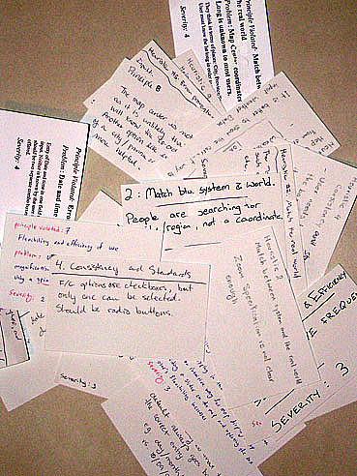
Figure 1: All heuristic problems

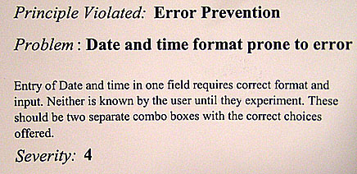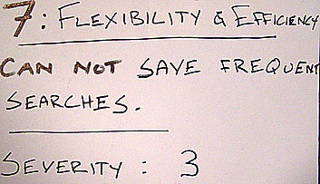

Figure 2: Example of individual heuristic problems.

Step 2: Group the individual problems by heuristic. At this stage, there may not be a common consensus as to which problem belongs to which heuristic. Evaluate and discuss the entire data collection with other participants. Notice your contribution and how it relates to the contribution to others. Get a single understanding of the whole collection and how everything relates together. Duplicates may be found and put side by side.
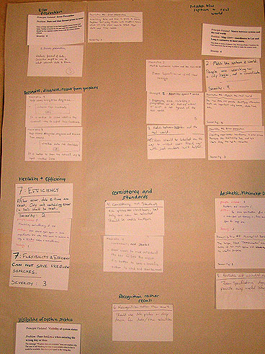
Figure 3: First global grouping – by heuristic.

Step 3: Emergence of a new understanding and interpretation of the data. Here, participants take individual problems and come up with a more insightful organization of problems than the mere concatenation of the individual views. In this step, participants may iteratively reorganize and refine to achieve what they believe to be the best conceptualization and grouping of the problems. Participants may try to minimize the amount of problems by stacking similar problems together, where the problem at the top is the best representative of the problem and possible solution. Participants may use spatial proximity to show relationships between the problems and mark up the workspace in meaningful ways. Problems may get moved to new groups or obtain new labels.

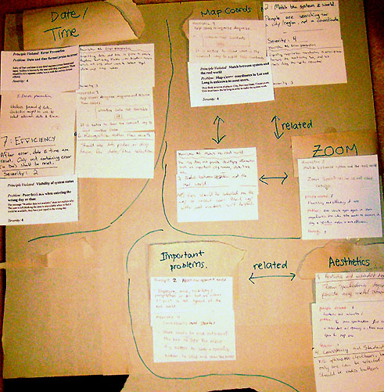
Figure 4: Grouping and re-grouping to find the best conceptual model of problems

Step 5: Finally, a consensus will be reached about the best possible grouping. From this grouping, participants tried to discover the root causes of the problems in a high-level manner, rather than only considering the symptoms. (For example, if there are many problems related to finding a city on the map, the root cause of the problem is awkward map navigation rather than low-level problems like “better error messages”.)

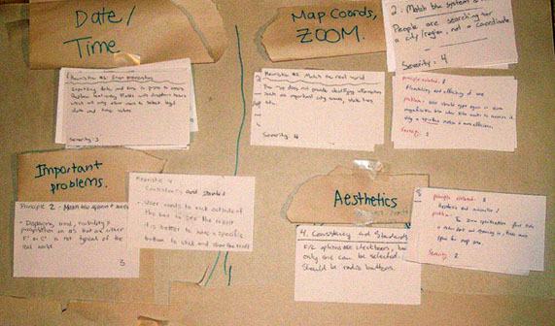
Figure 5: Consensus reached about final grouping.

Step 6: Interpretation of results by turning the groupings into detailed problem reports to give to developers. For each problem, the report should contain a full description of:
- What is the problem? (Write in terms of users and their tasks)
- Severity of the problem. Who does the problem affect?
- Suggested course of action. May also include alternate solutions.

(EXAMPLE 1)
Example of 5 individual, raw heuristic problems:

1. (good error messages)
Unknown map coordinates” is not precise.
Should repeat user’s input and give different error messages depending on error

2. (prevent errors)
More forgiving in longitudes and latitudes.

3. (simple and natural dialog)
Magnification factor is obscure. Unsure what it means. Zoom slider better.

4. (simple and natural dialog)
Navigation about map is awkward. Coords and zoom box are confusing. Use zoom slider instead.

5. (speak user’s language)
Not comfortable using coords. Allow user to click and zoom in.

Observations:
From these individual problems, we may develop an insight that the root cause of these problems is an awkward map navigation system. All of these problems can be removed if a completely different way of interacting with the map was possible.

Example problem description:

Problem description #1:
Centering and zooming into the map is awkward as users will not be knowledgeable about what longitude and latitude coordinates to use in defining the map center and do not know what to use as the appropriate magnification factor to get the desired zoom.
Severity:
4 = Usability catastrophe. This is a fundamental and frequent task that all users will be expected to perform.
Recommended course of action:
Remove the groupbox “Zoom specifications” including the textboxes for “Map Center” and “Magnification”. Instead, allow users to both center and zoom into the map by a constant, default amount by double-clicking with the left-mouse button directly on the area of the map they wish to center and zoom into.

(EXAMPLE 2)
Example of 4 individual, raw heuristic problems:

1. (visibility of system status)
Poor feedback when entering wrong day or time. Message “Weather data not available” does not explain why. The user is left thinking that the data is unavailable when in fact it could be available, they have just typed in the wrong day.

2. (efficiency)
After error, date and time are reset. But, only unit containing error (ie. day) should be reset.

3. (prevent errors)
The day/month/year date format may be misinterpreted by foreign tourists. One way of avoiding this problem is to represent months by their name instead of their number.

4. (recognition rather than recall)
Should use date picker or drop down for date/time selection.

Observations:
From these individual problems, we may develop an insight that the root of these problems an inefficient date/time input system. If we use a drop-down menu instead of user input, all of these problems can be avoided.

Example problem description:

Problem description #2:
Having the users enter a ‘date/month/year’ format for the day they wish to see the weather for is inefficient and prone to error.
Severity:
4 = Usability catastrophe. This is a fundamental and frequent task that all users will be expected to perform.
Recommended course of action:
Instead of an editable text-box to enter the ‘date/month/year’, use a drop-down menu with the allowable choices for dates and times. This prevents all erroneous input and allows options for “Today” and “Tomorrow”.

Step 7: Finalize the separate reports into single report format to give to developers.

REFERENCES

[1] Nielsen, J. (1993). Usability Engineering. Academic Press, p 273-274 (TravelWeather interface example).

[2] Examples of raw data gathered are from a CPSC681 in-class heuristic evaluation exercise of the TravelWeather interface.

FIGURES

Figure 1: All heuristic problems
Figure 2: Example of individual heuristic problems
Figure 3: First global grouping – by heuristic.
Figure 4: Grouping and re-grouping to find the best conceptual model of problems
Figure 5: Consensus reached about final grouping.

