CPSC 681 Topic
Home Page Usability
A heuristic evaluation method

Yibo Sun
Oct. 24, 2007

Introduction to home page usability 1
Evaluation method 1
Guidelines 1
Conventions 2
Advantages and shortcomings of this method 3
A concrete evaluation of worked example 3
A quick evaluation with guidelines 5
A quick evaluation with conventional home page design principles 13
A complete walk through 14
References 21

Introduction to home page usability
The home page is the door to a website and thus becomes its most important page. A well designed home page gives users a good impression and thus attracts users’ interests and attentions. A badly designed home page, on the other hand, will encourage users to leave the site without further exploration. Thus home page design is critical. Within this context, design encompasses aesthetical appearance and usability, where people can easily find and access to information they are interested in. A good looking home page with low usability is still a failure.

Evaluation method

Guidelines
Nielsen and Tahir (2001) developed a heuristic evaluation method for home page usability. They propose 113 guidelines that formulate good home pages. To paraphrase Nielsen and Tahir’s (2001) explanation (p. 7), these guidelines were observed in their practice to do consulting services to review home pages. These guidelines can be used as a checklist to design a new home page. Users can also be involved in usability testing to give feed back to the iterative development cycle.
These heuristic principles are easy to apply to any home page in real world because they are very specific. For example, the first guideline (Nielsen & Tahir, 2001, p. 10) “Show the company name and/or logo in a reasonable size and noticeable location” says that the site logo should be large enough to get attention of users and the best placement of the logo is usually the upper-left corner. Therefore, we can see that this is a very specific and clearly stated instruction and there is no ambiguity at all about this rule of thumb.
Not all guidelines can be applied to every home page design depending on the purpose and nature of the website. For example, one of the guidelines (Nielsen & Tahir, 2001, p. 19) “If you have a shopping cart feature on your site, include a link to it on the home page” obviously cannot be applied to every home page because only a online shopping web site has a shopping cart feature. Therefore, inapplicable guidelines should be excluded when a home page is evaluated.
As Nielsen and Tahir (2001) suggested, a home page can be marked by a list of applicable guidelines selected from the 113 guidelines. Count 0 point for violation to one guideline, ½ point for partial compliance to a guideline and 1 point for fully following one guideline. If a home page scores over 80% in all applicable guidelines, it is in good shape and only needs some minor fixes. If the score lies between 80% and 50%, the home page needs to be redesigned but it is not considered a disaster. If it scores below 50%, this home page is a complete failure and it should be abandoned.
A concrete example is included at the end this paper in which the home page of Acadia University’s website is evaluated. To foreshadow our worked example, we can apply the second guideline “Include a tag line that explicitly summarizes what the site or company does” (Nielsen & Tahir, 2001, p.10) to the University of Calgary home page. In the upper left part of the page shown Figure 1, we can see the tag line “U of C. THIS IS NOW”. This tag line is not good because no one can know what it means and it fails to tell users what this university offers. A better tag line could be “one of the top research intensive universities in Canada”. It will tell the users that this university offers research intensive learning environment to students. It will also comply with the third guideline “Emphasize what your site does that’s valuable from the user’s point of view, as well as how you diff from competitors” (Nielsen & Tahir, 2001, p.10) and communicate to the users that the university is a better place to do research and graduate studies.
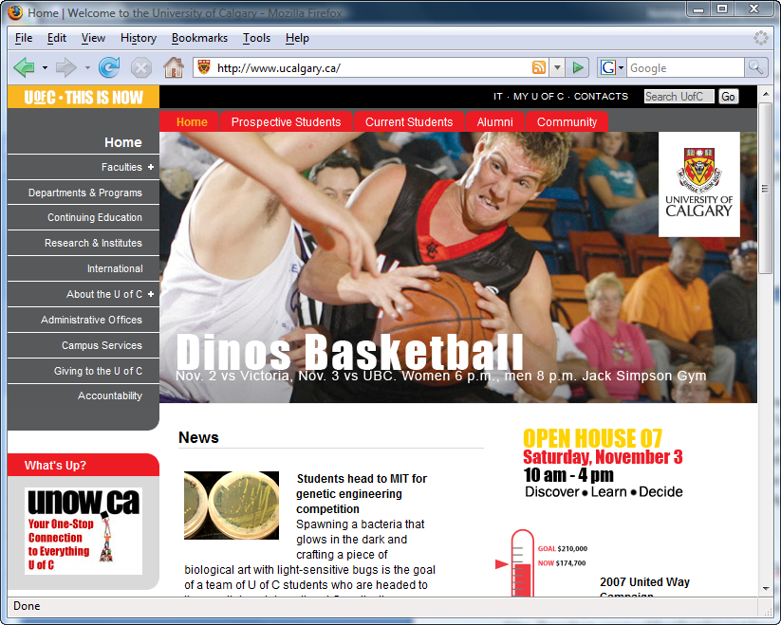
Figure 1 (www.ucalgary.ca screen shot)

Conventions
The law of internet user experience (Nielsen & Tahir, 2001, p.37) tells “Users spend most of their time on other sites than your site” because a user has visited numerous web sites and been used to the standard or prevalent design conventions which most sites use before she arrives at your web site for the first time. Therefore, users will feel familiar and friendly if these conventional design patterns are followed in a home page that they visit for the first time.
Conventions in home page design exist and they can be revealed by statistical analysis. Nielsen and Tahir (2001) analyzed 50 well known home pages and presented some statistical data. These statistical numbers are significant because people visit the 50 famous web sites very frequently and spend a lot of time on their home pages.
Like the 113 guidelines, these conventions illustrated by these statistical numbers are straightforward and easy to apply. For example, Nielsen and Tahir (2001) analyzed the placement of search function on the 50 home pages and found that 81% of the home pages have a search feature represented as a box for users to type a query and 35% of the pages, which is the largest portion, place the search in the upper right corner (p.41). Again, we look at the home page of University of Calgary in Figure 1; the home page has a search box in the upper right corner. Thus a user can easily locate the search function in the conventional place if she arrives at the home page of University of Calgary for the first time because this home page follows this convention well.

Advantages and shortcomings of this method
On the positive side, these guidelines and conventions are simple, specific and straightforward. The easiness to apply to real world instances has been shown with the example of the home page of University of Calgary.
However, they are not axioms (Nielsen & Tahir, 2001, p. 7). There are always exceptions in all sites so that a few guidelines are broken for some reasons. These guidelines can point out possible usability problems but cannot indicate how severe a problem is for a certain case. Thus, a violation can be a usability issue in one home page but it may be not a real problem at all in another home page depending on the specific situation. Moreover, conventions should not always be followed because sometimes most home pages may all follow a certain kind of bad design convention. For example, 82% of example home pages given by Nielsen and Tahir (2001) use a frozen page layout but it is obviously better to use a liquid layout. On the other hand, these rules provide a basic framework of home page usability but define only a limited subset of usability practice. Thus they cannot cover every single aspect although they are comprehensive based on practice and analysis of real cases. Therefore, they should be generally followed but not constrained to.

A concrete evaluation of worked example
Acadia University is a small university located in Wolfville, Nova Scotia. It was established in 1838 as a university with an emphasis upon undergraduate study in the liberal arts. The university currently enrols more than 3200 full-time students.
Acadia University’s home page is not very successful. The major weakness is the cluttered interface with a frozen layout. This page has a lot of images but insufficient contents. It is very hard for users to find the useful information they need on the home page. Several obvious errors on the page tend to give users a bad impression on the university.
Figure 2 is the screen shot of the upper portion of the home page of Acadia University and Figure 3 is the screen shot of the lower portion of the page.
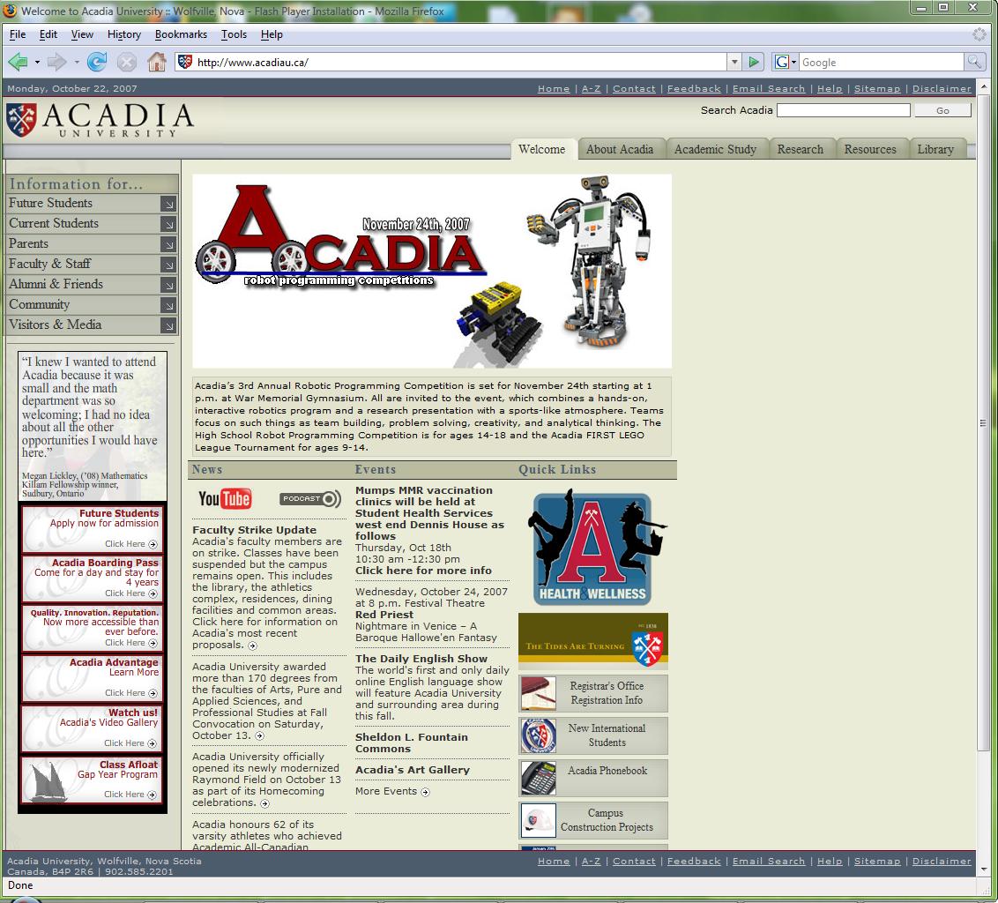
Figure 2 (screen shot of upper portion of www.acadiau.ca)
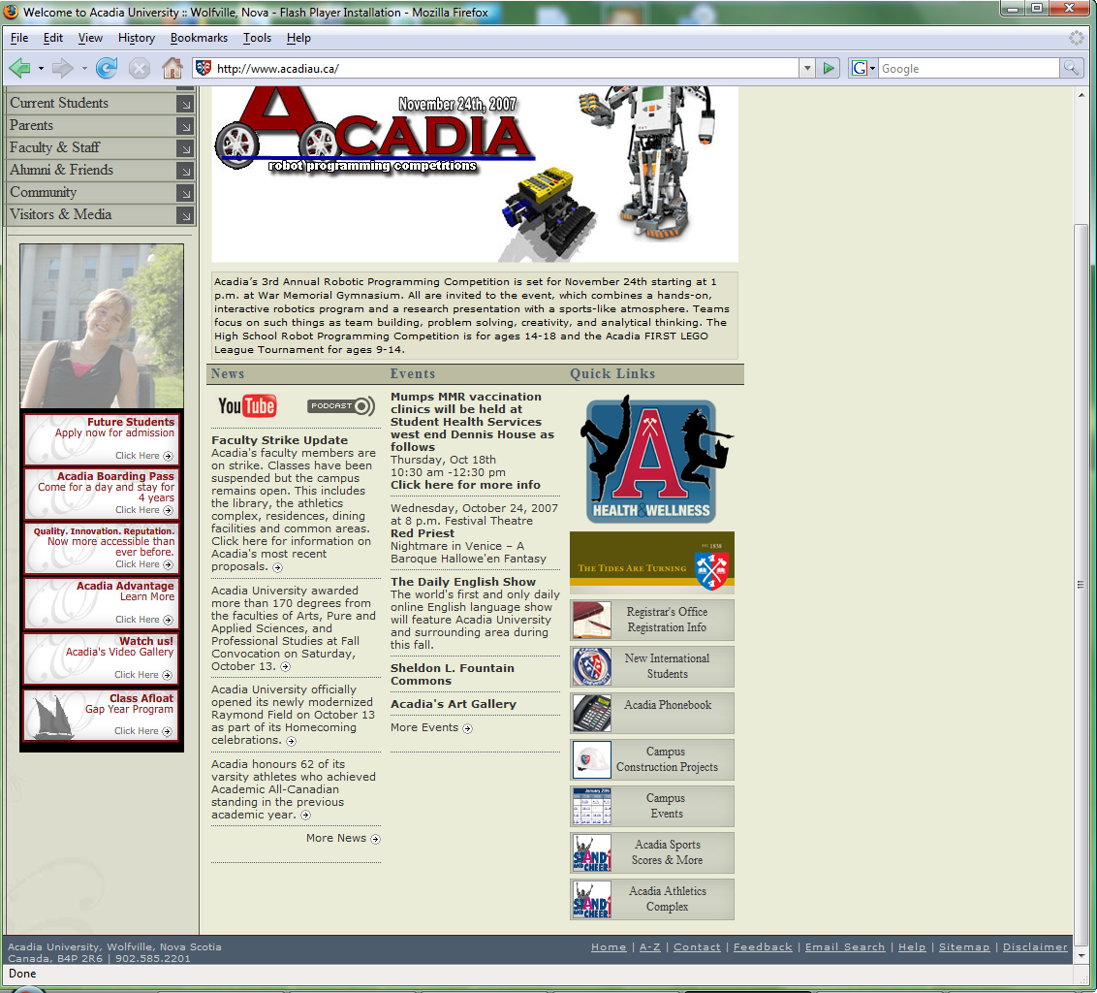
Figure 3 (screen shot of lower portion of www.acadiau.ca)

A quick evaluation with guidelines
First, we mark the home page of Acadia University according to the compliance with a list of selected applicable guidelines from the 113 guidelines (Nielsen & Tahir, 2001). The marking scheme is mentioned earlier as:
0 point for a violation
0.5 point for a partial compliance
1 point for a full compliance
Then we add up the score.
The guidelines are categorized into tables:
Communicating the Site's Purpose (7 guidelines)
Guidelines | compliance | score
Show the company name and/or logo in a reasonable size and noticeable location. | yes | 1
Include a tag line that explicitly summarizes what the site or company does. | no | 0
Emphasize what your site does that’s valuable from user’s point of view, as well as how you differ from key competitors. | no | 0
Emphasize the highest priority task so that users have a clear starting point on the homepage. | yes | 1
Clearly designate one page per site as the official home page. (multiple appearance of “home” linked to departmental home pages) | no | 0
On your main company website, don't use the word "website" to refer to anything by the totality of the company's web presence. | yes | 1
Design the homepage to be clearly different from all other pages on the site. (pages linked from home page tabs looks similar to the home page) | no | 0
 | Total | 3

Communicating Information About Your Company (7 guidelines)
Guidelines | compliance | score
Group corporate information, such as About Us, Investor Relations, Press Room, Employment and other information about the company, in one distinct area. (grouped to two areas redundantly, one on the top and the other on the bottom) | Partial | 0.5
Include a homepage link to an "About Us" section that gives users an overview about the company and links to any relevant details about your products, services, company values, business proposition, management team, and so forth. | yes | 1
If you want to get press coverage for your company, include a "Press Room" or "News Room" link on your homepage. | no | 0
Present a unified face to the customer, in which the website is one of the touchpoints rather than an entity unto itself. | yes | 1
Include a "Contact Us" link on the homepage that goes to a page with all the contact information for your company. | yes | 1
If you provide a "Feedback" mechanism, specify the purpose of the link and whether it will be read by customer service or the webmaster, and so forth. | no | 0
Don't include internal company information on the public website. | yes | 1
 | Total | 4.5

Content Writing (7 guidelines)
Guidelines | compliance | score
Avoid redundant content. | no | 0
Use consistent capitalization and other style standards. | yes | 1
Don't label a clearly defined area of the page if the content is sufficiently self-explanatory. | yes | 1
Avoid single-item categories and single-item bulleted lists. | yes | 1
Avoid exclamation marks. | yes | 1
Use all uppercase letters sparingly or not at all as a formatting style. | yes | 1
Avoid using spaces and punctuations inappropriately, for emphasis. | yes | 1
 | Total | 6

Archives and Accessing Past Content (1 guideline)
Guidelines | compliance | score
Make it easy to access anything that has been recently featured on your homepage, for example, in the last 2 weeks or month, by providing a list of recent features as well as putting recent items into the permanent archives. | yes | 1
 | Total | 1

Links (6 guidelines)
Guidelines | compliance | score
Differentiate links and make them scannable. | yes | 1
Don't use generic instructions, such as "click here" as a link name. | yes | 1
Don't use generic links, such as "More ..." at the end of a list of items. | yes | 1
Allow links colors to show visited and unvisited links. | no | 0
Don't use the word "Links" to indicate links on the page. Show that things are links by underlining them and coloring them blue. | yes | 1
If a link does anything other than go to another web page, such as linking to a PDF file or launching an audio or video player, e-mail message, or another application, make sure the link explicitly indicates what will happen. (use icons without description under news section) | Partial | 0.5
 | Total | 4.5

Navigation (6 guidelines)
Guidelines | compliance | score
Locate the primary navigation area in a highly noticeable place, preferably directly adjacent to the main body of the page. | yes | 1
Group items in the navigation area so that similar items are next to each other. (two quick links area, one in the lower left and the other in the lower right) | no | 0
Don't provide multiple navigation areas for the same type of links. (too many navigation areas) | no | 0
Don't include an active link to the homepage on the homepage. | no | 0
Don't use made-up words for category navigation choices. Categories need to be immediately differentiable from each other -- if users don't understand your made-up terminology, it will be impossible for them to differentiate categories. | yes | 1
Use icons in navigation only if they help users to recognize a class of items immediately, such as new items, sale items, or video content. (icons used are not descriptive enough in both news and quick links parts) | no | 0
 | Total | 2

Search (6 guidelines)
Guidelines | compliance | score
Give users an input box on the homepage to enter search queries, instead of just giving them a link to a search page. | yes | 1
Input boxes should be wide enough for users to see and edit standard queries on the site. | yes | 1
Don't label the search area with a heading; instead use a "Search" button to the right of the box. | no | 0
Unless advanced searches are the norm on your site, provide simple search on the homepage, with a link to advanced search or search tips if you have them. | yes | 1
Search on the homepage should search the entire site by default. | yes | 1
Don't offer a feature to "Search the Web" from the site's search function. | yes | 1
 | Total | 5

Tools and Task Shortcuts (3 guidelines)
Guidelines | compliance | score
Offer users direct access to high-priority tasks on the homepage. | yes | 1
Don't include tools unrelated to tasks users come to your site to do. | yes | 1
Don't provide tools that reproduce browser functionality, such as setting a page as the browser's default starting page or bookmarking the site. | yes | 1
 | Total | 3

Graphics and Animation (6 guidelines)
Guidelines | compliance | score
Use graphics to show real content, not just to decorate your homepage. | yes | 1
Label graphics and photos if their meaning is not clear from the context of the story they accompany. | yes | 1
Edit photos and diagrams appropriately for the display size. (quick link icons in the lower right part are too detailed for the size) | no | 0
Avoid watermark graphics. | no | 0
Don't use animation for the sole purpose of drawing attention to an item on the homepage. Animation rarely has a place on the homepage because it distracts from other elements. (animations on left hand navigation area) | partial | 0.5
Never animate critical elements of the page, such as the logo, tag line, or main headline. | yes | 1
 | Total | 3.5

Graphic Design (6 guidelines)
Guidelines | compliance | score
Limit font styles and other text formatting, such as sizes, colors, and so forth on the page because over-design text can actually detract from the meaning of the words. | yes | 1
Use high-contrast text and background colors so that type is as legible as possible. | no | 0
Avoid horizontal scrolling at 800x600 | yes | 1
The most critical page elements should be visible "above the fold" at the most prevalent window size. (half of the page is below the fold under 1024x768) | partial | 0.5
Use liquid layout so the homepage size adjusts to different screen resolutions. | no | 0
Use logos judiciously. | yes | 1
 | Total | 3.5

UI Widgets (3 guidelines)
Guidelines | compliance | score
Never use widgets for parts of the screen that you don't want people to click. | yes | 1
Avoid using multiple text entry boxes on the homepage, especially in the upper part of the page where people tend to look for the search feature. | yes | 1
Use drop-down menus sparingly, especially if the items in them are not self-explanatory. | no | 0
 | Total | 2

Window Titles (5 guidelines)
Guidelines | compliance | score
Begin the window title with the information-carrying word -- usually the company name. | no | 0
Don't include the top-level domain name, such as ".com" in the window title unless it is actually part of the company name, such as "Amazon.com". | yes | 1
Don't include "homepage" in the title. This adds verbiage without value. | yes | 1
Include a short description of the site in the window title. | yes | 1
Limit window titles to no more than 7 or 8 words or fewer than 64 total characters. | yes | 1
 | Total | 4

URLs (2 guidelines)
Guidelines | compliance | score
For any website that has an identity closely connected to a specific country other than the US, use that country's top-level domain. | yes | 1
If available, register domain names for alternative spellings, abbreviations, or common misspellings of the site name. | no | 0
 | Total | 1

News and Press Releases (4 guidelines)
Guidelines | compliance | score
Headlines should succinct, yet descriptive, to give maximum information in as few words as possible. (no headline for some news) | no | 0
Write and edit specific summaries for press releases and news stories that you feature on your homepage. | yes | 1
Link headlines, rather than the deck, to the full news story. | no | 0
As long as all the news stories on the homepage occurred within the week, there's no need to list the date and time in the deck of each story, unless it is truly a breaking news item that has frequent updates. | yes | 1
 | Total | 2

Welcomes (1 guideline)
Guidelines | compliance | score
Don't literally welcome users to your site. Before you give up prime homepage real estate to a salutation, consider using t for a tag line instead. | no | 0
 | Total | 0

Page Reload and Refresh (2 guidelines)
Guidelines | compliance | score
Don't automatically refresh the homepage to push updates to users. | yes | 1
When doing a refresh, update only content that has actually changes, such as news updates. (rotate through a set of photos) | no | 0
 | Total | 1

Dates and Times (3 guidelines)
Guidelines | compliance | score
Show dates and times for time-sensitive information only, such as news items, live chats, stock quotes, and so forth. | no | 0
Show users the time that content was last updated, not the computer-generated current time. | no | 0
Spell out the month or use month abbreviations, not numbers. | yes | 1
 | Total | 1

Total score = 3 + 4.5 + 6 +1 + 4.5 + 2 + 5 + 3 + 3.5 + 3.5 + 2 + 4 + 1 + 2 + 0 + 1 + 1 = 47
Total guidelines = 7 + 7 + 7 + 1 + 6 + 6 + 6 + 3 + 6 + 6 + 3 + 5 + 2 + 4 + 1 + 2 + 3 = 75
Total score/Total guidelines = 47/75 = 63%
Therefore, we can conclude that this home page needs major changes or a re-design project to fix all these usability problems although it is not a disaster.

A quick evaluation with conventional home page design principles
Besides the guidelines, conventions are a set of standard or prevalent home page design principles. Nielsen and Tahir (2001) give a list of recommended home page design principles based on conventions used by most of the 50 example home pages. We can quickly evaluation the home page of Acadia University with a list of this kind of recommended home page design principles.
A list of complied design principles is: (statistics from Nielsen and Tahir (2001) is in parentheses)
- Page width is less than 774 pixels.(75% of example home pages have a width less than 774 pixels)
- Page length is less than three full screens. (75% of examples home pages have a length less than three full screens)
- Frame is not used.(96% of example home pages do not use a frame)
- Search is placed in upper-right corner. (35% of example home pages place the search in upper-right corner)
- Search box colour is white. (97% of example home pages use a white search box)
- Search button is named acceptably as “Go”. (40% of example home pages name the search button “Go”)
- Width of search box is 25 characters. (the median width of search box is only 18 characters but more characters are recommended, thus this is an exception to follow conventions)
- Type of search is simple.(81% of example home pages use a simple search box)
- Name of the site map is simply “Sitemap”. (63% of example home pages name it “sitemap”)
- No routine page is included. (98% of example home pages do not use a routine page)
- No splash page is included. (94% of example home pages do not use a splash page)
- About link is included and named as “About Acadia”. (55% of example home pages name it “About <name-of-company>”)
- The help link is in the upper right corner. (41% of example home pages place help in upper right corner)
- No music. (96% of example home pages do not play music automatically)
- Body text colour is black.(72% of example home pages use black for body text)
A list of violated design principles are: (statistics from Nielsen and Tahir (2001) is in parentheses)
- The page layout is frozen. (82% of example home pages use frozen layout but it is not recommended, thus this is an exception to follow conventions)
- Too many navigation areas clutter the page. (94% of example home pages use only one navigation area).
- Graphics take too much space. (the median proportion of home pages allocated to graphics is no more than 8%)
- Animation is included. (70% of example home pages avoid animation)
- Body text size is smaller than 12 points. (the median is 12 points)
- Background colour is not white. (84% of example home pages use a white back ground)
- Links colour does not follow the conventional blue/purple combination.(60% of example home pages use blue as the colour for unvisited links and 54% use purple as the colour for visited links)

A complete walk through
In the end, a complete walk through to evaluate the home page of Acadia University is provided. Figure 2 is the labelled screen shot of upper part of the page corresponding to Comments [1-20] while Figure3 is the labelled screen shot of lower part of the page corresponding to comments [21-26].
Window Title [1]:
The “Welcome to” salutation is useless, the page will bookmark under “W” alphabetically instead of “A”. Thus the inherent advantage of being on top of the alphabetical Canadian universities list is not taken. The title is not too long but for some reason it cannot show properly that “Scotia” in “Nova Scotia” is chopped off in both Internet Explorer and Firefox. It is good to tell the location of the institution serving as a brief introduction though. However, the address can be redundant in the case that it also appears on the page itself and thus it can be replaced with a short descriptive text.
Reminding users of Flash Player installation in the windows title looks awkward and would not helpful at all. It does not provide any information about how to get and install the Flash Player and even worst it does not tell the user the Flash Player is for the proper showing of images and animations on the home page. For users who already have Flash Player installed, this remainder is redundant and annoying. For users who actually need the Flash Player, it is best to place this reminder with additionally detailed installation instruction or link in the blank areas where images or animations are supposed to appear.

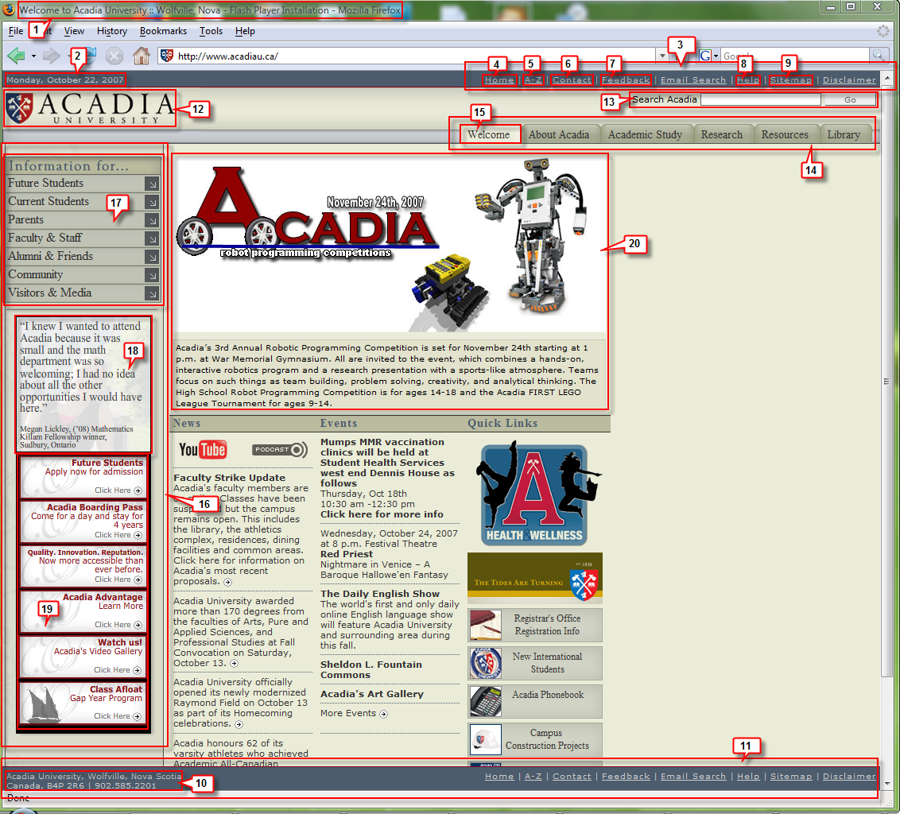
Figure 4 (www.acadiau.ca labeled screen shot of the upper part)
Tag Line:
Although the window title tells that this is a home page of an educational institution named Acadia University, a tag line can provide more information to a user unfamiliar with this university on what makes Acadia University differentiate from other educational institutions in Canada. When students are choosing universities, they may start a web research from the list of URLs of all accredited institutions in Canada. They try to just browse the home pages to help them get informed about each university due to time constraint. However, Acadia’s home page failed to tell the student what Acadia offers and why Acadia is different from many other universities and thus it could be easily filtered out from students’ application list. For example, “one of Canada’s best Liberal Arts Institutions since 1838” would serve the purpose well. It communicates to the user that Acadia is a leading Canadian undergraduate institution adopting the liberal arts system with renowned history since 1838.
Top and bottom navigation bars:
Date on top navigation bar [2]:
The date does not tell whether it is the date of the last update or just the current date which is automatically generated. It is only useful to include the date on which the content is updated so users can know whether the content has been updated since their last visit. It is useless to include the current date because the web site does not provide any time critical content as in a news website. Therefore, the date is not useful for a university home page.
Organizational information [3]:
Having the organizational information on both the top and bottom navigation bars are redundant. It will suffice to group them in one distinct place and it is a general usability principle to minimize duplication. The colour scheme used for this navigation bar fails to show a contrast for the text links and users tend to have banner blindness for a navigation bar above the banner area at the top of a home page. Therefore, users are likely to overlook this part.
Home Link [4]:
A link to the homepage on the navigation bar should not be clickable from the homepage. It makes users wonder what the current page is, if there is a link to the home page and it is a general principle not to include a an active link to the current page.
A-Z Link [5]:
This link almost serves the same function as the Sitemap does except that it means to list the sitemap in alphabetical order. It is better to remove this link and provide another A-Z link in the sitemap page linked from the sitemap link to alphabetize the sub web pages of this site.
Contact Link [6]:
It is good to have this link that directs to a separate page for detailed contact information. It is more conventional to name it “Contact Us” though.
Feedback Link [7]:
This link takes user to another page to fill out a form to provide general comments to the Acadia Website. Who will bother sending them a suggestion except a usability researcher who does an inspection on their website? The purpose of this link should be specified clearly.
Help Link [8]:
It is good to place the Help Link in the more standard position of the upper right corner.
Sitemap Link [9]:
It is good to follow the convention to name this link “Sitemap”.
Contact address on the bottom navigation bar [10]:
It is good to place the contact address directly on the home page.
Bottom navigation bar [11]:
This navigation bar has usability issues because the organizational information is redundant as mentioned above. This bottom bar also has a possible side effect of giving users wrong impression that it is actually the bottom of the home page because this bar simply always stays at the bottom of the browser regardless where the vertical scroll bar is. It is suggested to remove both the current top and bottom navigation bars and place a similar navigation bar in the real bottom of the home page instead of fixing it at the bottom of the browser. The address can be moved to in place of the useless current data on that bar located at the real bottom of the home page.
Logo [12]:
It is good to place the logo in the upper left corner as most websites do so. The logo should not be clickable from the homepage. Instead, it should be clickable from other pages on the website. Interestingly, at Acadia’s website, the logo seems only clickable from the home page.
Search [13]:
It is good to follow the convention to place the search at the top part of the home page. It is also good that input box is wide enough (25 characters) for users to review their queries. “Go” is acceptable for the action button but the label “Search Acadia” is a little redundant since every user knows this will search the Acadia website. Therefore the label can be shortened into just “Search”. It is best to name the action button “Search” and remove the label completely.
Tabs [14]:
These tabs below the banner area are clear and straightforward labels but there are too many navigation areas on this home page and thus they tend to clutter the entire interface. It is better to remove these tabs and place them in the left-hand navigation area within a well-separate category.
Welcome tab [15]:
The tab should not be clickable from the home page. There is no need to welcome users to this website and this tab should instead be named “Home” as users are browsing the home page when they are under this tab. This naming adds confusion to users and makes them wonder if the “Welcome” page is different from the home page.
Left-hand navigation rail [16]:
This area should be structured and categorized better. It is suggested to have three categories. First, move the tabs into this area and create a category for them. Leave the “Information for...” as a category and create another category for quick links which can be divided up into two sub-categories for prospective students and current students. Categories should be separated clearly.
Information for [17]:
This part is classified clearly for different groups of audience. This navigation area gives good visual cues for pull-down menus but the menus are all too long for users to find the items they are looking for. Instead of hiding so many choices under the pull-down menus, it is recommended to create a separate web page for each group of audience.
Rotating photos slideshow [18]:
Watermark graphics should be avoided as they add clutter and decrease visibility. Rotation through a set of photos should also be avoided as it distracts users’ attention. The rotating speed is also too fast to be useful because one can hardly finish reading the text before the next slide appears.
Quick links in lower left corner [19]:
Giving emphasis to high priority tasks directly on the home page conforms to the guidelines. However, offering too much emphasis is not necessarily to be good. Separating these quick links from the main navigation area by the photo slideshow is not necessary. This area should be integrated in to the main navigation area above and grouped under the sub category for prospective students in the quick links category. These links give clear visual cues when the mouse cursor hovers over one of the links. However, they are not consistent that there is no reason for the link on the bottom to receive special emphasis over others by having a different background image. The cursor hovering visual cue by the third link from the top is broken.
Image in the middle [20]:
The page randomly show a picture in a collection of pictures but it is generally not recommended to do so. Users may get distracted by the random cycling of big pictures every time they come back to the home page. Their attention may be drawn from their real tasks to the underlying sequence of changing pictures when there is actually no sequence at all. As these pictures are associated with news and events, it is good to have describing text below the image. However, the caption text seems too long and tries to tell the whole story and the test does not contain a link into a separate page for a full story. Even worst, not all of the news and events are listed in the news and events sections below. Therefore it means that users have to keep refreshing the home page until they run through the whole set of randomly cycled pictures to see the full collection of recent news or events.

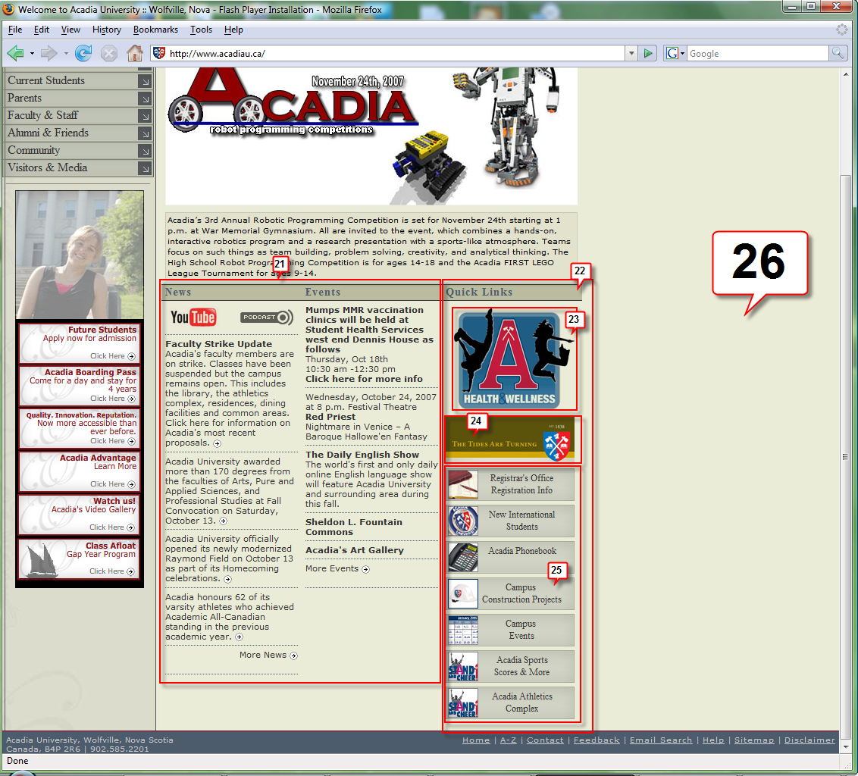
Figure 5 (www.acadiau.ca labeled screen shot of the lower part)
News and events [21]:
The part is totally inconsistent. In the news section, the top line has two icons without captions. Without illustrative descriptions, users can barely know that those two icons are links to multimedia news content on other websites. Not all news has a deadline. Decks or summaries are linked to the full news instead of headlines. It is not obvious to use little arrows to indicate each summary is linked to a separate web page unless the text is highlighted when the mouse cursor hovers on the links. Different colours should be used on links to show visited and unvisited states. The situation is even worse for the events section that some events provide links from the headlines, some have links from summaries and some gives an isolated “Click here” link. The only good side of this part is to provide links to archived news and events with specific text “More news” and “More events”.
Quick Links part to the right of events [22]:
Too many navigation areas increase unnecessary complexity to the user interface. This navigation area should be considered moving to the main navigation area on the left-hand side under the sub-category for current students in the quick links category.
Health & Wellness Link [23]:
There is no reason to give more emphasis separating the quick link to health and wellness from the others.
“The Tides are turning” Link [24]:
The “Tide are Turning” link looks like a title bar for the links below, but it is a link itself. The caption does not reveal what the link is about and even worse, it is a dead link directed to a 404 error page. Having an invalid link on a home page gives users an unprofessional and irresponsible impression. Prospective students will likely to perceive a low level of confidence in this university.
Other quick links [25]:
For the list of links below, icons are too detailed for the small size and they are not clickable. Icons serving as bullets next to text should be clickable and linked to the same page as the text is linked to.
Empty space [26]:
This home page uses a typical frozen layout. A large amount of space to the right of the page is wasted. Especially when the users are watching at a wide screen monitor, the home page appears very ugly. A Liquid layout should be used to fill more content in the ugly empty space wasted.

References
Nielsen, J., & Tahir, M. (2001). Homepage usability: 50 websites deconstructed. Indianapolis: New Riders Press.
The authors developed 113 guidelines to evaluate homepage usability through years of experience providing consulting services to websites. By analyzing statistics collected from design of 50 well-known home pages on the web, the book formulates a set of conventions which web designers should follow to create home pages with high usability. The authors also include 50 concrete examples been consulted in the end of the book.

