Hashing

Searches discussed so far vary in the efficiency with which they can find
the appropriate key.
Obviously, the ideal is to have a way of searching which was always O(1).
While this is rarely possible, there is a method which is O(1) or some multiple
rather than being dependent on the number of data elements.
Hash tables are a way of finding a record using keys which are a part of the
record and which also can be found by using specific algorithms which
operate on the key to determine the location of the information. The
information (records for example) can be stored in the hash table and the
process of determining the location of the information in the hash table uses
a hash function. The process of building or finding information in
the hash table is called hashing.

Hashing is the antithesis of sorting. Sorting arranges the records in some
pattern. Hashing scatters the records throughout the hash table in a
completely random fashion. Therefore, hashing is appropriate for implementing
a specified relationship among elements but it does not lend itself to operations
which attempt to make use of any other relationships among the data. In
implementing the hash table, other relationships may be destroyed. For example
an ordered list can be put into a hash table but since hashing is the antithesis of
sorting, the sorted nature of the data is lost. It is therefore difficult to determine
the fourth item in the ordered sequence. The price you pay for efficient searching
is the loss of relationships which previously existed in the data.

Suppose that a company has 500 employees and that the record
for each employee is to be hashed (placed in the table) by social insurance
number. Using the whole number would require 1 billion storage locations
in order to guarantee that each number would end up in a unique location.
This is an obvious waste of memory and may not be possible. What
is needed is a way to use the social security number with a hashing function
which would determine a unique location for each name and really only use
an array of records which is slightly longer than 500 records.

Hashing, by definition, assumes that there is random access to an element which
contains the key. It therefore assumes that the implementation provide this
(at least initially) and therefore the structure employed is an array. If the
data is composed of records it may be an array of records, or an array of
references may be combined with some structure which can be dynamically
allocated.

Hash Functions

Since hash functions must manipulate the data in some way to find a hash
location, arithmetic and logical process may form some part of any one of the
categories. Further, the language chosen may also affect how a hash function
is actually implemented. The ideal is that the key exists in a form which
would uniquely identify each entity and that if an array were constructed, the
number of elements in the array would be equal to the number of pieces of data.
Since this situation rarely exists, we try to find a way to fit all of the data
into an array of the smallest size that will accommodate all of the data. This
array size is also dependent on how the hashing process is implemented.
Initially, we will assume that the array must be at least equal in size to the
number of pieces of data that will be inserted. Actually, we will choose an array
which has a prime number of elements.

Hashing is the process of chopping up the key and mixing it up in various ways
in order to obtain an index which will be uniformly distributed over the
range of indices -- hence the 'hashing'. There are several common ways of
doing this. Your text categorises these somewhat differently so these notes
and the text should augment one another.

Truncation
This is a method in which parts of the key are ignored and the remaining
portion becomes the index. We take the given key and produce a hash location
by taking portions of the key (truncating the key so that the result
is smaller). For example, if a hash table can hold 1000 entries
and an 8-digit number is used as the key, the third, fifth, and seventh digits
starting from the left of the key could be used to produce the index.
[e.g... key is 62538194 the hash location is 589]. Notice that the range of
possibilities using this hash function is from 0 to 999 which is 1000 different values.
Although this type of function is simple and easy to implement,
it unfortunately often fails to distribute the keys evenly. When keys
fall into groups in the table, clustering is said to occur. By using only
portions of the key, the possibilities are reduced and in many cases (such
as specific digits in social security numbers) many may be the same.

Folding
This process breaks the key into several parts and recombines the parts to
form an index. The parts may be recombined by addition, subtraction,
multiplication, etc and may have to be truncated as well. Such a process
is usually better than truncation by itself since it produces a better
distribution because all of the numbers in the key contribute to the hash
function. [ e.g... using a key of 62538194, and breaking it into 3 numbers
using the first 3, the second 3 and the last 2 digits would produce 625, 381,
and 94. These could be added to get 1100 which could be truncated to 100.
They could also be multiplied together and then three digits chosen from the
middle of the number produced]. If the language allows, bit shifting and
exclusive oring are forms of folding. We are really manipulating parts of a
key at the lowest level in order to obtain new combinations to provide an index
to the hash table.

Modular Arithmetic
This process essentially assures that the index produced falls within a specified range.
The key is converted to an integer which is divided by the range of the index with
the resulting function being the value of the remainder. In its simplest form the key
is an integer and the modulus of the key is found directly. In other cases,
converting to an integer may use any number of processes to convert the key to
an integer and also might employ something from the two categories above.
If the value of the modulus is a prime number, the distribution of indices
obtained is quite uniform, in fact, hash tables almost always have a size which is a
prime number. A table whose size is some number which has many prime factors
provides the possibilty of many indices which are the same. You would not
choose a hashsize which is a multiple of 2, for example. Therefore, if a hash table is to be constructed for about 1000 records, the best bet would be to have a table which can hold
at least 1009 records.

Sometimes the hash function is suggested by the structure of the key. In
other cases, the best hash function can only be determined by experimentation.
Perfect minimal hash functions do exist. These are hash functions which will place
every item uniquely in the smallest possible hashsize (ideally equal to the number of items). Generally these hash functions are produced when all of the keys are known in advance. It is
extremely rare to find a perfect hash for an arbitrary number of keys.

Hash functions which use all of the key are almost always better than those
which use only some of the key. When only portions are used, information is
lost and therefore the number of possibilities for the final key are reduced.
Similarly, if we work with only integers or characters, there is a limit to
what can be done. However, if we deal with the integer in its binary form,
then the number of pieces that can be manipulated by the hash function is
greatly increased. This is one of the instances where working at the lowest
level is advantageous. We still abstract the function because the code which
uses the hash function does not need to know how the hash key is obtained, only
its range of values.

It is obvious that no matter what function is used, the possibility exists
that the use of the function will produce an index which is a duplicate of
an index which already exists. This is termed a collision. Therefore,
choosing a hash function which is efficiently calculated and which yields a
good distribution is only solving part of the problems in hashing. The
resolution of collisions must also be addressed.

Collision Resolution

The process of using a hash function to find some initial
location in a hash table is often referred to as open hashing. If the position
obtained is already occupied, then another open position must be found since
there is a collision. Collisions are resolved by a process of rehashing (also called
closed hashing). As an example, we will use the following list of keys in order to show what happens. We will also use
position = key mod hashsize

to determine the position in the hash table of size 11.

Key 23 18 29 28 39 13 16 42 17
Position 1 7 7 6 6 2 5 9 6

There are two major ways of resolving the collisions.

1. Open Addressing

Resolving collisions by open addressing is resolving the problem by taking
the next open space as determined by rehashing the key according to some
algorithm. Since the hash table has enough space to hold all of the records
some space must be open -- thus the 'open addressing'. Some open addressing
procedures are:

Linear Probing

This process starts with the position at which the collision occurred and does
a sequential search for the next open position. This essentially the function

newposition = (currentposition + 1 ) MOD hashsize

The results of using linear probing are shown below
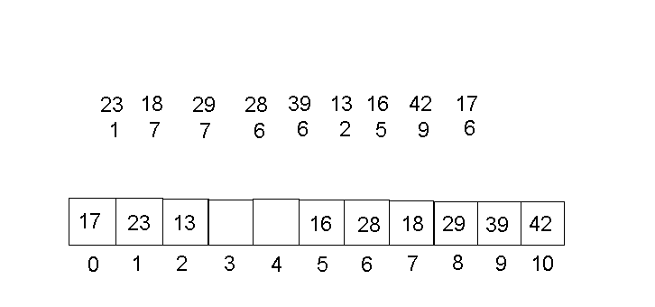
One of the major problems with this approach is that once the table becomes
quite full the length of the search for an open space increases. In practice,
clustering occurs, that is, the used spaces tend to appear in groups
which tend to grow and thus increase the search time to reach an open space.
It does, however, eventually find an open space.

Incremental Functions

In order to try to avoid clustering, a method which does not look for the first
open space must be used.
Two common methods are used.

Quadratic Probing

If there is a collision at hash address 'h', then the probing begins by adding
1 to the address, then 4, then 9, etc. In general form this can be expressed
as:

new position = first collision position + j² MOD hashsize

where j is the number of the probe and hashsize is the size of the hash table. The results of using a quadratic probe are shown below.
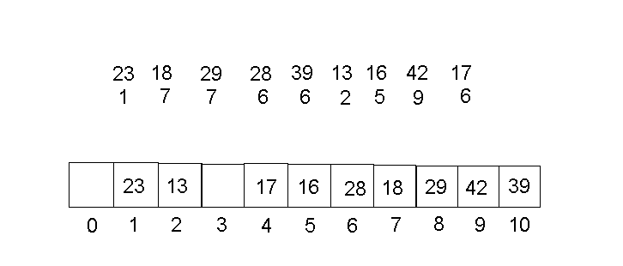

Once again, the best results are obtained when the size of the hash table is
a prime number since numbers which have several divisors would yield a fair
number of duplicate values when the mod function is used. When a prime is
used for hashsize, the number of distinct probes which will be made is
(hashsize + 1) DIV 2. Therefore, not all positions are probed but the results
are generally satisfactory. If the collision cannot be resolved, then
overflow is said to occur.

Key-dependent Increments

An obvious difficulty in the quadratic probe is that overflow may occur when
there is still space in the hash table. While this can be partly rectified
by making a table slightly larger than would be required when all elements are
in the table, this is wasteful, especially for large hash tables. Therefore,
key-dependent increments are used. These increments vary according to the
key used for the hash function. If the original hash function results in
a good distribution, then key-dependent functions work quite well for
rehashing and all locations in the table will eventually be probed for a
place to put the element.

Key-dependent increments are determined by using the key to calculate a new
value and then using this as an increment to determine successive probes.
Some checks should also be done before the increment obtained is used to
search for new positions. For example, since the original hash function was key
MOD 11 we might choose a function of key MOD 7 to find the increment. Thus
the closed hash function becomes

newposition = currentposition + (key DIV 11) MOD 11

The results of using this key dependent increment method is shown below.
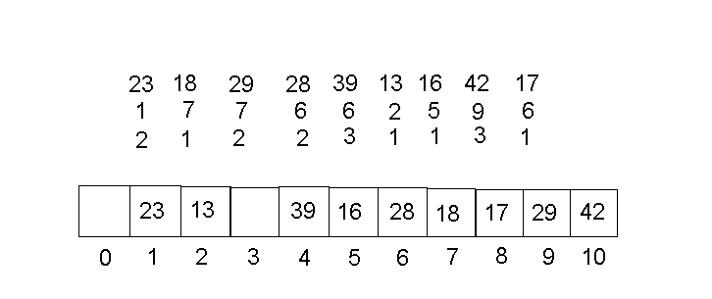
This closed hash function works for the data in the example because there are no keys
with a value of less than 11. In all of the closed hash functions it is important to ensure
that an increment of 0 does not arise. If the increment is equal to hashsize the same
position will be probed each time so this value cannot be used.

The increment is now dependent on the key and different increments exist. Generally,
a different number is used to find the modulus and while the open hash function could
be used to find an increment for the closed hash function, this should be avoided if possible.
Another problem exists if the size of the hash table is not a prime. For a number of the
increment values only some of the positions will be probed regardless of the number of
increments.

If we ensure that the hashsize is prime and the divisors for the open and
closed hash are prime, the rehash function does not produce a 0 increment, then
this method will usually access all positions as does the linear probe.
Using a key-dependent method usually result reduces clustering
and therefore searches for an empty position should not be as long as for the
linear method.

Collisions increase the search length to find any key since the search follows the same procedure as doing the original insertion. However, since hash functions are used often in writing efficient programs for a wide variety of applications, there are many modifications and extensions to the information that was presented here.

One of these is a simple coalesced hash table which is an attempt to make the searches shorter. To do this it adds some steps to the process of building the table and it also requires a second vector rather than a single one-dimensional array. The first column/row in the table is the hash table of keys. The second row or column is an indicator of which element to look in if a collision occurs. The table below was built using the simplest collision resolution technique, that ofa linear probe. The complete table is shown below, with a short explanation following.
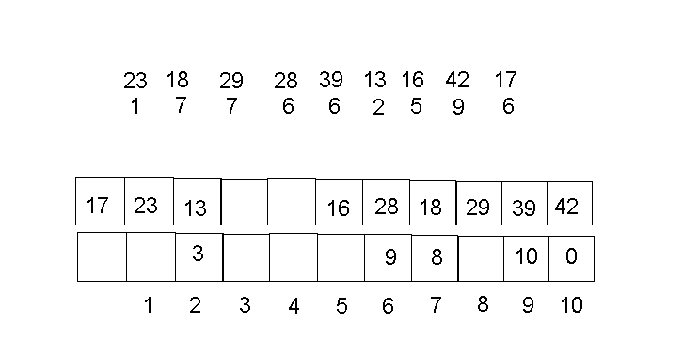
Notice that 23 and 18 hash into empty positions. However, 29 collides with 18 and so ends up in position 8. In the reference vector, an 8 indicates that a collision at position 7 was initially resolved by going to position 8. 28 hashes to position 6 and is placed there. 39 also hashes to position 6, but there is no previous collision there so we just use the rehash and move one more to position 7. At this point, we see that there was already a collision there and it was necessary to go to position 8, so we move to 8. There have been no previous collisions there so we use the rehash to get to position 9 where 39 can be placed. It is then necessary to go back to position 6 and indicate that the resolution is in location 9. The number of probes that we went through to place 39 is now reduced to only 2. If we put a 9 in the reference vector in position 6, then a search for 39 would go to position 6, and then to position 9, eliminating some of the probes. The next collision occurs when an attempt is made to place 42 which should go in position 9. There is no link to another place so we use the rehash to put 42 in position 10 and set the indicator in 9 to 10. Similarly, 17 eventually ends up in position 0 by starting at 6 and going to 9 and 10, and finally 0. The indicator in 10 is set to 0. Resolving collisions by coalescing the table can reduce the average probes to find a key. It is also slightly easier to just follow the indicator to a new array element than to rehash and then go to the element.

Effect of Deletions

Deletions from a hash table cause considerable problems. Memory space
which comes available because of a deletion should be re-used. If there
have been no collisions at that location resulting from hashing the key,
then the deletion would pose no problem. However, if after inserting the
first element into the location, subsequent hashing has resulted in the same
location and rehashing has been used to place the element in another position,
taking out the first element causes problems. When searching for an element
in a hash table, it is important to note that the searching algorithm is really
the same as the insertion algorithm. Therefore, if there is a collision some
mechanism is available to resolve the problem and place the element. The probe
continues until an open space is found. Removing any element breaks the
search because an open element indicates that an element can be placed, or
conversely, indicates that no more elements hash to that location given the
initial key. In order to cope with this, any deletion must set a key in the
hash table (often called a tombstone) to indicate that the space is now open
for the insertion of a new element if insertion is taking place but that if the
hash table is being searched, there are other elements which follow and the
collision resolution procedures should be used to continue searching the table.

Because deletions cause considerable difficulties and can reduce the
efficiency of using hash tables, they should be avoided whenever possible.

2. Collision Resolution by Chaining

External Chaining

Using arrays for hash tables is reasonable because there is random access
to any element. Thus access can be reduced to O(1), or if collisions occur
some multiple depending on the number of rehashes required before the
collision is resolved. However, arrays can use substantial amounts of
memory and in order to make collision resolution effective it is often
necessary to declare arrays which are larger than are actually filled with
elements (so searches for empty positions do not reach an overflow condition).
An option is to make the hash table an array of pointers to linked lists.
Then when a key is hashed, the position in the table is accessed which
refers to a linked list. Resolution of collisions is simple -- it requires
only that a node be added to a linked list. This insertion is usually as the
first item in the list which is the easiest to accomplish since it does not
require a traversal of the list. Deletions also pose no special
problems. The oringinal data are shown below in a table where collisions are resolved by chaining.

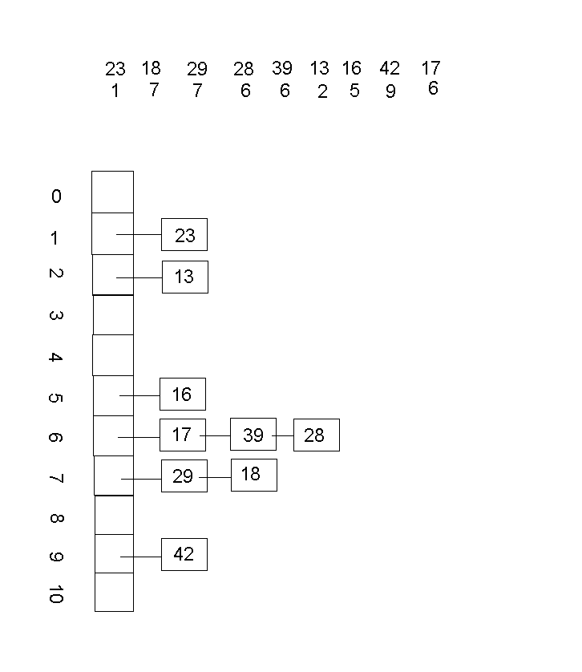
As long as the hash function produces a reasonable distribution,
none of the linked lists is likely to be very long. While there may be
elements in the hash table which remain unused, the savings in using dynamic
storage for the information should make up for the few un-used elements.
This is not true when the key and the information each only need one word of
storage space. In this case, for n elements, n words would be required to
store the hash table, n words for the information and n words for the links
in the chain. Using an array implementation which uses the same storage
would result in a table one-third full and an implementation in which all
elements could be accessed randomly. If the table is only one-third full,
there are not likely to be many collisions and therefore the array
implementation with open address collision resolution would likely be the
best.

Analysis of Searching Using Hash Tables

As mentioned, searching follows the same procedure as insertion. When
collisions occur, a method exists for resolving the collisions. When
searching, if the element is not found at the first locations, the rehashing
procedure is used to determine the next position to check until the search
is either successful or not.

With any reasonable size problem, collisions are likely to occur, therefore,
these should be minimized by using functions which produce a uniform
distribution and collision resolution procedures should be efficient (not
access too many positions which are already filled or produce clusters).

In analyzing search efficiency, the average is usually used. Searching with
hash tables is highly dependent on how full the table is since as the table
approaches a full state, more rehashes are necessary. The proportion of
the table which is full is called its load factor. When collisions
are resolved using open addressing the maximum load factor is 1. Using
chaining however, the load factor can be greater than 1 when the table is
full and the linked list attached to each hash address has more than
1 element.

The table below gives the average number of probes for different collision
resolution methods derived from experimentation at various load levels for the
hash table. The values are for large hash tables, in this case larger than 430.

.
Load factor 0.10 0.50 0.80 0.90 0.99 2.00

Successful
Chaining 1.04 1.2 1.4 1.4 1.5 2.0
Key-dependent 1.04 1.5 2.1 2.7 5.2
Linear 1.05 1.6 3.4 6.2 21.3

Unsuccessful
Chaining 0.11 0.53 0.78 0.90 0.99 2.04
Key-dependent 1.13 2.2 5.2 11.9 126
Linear 1.13 2.7 15.4 59.8 430

Obviously, chaining consistently requires fewer probes than open addressing.
However, traversal of the linked list is slow and if the records are small
it may be just as well to use open addressing. Chaining is best under two
conditions -- when the number of unsuccessful searches is large or when
the records are large. Open addressing would likely be a reasonable choice
when most searches are likely to be successful, the load factor is
moderate, and the records are relatively small.

In comparison to other methods of search it is important to note that the
number of probes is dependent only on the load factor on the hash table
and not on the absolute number of items in the table. On average, retrieval
from a hash table which contains 20000 items out of a possible 40000 items is
no slower than retrieval from a table of 20 items out of a possible 40.
With sequential search, if the number of items is increased 1000 times, it
would take 1000 times as long to search. If a binary search tree is increased
1000 times, the search would take 10 times as long. Obviously, the price
paid for the efficiency of the hash table is that large amounts of memory
must be available for a large amount of data in order to keep the load factor
moderate. Obviously, if the hash table contains only the keys and a reference
to the actual data, then the use of an array is preferable in most cases.

