Rendering Cracks in Batik
By Brian Wyvill
University of Calgary

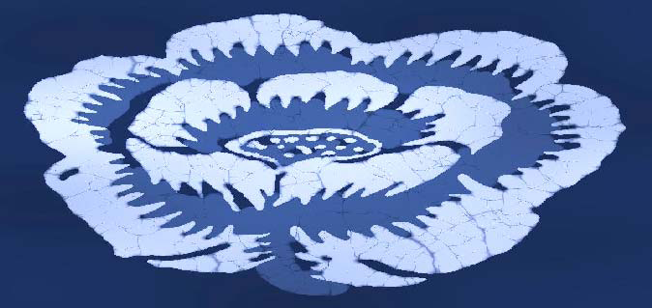

In this talk an algorithm is presented for simulating the cracks found in Batik wax painting and dyeing technique used to make images on cloth. The algorithm produces cracks similar to those found in batik due to the wax cracking in the dyeing process. The method is unlike earlier simulation techniques used in computer graphics, in that it is based on the Distance Transform algorithm rather than on a physically based simulation such as using spring mass meshes or finite element methods. Such methods can be difficult to implement and computationally costly due to the large numbers of equations that need to be solved. In contrast, our method is simple to implement and takes only a few seconds to produce convincing patterns that capture many of the characteristics of the crack patterns found in real Batik cloth.

Brian Wyvill graduated from the University of Bradford, Uk with a PhD in computer graphics in 1975. As a post-doc he worked at the Royal College of Art and helped make some animated sequences for the Alien movie. He emigrated to Canada in 1981 where he has been working in the area of implicit modeling, sometimes with his brother Geoff Wyvill (University of Otago). He has recently become interested in NPR (Non-Photorealistic Rendering) and enjoys combining these areas of research.

